Discussion Topics:

Theodore Roosevelt’s “Square Deal”

TR’s “bully pulpit”

What is meant by the phrase “speak softly and carry a big stick; you will go far” ?

Woodrow Wilson’s “New Freedom”

Impact of a tariff

Main Purpose of Federal Reserve Banks

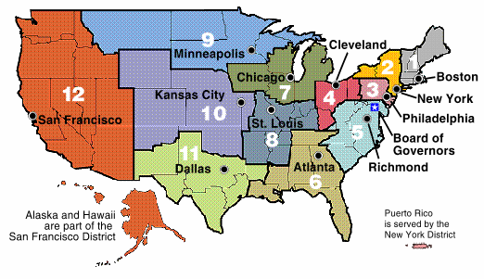

- Dollar diplomacy
- Explain and provide an example
- http://www.harwich.edu/depts/history/pp/imperialism/img057.jpg
- The first era of a true “global economy”

Latin America
- Spanish American War
- How does the U.S. become involved?
- What is the role of Hearst & Pulitzer? (Define yellow journalism.)
- What are the Rough Riders? Who leads them?
- Picture of the Maine explosion: http://www.homeofheroes.com/wallofhonor/spanish_am/images/02_maine_explosion.jpg
- Cartoon strip of the Spanish American War: http://www.dailypress.com/extras/solutions/images/SOL042303.gif
- As a result of the Spanish American War, what territories does the U.S. now control?
- Explain the relationship between the U.S. and Cuba after the war. How is it an example of imperialism?

Panama Canal
- Panama Canal and the role of Theodore Roosevelt
- How did the U.S. acquire the rights to build the Panama Canal?
- How can this be seen as an example of imperialism?
- Know the geographic location of the canal (link below).
- Explain the importance of the Panama Canal (Why such an interest to build it?)
- Panama Canal: http://www.pancanal.com/eng/persona/ed/index.html
Creation of international markets
China
- Open Door Policy
- Who was responsible for negotiated the Open Door Policy?
- What is the importance of this policy, particularly to the U.S.?
- What are spheres of influence?
- Map#1: http://www.thelatinlibrary.com/imperialism/maps/chinaspheres.jpg
- Map#2: http://sun.menloschool.org/~sportman/westernstudies/second/24/2003/eblock/kristinb/index_files/image004.jpg
Asia and the Pacific (U.S. Expansion)
- Hawaii
- Philippines
- Open Door Policy
- What areas today are territories of the U.S.?
- Map of U.S. Territories in Pacific: http://content.answers.com/main/content/wp/en/7/7e/GreaterAmericaMap.jpg
- May of Showing Guam: http://archives.cnn.com/1999/TECH/computing/12/31/y2k.reports.roundup.01/map.guam.gif
- May showing territories in the Caribbean: http://www.caribpro.com/Caribbean_Map/!Caribbean_MAP.gif

U.S. involvement in World War I
- When did the war begin?
- Between which two countries, initially?
- What was America’s stance on the war in the beginning? Why?
- Why did America get involved in the war?
- What was Wilson’s ultimate goal at the end of WWI?
- What is considered the reason the Allied Powers won the war?

Fourteen Points
- Wilson’s plan to eliminate the causes of war
- Key ideas
- Self-determination
- Freedom of the sea
- League of Nations
Mandate system

Treaty of Versailles
- The French and English insisted on punishment of Germany.
- A League of Nations was created.
- National boundaries were redrawn, creating many new nations.

League debate in United States
- Objections to U.S. foreign policy decisions made by an international organization, not by U.S. leaders
- Senate’s failure to approve Treaty of Versailles

