Axum

1)Where is Axum?

2) What religion is practiced in Axum?

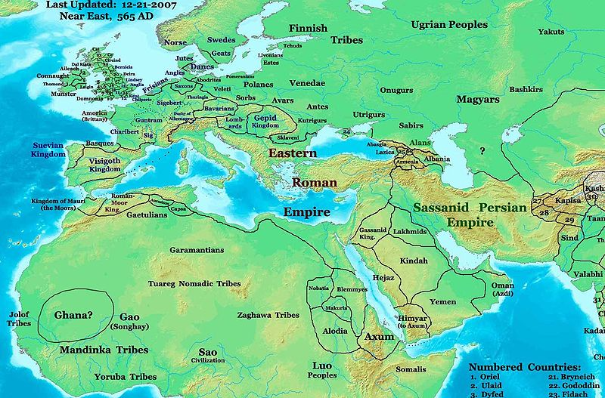

- Axum is in Northeast Africa, near the Nile River and Ethiopian Highlands.
- The Axum empire was a Christian kingdom.

