West African Kingdoms of Ghana, Mali, & Songhai

1) What is the major desert they are near?
2) What major river are they near?
3) What are is the major trade item from West Africa?
4) What trade item does West Africa need?
5) What is the major city of learning?
6) What are their basic religious beliefs?

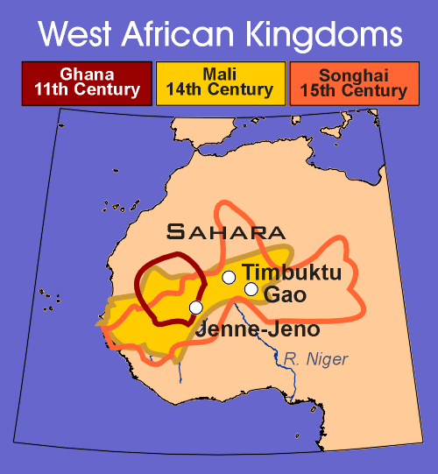

- Sahara Desert

- Niger River

- Gold is found in West Africa

- Gold is traded for salt (found in North Africa)

- Timbuktu

- Animism: the belief that natural objects have souls that may exist apart from their material bodies

and Islam spread to West Africa

