Zimbabwe
1)Where is Zimbabwe?

2) What is the importance of the city of “Great Zimbabwe”?

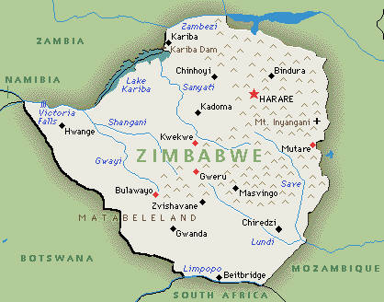

- Zimbabwe is close to the Zambezi and Limpopo Rivers.
It is also close to the Indian Ocean.
It is in Southern Africa.

- The title “Great Zimbabwe” refers to Zimbabwe as a capital of a prosperous empire.

