World History I
Emergence of Man to Neolithic Age

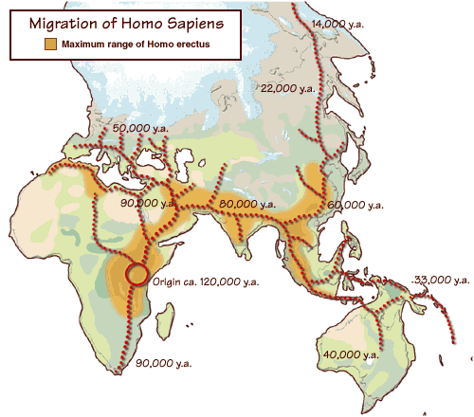

Timeline Activity

Directions: Answer the questions below by referencing the Pre-historic timeline from National Geographic. The timeline is interactive; click on an icon (picture on the timeline) and it will give you more information on that specific topic. To begin, click on Pre-historic timeline.

1. How long ago did planet Earth form?

2. What does m.y.a. mean (see the dates at the top of the timeline)?

3. When do life forms emerge--

4. When do Dinosaurs emerge?
When do Dinosaurs go extinct?

5. When does man emerge?

6. Choose three other topics and learn more about them. Click on the icon (picture)
of three subjects that interest you. Record the topic and information below.

Topic 1:
Notes:

Topic 2:
Notes:

Topic 3:
Notes:

MapActivity: Emergence of Homo Sapiens (Africa)

Migration Map (scroll down to see it)
World Map (Use World Map 1)
Colored Pencils

Directions:
- Draw the migration routes on your world map.
Label the map with the appropriate place names:
Africa
Eurasia
Australia
Americas

- Discussion:
Where did the migration route begin?

In what direction(s) did man migrate from there?

What was the last place man migrated to?

Migration of Man Map

Warm-up Activity

Cues (Question) | Subject (Note-taking)

Cues (Question) | Subject (Note-taking)
Summary

Paleolithic Age and Neolithic Age Chart

Map Work: Early Settlements
Directions:
- Locate the Fertile Crescent on your maps by shading in the correct area, and then label it.
- Locate the cities of Aleppo & Jericho on the same map by using a dark circle. Then label the cities.
- Locate the settlement of Catalhöyük in Anatolia by using a dark circle. Label the settlement.
- Locate Stonehenge in England by using a dark circle.

Vocabulary Activity
Directions: Supply a definition of each.
Write a sentence of your own for each.
Attach or draw a picture for each to the right of the term.

 | Definition | Sentence | Picture
Nomadic

Agriculture

Clan

Domesticated
(animals)

Settlement

Emergence of Man (Review)

Directions: Fill in the blanks with the appropriate word.

- Homo ____________ emerged from _________ ____________ between 100,000 and

- ___________________ years ago.

- Homo __________ migrated from ____________ to _____________, ______________,

and finally the _________________.

Questions: Paleolithic Age

Directions: Answer the following questions on a separate piece of paper.

- Describe how a Paleolithic man got his food.
- How did he make his shelter?
- What types of tools did he use?
- Did he use fire?
- Paleolithic man lived in groups called ___________________.
- Describe the language abilities of a Paleolithic man.
- What was cave art?

Questions: Neolithic Age

Directions: Answer the following questions on a separate piece of paper.

- How did Neolithic man get his food?
- What types of tools did he use?
- How are these tools different from the ones man in the Paleolithic Age produced?
- What skills did man developed during the Neolithic Age?
- Where is the settlement of Jericho located?
- Where is the settlement of Aleppo located?
- Where is the settlement of Catalhoyuk located?
- Why are these settlements important?
- Where is Stonehenge located?
- When was Stonehenge built?

