Title : CSS-Marlink Pre-Process Participants Module



What is Satellite Communication?
- A communications satellite is an artificial satellite that relays and amplifies radio telecommunications signals via a transponder.
- It creates a communication channel between a source transmitter and a receiver at different locations on Earth.
- Communications satellites are used for television, telephone, radio, internet, and military applications.
- There are 2,134 communications satellites in Earth's orbit, used by both private and government organizations.

How they work ?
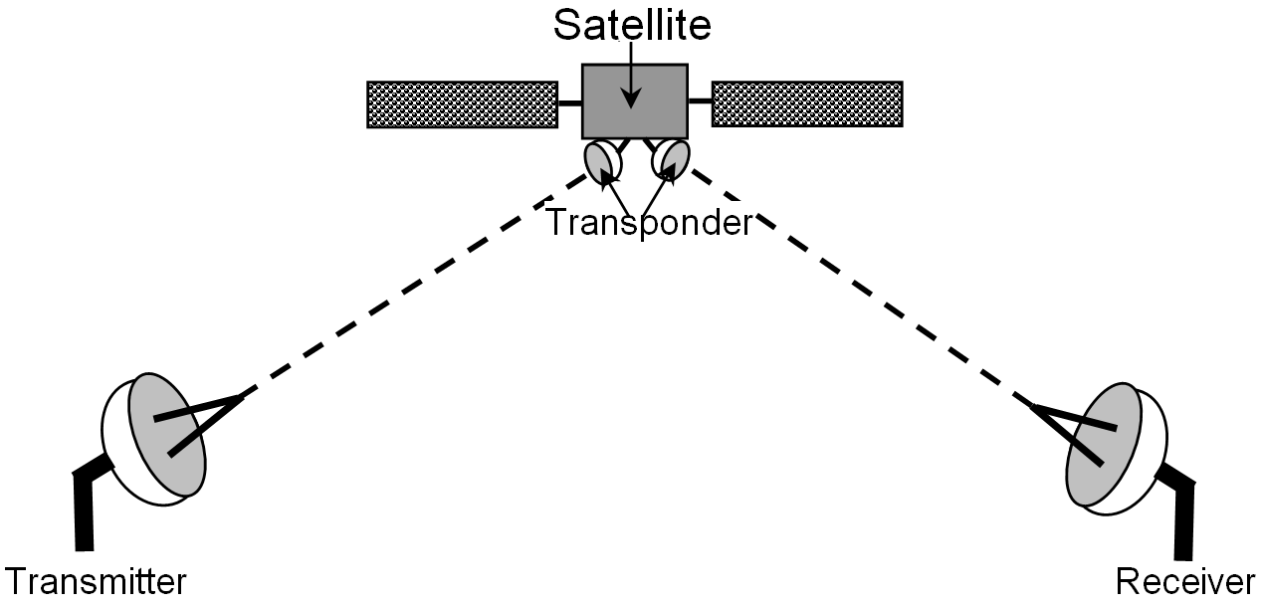

- Communications satellites are essentially used to relay radio waves from one place on Earth to another.
- They receive the signal from earth station, amplifies them and send it to another earth station.

Three Link Chain

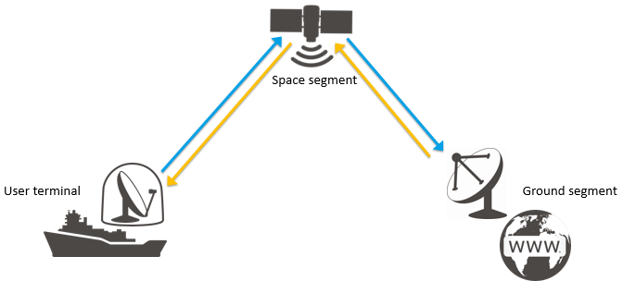

The difference:

- Traditional landline requires network of wires and exchanges to make a complete physical circuit.
- Cellphones need to be within range of cellphone masts.
- Satellite phones gives geographic freedom and an instant ability to communicate.

The Advantage
- Communications satellites overcomes the problem of sending radio waves in straight lines around our curved planet.
- Useful for communicating to and from remote areas.
- Services are not disrupted by any natural calamities.

SATELLITE ORBITS

Geostationary Earth Orbit

- These satellites are in orbit 35,863 km above the earth’s surface along the equator.
- Objects in Geostationary orbit revolve around the earth at the same speed as the earth rotates. This means GEO satellites remain in the same position relative to the surface of earth.

Advantages
  - A GEO satellite’s distance from earth gives it a large coverage area, almost a fourth of the earth’s surface.
  - GEO satellites have a 24 hour view of a particular area.
  - These factors make it ideal for satellite broadcast and other multipoint applications.
Disadvantages
  - A GEO satellite’s distance also cause it to have both a comparatively weak signal and a time delay in the signal, which is bad for point to point communication.
  - GEO satellites, centered above the equator, have difficulty broadcasting signals to near polar regions

Low Earth Orbit
- LEO satellites are much closer to the earth than GEO satellites, ranging from 500 to 1,500 km above the surface.
- LEO satellites don’t stay in fixed position relative to the surface, and are only visible for 15 to 20 minutes each pass.
- A network of LEO satellites is necessary for LEO satellites to be useful

Advantages
  - A LEO satellite’s proximity to earth compared to a GEO satellite gives it a better signal strength and less of a time delay, which makes it better for point to point communication.
  - A LEO satellite’s smaller area of coverage is less of a waste of bandwidth.
Disadvantages
  - A network of LEO satellites is needed, which can be costly
  - LEO satellites have to compensate for Doppler shifts cause by their relative movement.
  - Atmospheric drag effects LEO satellites, causing gradual orbital deterioration.

Medium Earth Orbit
- A MEO satellite is in orbit somewhere between 8,000 km and 18,000 km above the earth’s surface.
- MEO satellites are similar to LEO satellites in functionality.
- MEO satellites are visible for much longer periods of time than LEO satellites, usually between 2 to 8 hours.
- MEO satellites have a larger coverage area than LEO satellites.

Advantage
  - A MEO satellite’s longer duration of visibility and wider footprint means fewer satellites are needed in a MEO network than a LEO network.
Disadvantage
  - A MEO satellite’s distance gives it a longer time delay and weaker signal than a LEO satellite, though not as bad as a GEO satellite.

Frequency Bands
  - L–Band: 1 to 2 GHz, used by MSS
  - S-Band: 2 to 4 GHz, used by MSS, NASA, deep space research
  - C-Band: 4 to 8 GHz, used by FSS
  - X-Band: 8 to 12.5 GHz, used by FSS and in terrestrial imaging, ex: military and meteorological satellites
  - Ku-Band: 12.5 to 18 GHz: used by FSS and BSS (DBS)
  - K-Band: 18 to 26.5 GHz: used by FSS and BSS
  - Ka-Band: 26.5 to 40 GHz: used by FSS

About Marlink

- Number 1 Maritime VSAT and Connectivity Provider.
- Partner of all Satellite Network Operators and terrestrial partners.
- Marlink helps customers to digitalize their remote business operations wherever they are.
- 1 in 3 vessels served globally

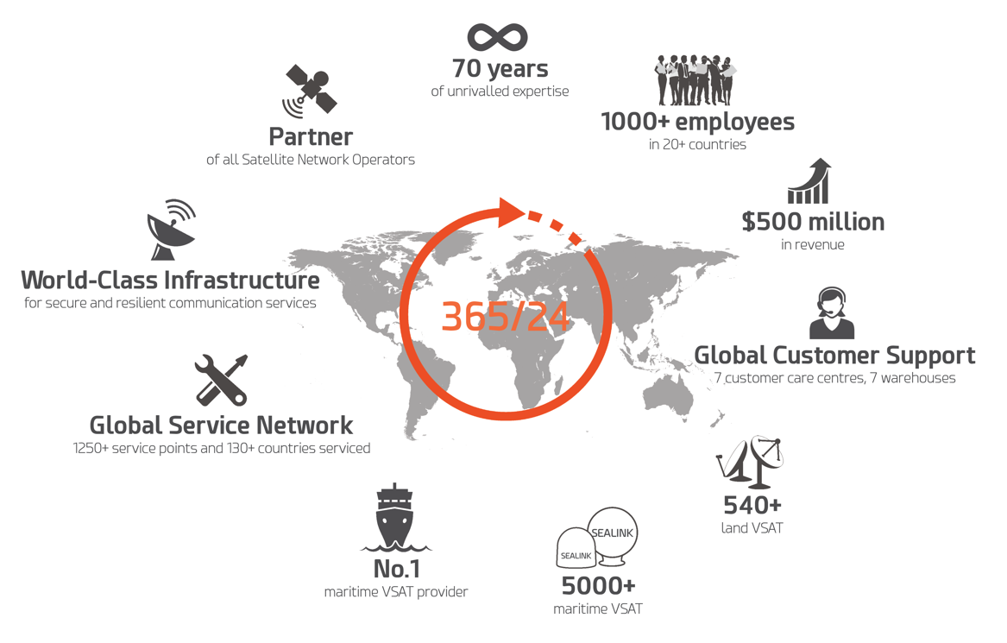

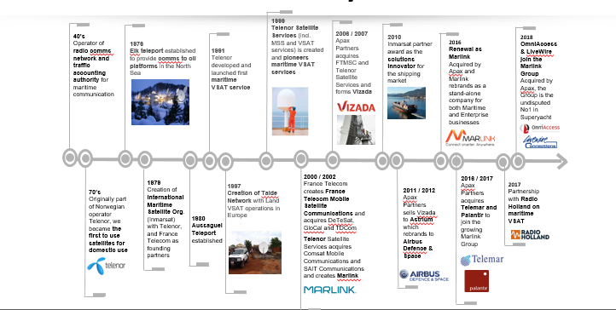

Marlink Group
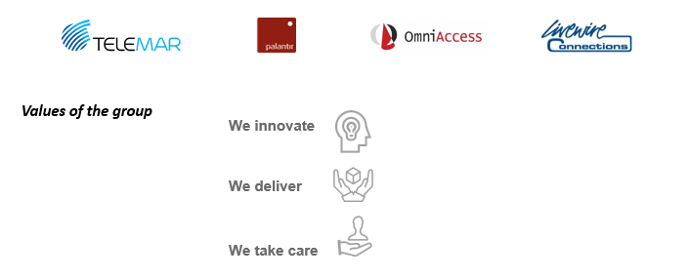

Marlink Offices

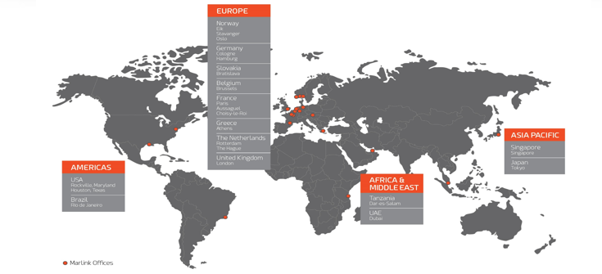

Global Customer Support
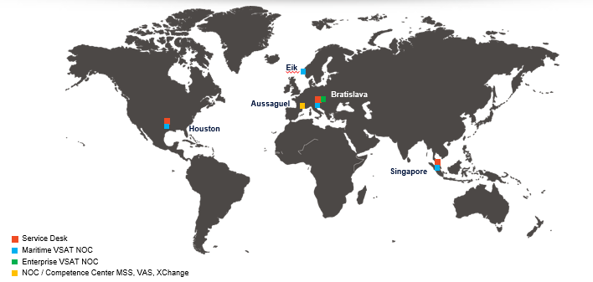

Global Customer Support
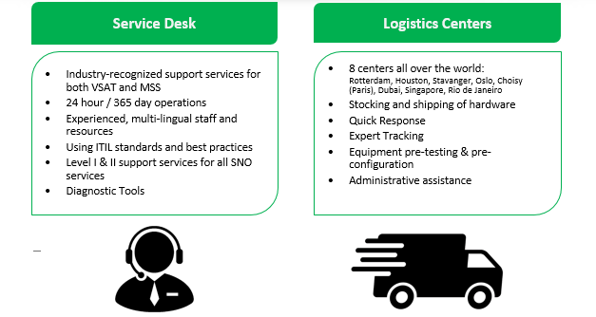

Solutions for all Markets


Products & Service Offerings

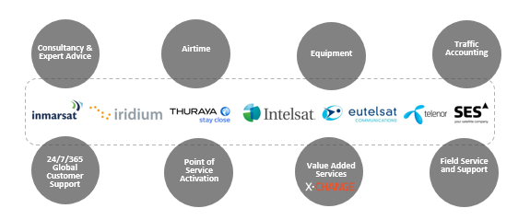

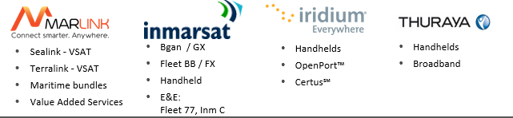

VSAT
- VSAT (Very Small Aperture Terminal) is a satellite communications system that can handle data, voice, and video signals.
- The transceiver receives or sends a signal to a satellite transponder in the sky. The satellite sends and receives signals from an earth station computer that acts as a hub for the system.
- Each end user is interconnected with the hub station via the satellite in a star topology.
- For one end user to communicate with another, each transmission has to first go to the hub station which retransmits it via the satellite to the other end user's VSAT.

VSAT Equipment
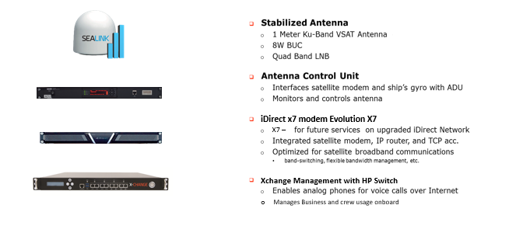

VSAT in Rain
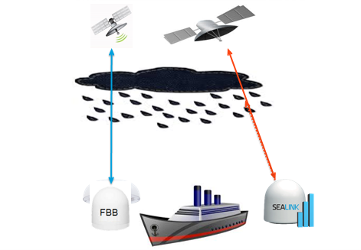

Extensive Ku Band Coverage
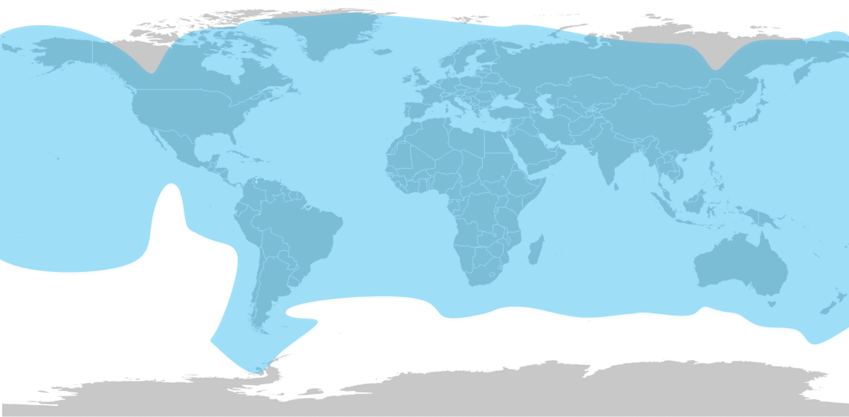

Inmarsat Devices
Inmarsat-3 — E&E
        - Network and coverage
        - Inmarsat Fleet 77
        - Inmarsat C
Inmarsat-4
        - Network and coverage
        - BGAN
        - FBB
        - IsatPhone / Fleet Phone
        - Isat Hub
        - M2M
Inmarsat-5
        - Global Express

About Inmarsat

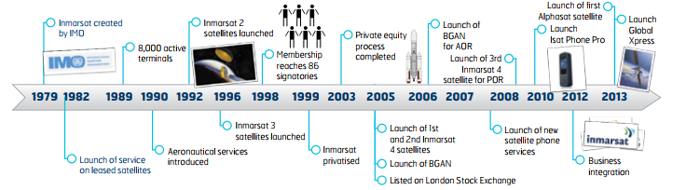

Inmarsat C & Mini C
- Used for distress and safety communications as well as fleet tracking, Inmarsat C and Mini C enable you to send & receive data messages of up to 32 kilobytes.
- Inmarsat C and Mini C are store-and-forward messaging services using inexpensive satellite terminals to send and receive data messages from fixed devices such as PCs and telex machines.
- They are ideally suited for messaging, fleet management, Supervisory Control and Data Acquisition (SCADA), Homeland Security, maritime and aero safety solutions.

Inmarsat C
- 2-way data, telex*, fax (ship2shore), TCP-IP, email & SMS communications to destinations worldwide
- Approved for use under the GMDSS and mandatory for Solas-compliant ships operating outside Navtex coverage areas
- Enhanced services for VMS (Vessel Monitoring System)

Inmarsat Mini C
- 2-way data, telex*, fax (ship2shore), TCP-IP, email & SMS communications to destinations worldwide
- 6 inputs/outputs for sensors
- Very low power consumption (only 10.2 mW on standby)
- Approved for use under the GMDSS and mandatory for Solas-compliant ships operating outside Navtex coverage areas
- Enhanced services for VMS (Vessel Monitoring System)
- EDR (Enhanced Data Reporting) and EPADR (Enhanced Pre Assigned Data Report) compliant

Inmarsat C & Mini C - Benefits
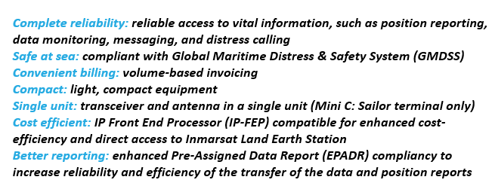

Inmarsat C & Mini C - Equipment
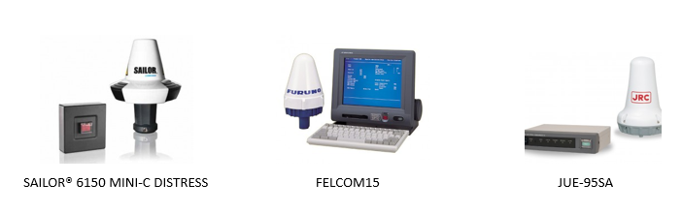

Inmarsat C - Coverage
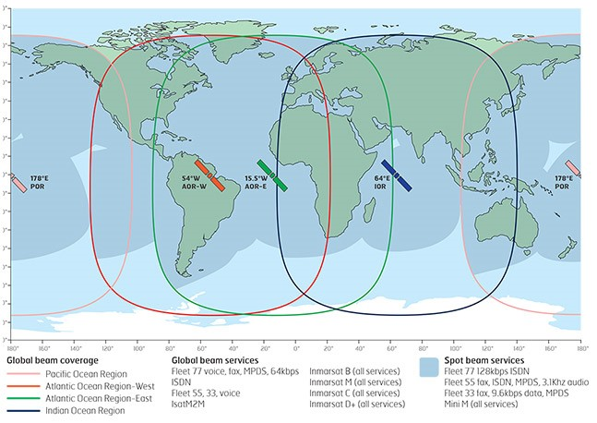

Inmarsat FBB
- Inmarsat FleetBroadband provides cost-effective broadband data up to 432 Kbps and voice simultaneously through a compact antenna on a global level.
- Based on the BGAN network using 3G standards, FleetBroadband provides you with a seamless broadband connection utilizing Inmarsat’s I-4 satellite constellation.
- With FleetBroadband you can access email, surf the web and run operational systems remotely, while our solutions enhance the service with cost-effective tools for your daily communication and administration needs.

Inmarsat FBB – Features
- Standard IP: up to 432 Kbps over a shared channel, for email, Internet & intranet access and remote maintenance
- Streaming IP: guaranteed on-demand data rates of up to 256 Kbps for live video/audio applications and 8 kbps and 16 kbps for voice over IP (VoIP) applications
- Voice: up to 9 simultaneous voice lines for bridge and crew communication
- ISDN: supports ISDN at 64 kbps for legacy applications
- SMS: send and receive 160 character text messages
- Coverage: available globally, except in polar regions

Inmarsat FBB - Benefits
- Simultaneous voice & data communications
- High throughput speed up to 432 Kbps for seamless broadband connection
- Up to 9 simultaneous telephone calls with Inmarsat Multi-voice service
- Reliable equipment with a range of performance capabilities
- Compatible with many crew welfare applications
- Small terminals and compact stabilized antennas

Inmarsat FBB – Equipment
- High performance in a compact format.
- FleetBroadband uses compact below-deck terminals and stabilized, directional antennas ranging in diameter from 27 cm to 68 cm to deliver optimal maritime connectivity.

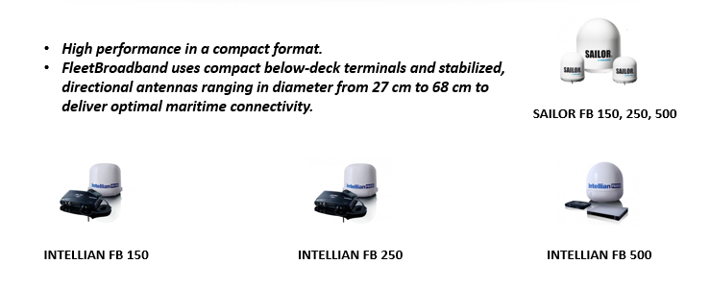

Inmarsat Fleet One
- Inmarsat Fleet One enables L-band data connectivity up to 100 Kbps and voice calling on a single line, delivered through a compact, lightweight antenna and simple installation.
- Its capabilities are ideal for smaller recreational and fishing users who need reliable voice communications and Internet connectivity on board.
Two service options are available:
- Fleet One Global
- Fleet One Coastal

Fleet One Global
Fleet One Global: Ideal for both seasonal and regular users
- Fully flexible - de-activate and re-activate the service at any time so you only pay for it when you need it
- Fleet One Global offers flexible connectivity for any size of vessel, available for one price anywhere on the world’s seas
- Fleet One Global meets the voice and data needs of a wide range of users, from fishing and regional merchant vessels to global recreational seafarers.
- There is no vessel size limit
- Fleet One Coastal: Ideal for recreational sailors and small regional fishing boat operators

Fleet One Coastal
- Fleet One Coastal is aimed at occasional users looking to stay connected without having to worry about cellular coverage or network roaming charges
- Enables access to tailored airtime pricing in key coastal regions to keep costs down
- Competitive rates are available for prepaid use – ideal for one-off trips
- Fleet One Coastal is available to vessels under 500 gross tonnage - typical users are small fishing and leisure boats up to 24 meters.

Fleet One – Benefits
- Standard IP speeds of up to 100 Kbps
- 1 Voice Line + SMS (no multi-voice)
- Wi-Fi capability for mobile applications, Ethernet, RJ11, RJ45
- Optional SIP router for WiFi, firewall capability, PIN control
- Emergency Safety Calling Service (505)
- Global Coverage above 5 degrees

Fleet One - Equipment
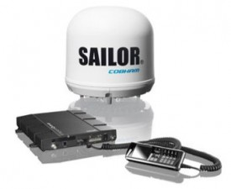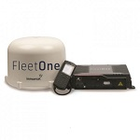

Inmarsat Fleet Xpress
- Fleet Xpress delivers the high data speeds enabled by Inmarsat’s Global Xpress Ka-band technology combined with the proven reliability of Inmarsat’s FleetBroadband L-band service.
- FleetBroadband being the backup service of the main Global Xpress service, the switch between both services is fully managed automatically.
- Guaranteed global bandwidth ensures that ship owners and operators can improve business intelligence, enhance efficiency, performance and crew welfare, and in turn run their businesses more effectively.

Inmarsat Fleet Xpress - Features
- Unlimited data service across Ka-band and FB on one price
- Fully managed service
- Wide choice of affordable voice options (including prepaid) for crew and operations
- Advanced data monitoring, tracking and analysis tools via Portal360
- 24/7 global customer support
- Low cost voice calling from as little as $0.10 per minute
- More in-depth status data will also soon be available onboard in a unique Marlink customer dashboard, providing easy to understand bandwidth performance and traffic statistics
- A variety of flexible data plans

Inmarsat Fleet Xpress - Benefits
- Continuous connectivity: ultimate reliability through a dual satellite constellation using Ka-band with unlimited L-band back-up, ensuring seamless global mobility
- Controlled costs: more accurate cost management with a wide selection of flexible subscription packages and one invoice
- Fully managed support: standardized plug-and-play service with 24/7/365 management, monitoring and support globally, for simplicity and complete peace of mind
- Business applications: a unique opportunity for enhanced operations by deploying value added services expertly developed by Marlink
- VSAT expertise: as a pioneer provider of maritime VSAT, Marlink has unique long-term experience and knowledge in VSAT delivery and support

Inmarsat Fleet Xpress - Benefits
Real-time on-board connectivity status: enabling the captain and on board personnel to track and monitor which connectivity is active at any time (i.e. the Ka-band primary Fleet Xpress service, or L-band FleetBroadband back-up service)
Real-time on-shore connectivity status: enabling the shore headquarters and Marlink’s global support network to monitor which connectivity is active at any time and get real-time info to ensure efficient remote troubleshooting
Traffic prioritization: onboard usage can be managed according to status and traffic can be prioritized to ensure critical applications are always globally available
Hassle-free roll out: XChange FX is not subject to an Export Control License, so can be delivered globally without customs and border delays. The system is simple to install, and once on board, delivers the most advanced functionality available for Fleet Xpress network management available today
Future ready: XChange FX is designed to accommodate over-the-air updates, reducing the need for ordering and installing new hardware in the future

Inmarsat SIM
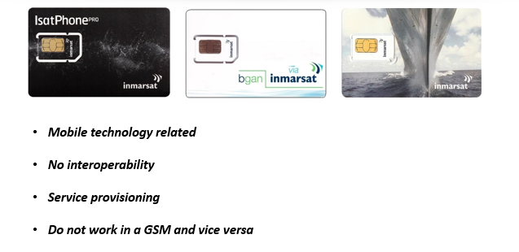

Inmarsat 4 BGAN
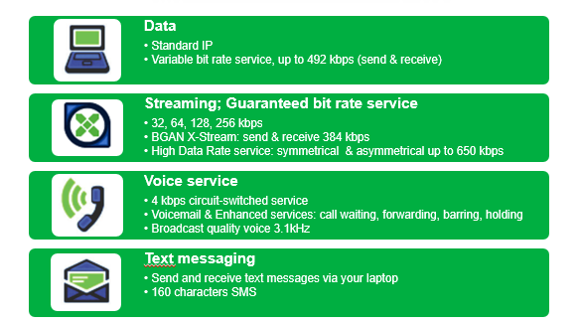

Inmarsat 4 Connection Steps
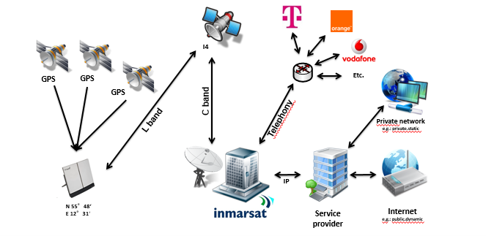

Dialing Pattern
From Inmarsat to e.g. +1 234 4567 8910
  - 00 - Country Code - Area Code - Subscriber number:
    - 00 outgoing prefix, can be replaced by a ‘+’ on newer technologies
    - 1 country code – North America
    - 234 area code – Ohio
    - 4567 8910 destination number
  - The leading ‘0’ of the area code may or may not be omitted depending on the specific country’s dialling plan.
To Inmarsat to e.g. +870 772 123456
  - 00 - 870 - Subscriber number:
    - 00 international prefix, country dependent eg. 011 in North America
    - 870 Inmarsat ‘country code’
    - 772 123456 Subscriber number, here a Bgan
  - The 3 first digits of the subscriber number correspond to the type of mobile.

IP Services – Standard IP
- Best Effort
- Background IP
- Contented Channel
- ‘Designed’ for TCP applications

IP Services – Streaming IP
- Dedicated channel
- ‘Designed’ for UDP applications

Inmarsat I4 – BGAN Portable
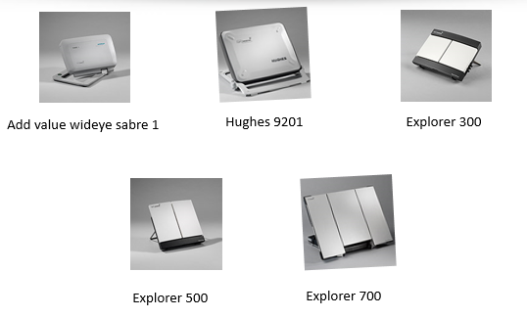

Inmarsat I4 – BGAN Vehicular
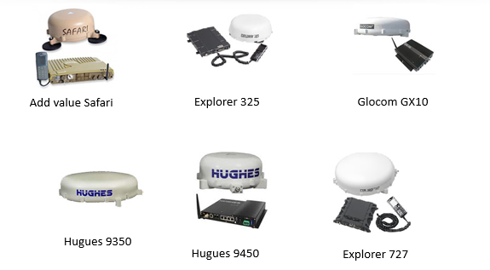

Inmarsat 4 – Bgan M2M
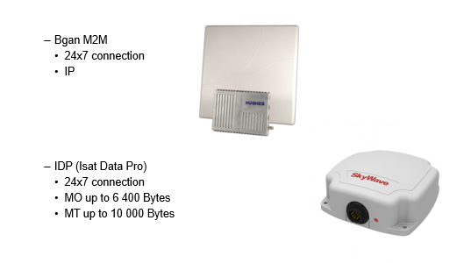

Inmarsat 4 – Swift Broadband
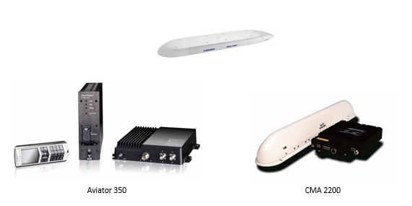

Inmarsat 4 – Isat Phone
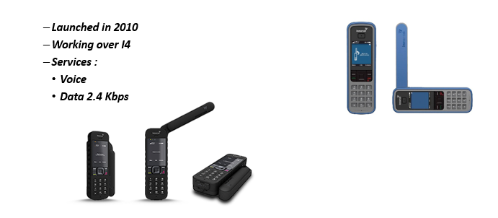

Inmarsat 4 – Fleet Phone
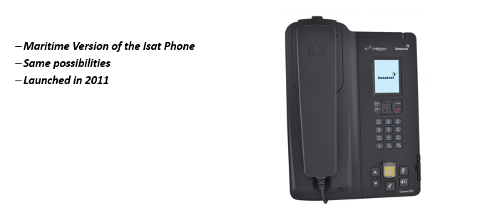

Inmarsat 4 – Isat Hub
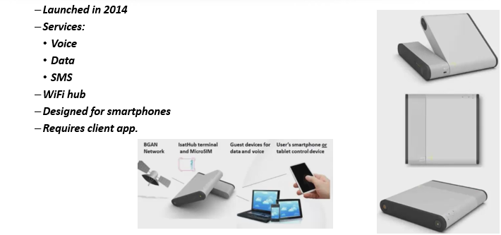



Iridium – The Satellites
- 66 satellites and 13 spares
- 6 orbits and 11 satellites per orbit
- Polar orbits
- Speed = 27 088 km/h

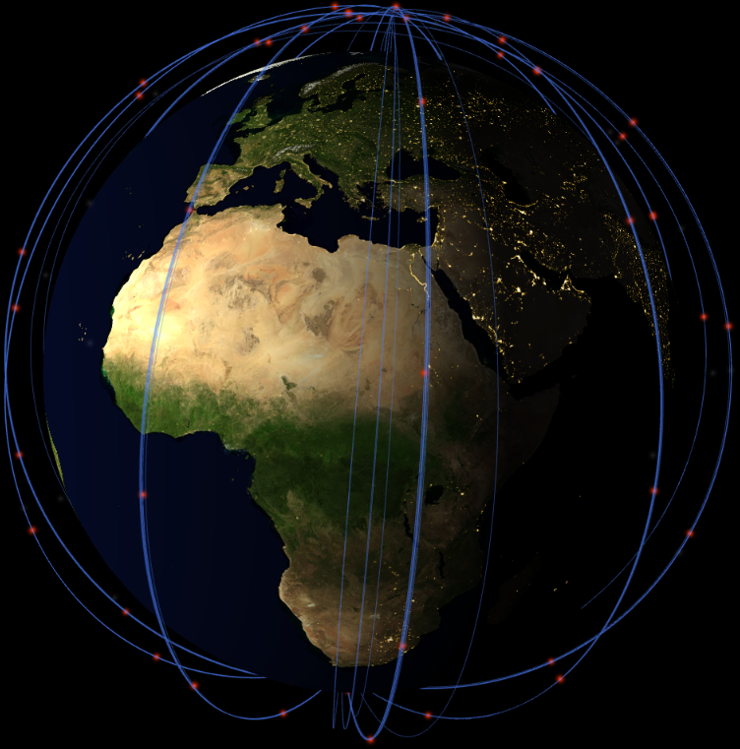

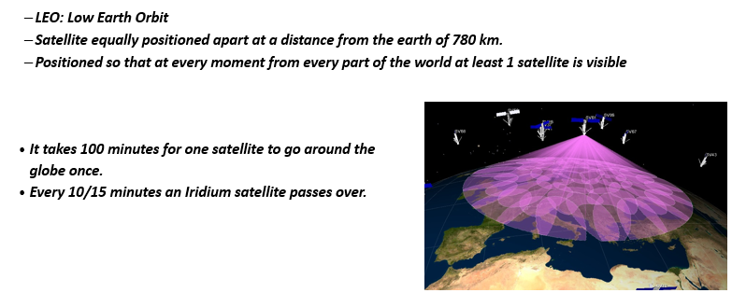

Iridium – Ground Infrastructure
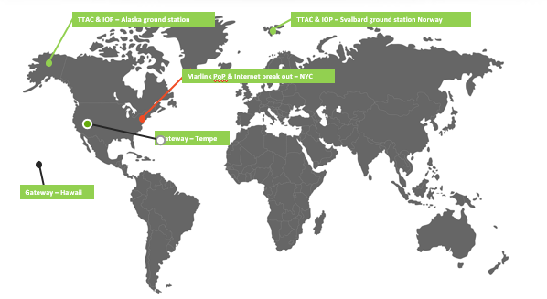

Iridium – The Sites
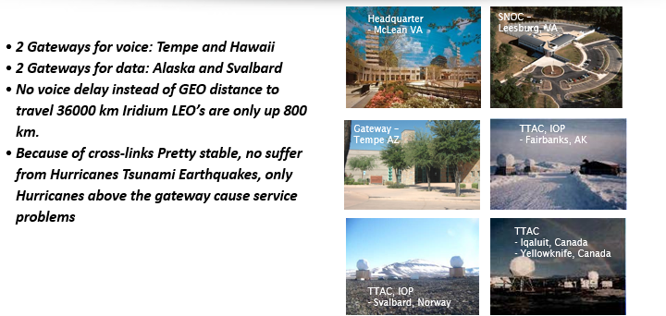

Using Iridium
- Clear sight towards the sky—keep far from buildings, trees, etc.
- Fully extended antenna, pointing up towards the zenith to maximise reception.
- Mind interferences with other devices in the surrounding such as VSAT, VHF, radars, high voltage power lines, etc.
- The Iridium phones quite are not sensitive to local weather conditions.
- Up-to-date firmware version, downloadable from www.iridium.com.

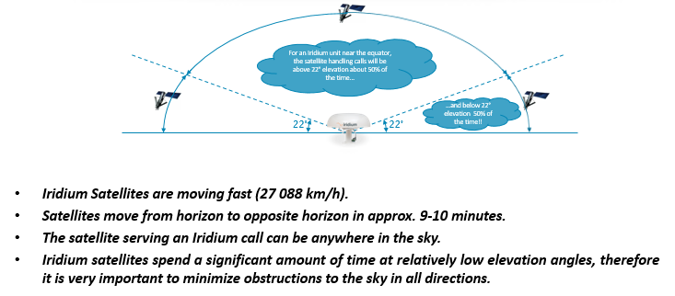

Iridium Certus
- Powered by the Iridium NEXT satellite constellation, Iridium Certus serves as a multi-service platform, providing uncompromising coverage for various industry verticals.
- Low Earth Orbit (LEO) satellites combine with ultra-fast L-band to enable satellite communications anywhere in the world; even in the poorest of weather conditions.
- Its unique flexibility supports a wide range of voice, data and broadcast services, meeting the needs of today’s connected ships and vehicles.

Iridium Certus – Features
Unique Low Earth Orbit: 66 Low Earth Orbit (LEO) satellites ensure excellent global satellite broadband with high-speed cross-links to every corner of the world
Speed: the high-speed service enables efficient business operations with speeds starting from 352 Kbps, later upgradable to 704 Kbps. Eventual speeds will reach up to 1.4 Mbps
Multi-Service Platform: providing users with several options for seamless data, voice and safety services in just one terminal, keeps crew and corporate business connected at all times
Robust Equipment: operating seamlessly in even the remotest of locations and in all weather conditions
Fully Mobile: by combining lightweight solutions with the speed and power of new satellites, it’s never been easier to be on the move and stay connected
Safety Services: Iridium Certus is certified to offer the life-saving service for mariners - Global Maritime Distress Safety System (GMDSS) – expected by 2020
Cost Effective: high quality, competitively priced services with low cost equipment present excellent value and new opportunities for ship owners
Scalable: Iridium Certus supports your expansion and will scale up whenever you need an increase in volume of users, data speeds or introductions to new regions
Global: the only mobile voice and data satellite communications network that spans the entire globe
Proven L-band Reliability: established, compact technology that provides reliable speeds even in severe weather conditions
Extensive Range: whether Enterprise or Maritime, with the wide range of service offerings, Iridium Certus customers will benefit from best-in-class voice, data, personal safety and asset tracking solutions

Iridium Certus - Equipment
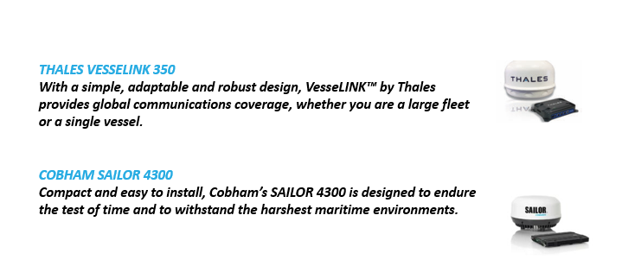

Iridium Openport
- Simultaneous always-on internet & voice services
- Standard IP-based data configurable from 32 to 128 Kbps
- A single ethernet port provides a connection to a standard PC o to a router or hub for multiple PCs
- Cost-effective per megabyte or per minute rates
- 3 independent RJ11 ports for simultaneous use
- Crew calls are easily separated from ship’s business calls for simplified accounting
Iridium Openport - Benefits
- Simultaneous always-on data & voice services ideal for crew and professional usage at the same time
- Flexible IP-based data service configurable from 32 up to 128 Kbps
- Lightweight, easy to install equipment and antenna
- Backed by an unparalleled 5 year warranty and maintenance service at over 60 ports worldwide
- Iridium truly global coverage: including all oceans and polar regions
- Value-added services: a range of solutions for easy administration, security and cost-control

Iridium Openport - Equipment
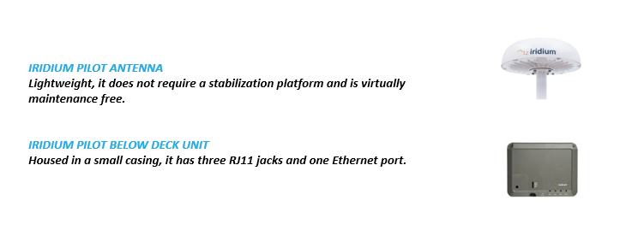

Using Iridium – SIM Cards
- ICCID
  - The SIM number starting 8988169. This detail will be asked by support upon call
  - The SIM holds all provisionning, i.e. telephone number, subscription, services.
- MSISDN
  - The telephone number of the subscriber, starting +8816
  - Regular SIM card may have an AMSISDN assigned for data, relevant only from Iridium to Iridium calls
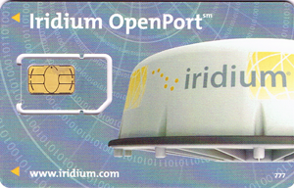
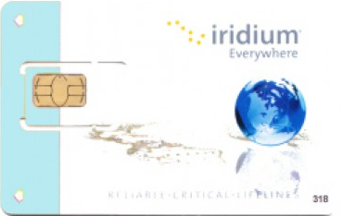
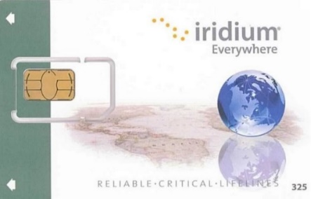
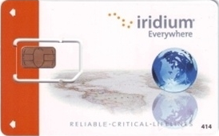

Dialing Pattern
From Iridium to e.g. +1 234 4567 8910
  - 00 - Country Code - Area Code - Subscriber number:
    - 00 outgoing prefix, can be replaced by a ‘+’ on newer technologies
    - 1 country code – North America
    - 234 area code – Ohio
    - 4567 8910 destination number
  - The leading ‘0’ of the area code may or may not be omitted depending on the specific country’s dialling plan.
To Iridium to e.g. +8816 414 12345
  - 00 - 8816 - Subscriber number:
    - 00 international prefix, country dependent eg. 011 in North America
    - 8816 Iridium ‘country code’
    - 414 12345 Subscriber number, here an Iridium postpaid user
  - The 3 first digits of the subscriber number correspond to the type of subscription.

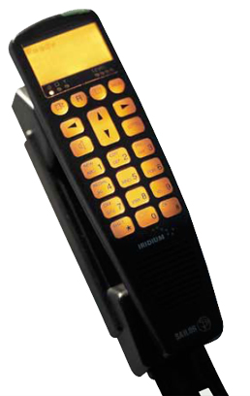
Dialing Pattern
Iridium
  - 8816 – xx4 post-paid subscription
  - 8816 – xx5 pre-paid subscription
  - 8816 – xx6 pre-paid subscription
  - 8816 – 318 Crew calling / Captain’s call
  - 8816 – 777 Iridium Open Port

Iridium – Special SMS
- The SMS service center has to be configured on the Iridium device +881662900005
- Email to SMS (shore service)
  - Write an email and send to the recipient’s Iridium phone number followed by @msg.iridium.com e.g. 881641412345@msg.iridium.com
  - Mind the following:
        - Limitation to 160 characters
        - The character count includes the sender’s email address and the subject line
        - All characters count inlucding spaces and line breaks
  - https://messaging.iridium.com/
- SMS to email (Iridium user service)
  - Write an SMS starting with the recipient’s email address, e.g. email@address.net
  - Send this SMS to +*2 or 00*2

Iridium – Handhelds
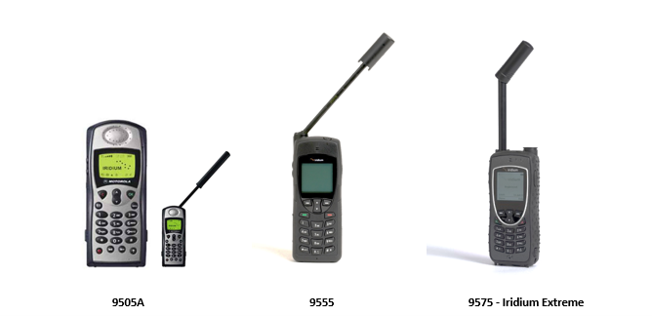

Iridium – Open Port, Iridium Pilot
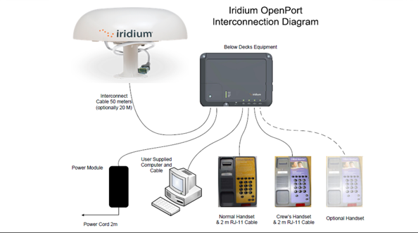

Iridium Devices – SBD, Pager and Go
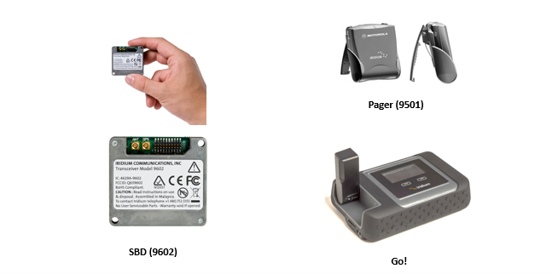



About Thuraya
  - Thuraya was founded in 1997 in the UAE by a telecoms providers consortium and private investors
  - Named Thuraya after the Pleiades' stars cluster in the Taurus constellation
  - The main goal of the Thuraya network is to provide a satellite coverage associated to the GSM coverage.
- Thuraya offers a range of reliable and cost-effective maritime voice and data products which can keep you connected at sea, no matter the type of vessel you are crewing.
Two hardware options are available:
- Thuraya Atlas IP delivers added value to end-users seeking advanced connectivity and greater operational efficiency on board ships.
- It provides merchant maritime, fishing, government and leisure users with a purpose-designed, fully-featured maritime satellite terminal that supports voice and broadband IP data connectivity at speeds of up to 444 kbps.
- For ship owners or managers who need a robust and highly reliable maritime-specific terminal for basic data and VoIP capabilities, look no further than the Thuraya Orion IP.

Thuraya - Features
- Background IP at speeds up to 444 Kbps
- Streaming services up to 384 Kbps
- Gives maritime users fast connectivity for business-critical and crew welfare applications
Available through 2 terminals:
- Thuraya Orion IP: low-cost terminal with basic functionalities
- Thuraya Atlas IP: offering the same broadband data capabilities, combined with voice

Thuraya - Benefits
- Small, lightweight terminal
- Easy to install & to operate
- Cost-effective
- Truly plug & play
- Optional voice service
- Built-in WiFi
- Flexible airtime service plans meeting all different requirements

Thuraya – Equipment

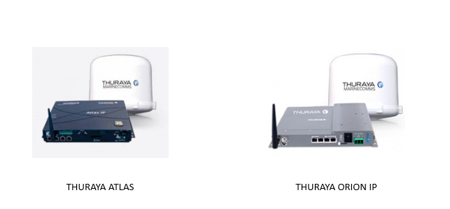

Thuraya Orion IP
  - Maritime version of the Thuraya IP+
  - Data Broadband IP (symmetric and asymmetric)
  - Built-in WiFi
  - GPS tracking system
  - Geo-fencing

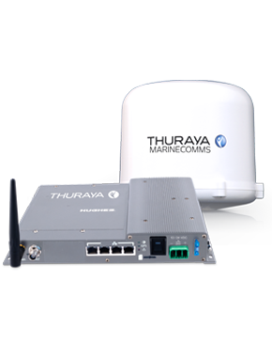

Thuraya Atlas IP
  - Maritime terminal by Thuraya
  - Voice
  - SMS
  - Data Broadband IP
  - Built-in WiFi
  - GPS tracking system
  - Geo-fencing
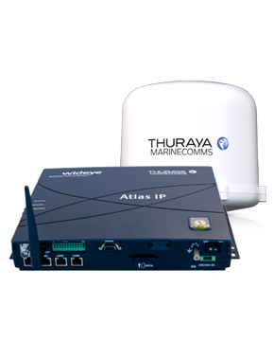

Thuraya Satellite Coverage

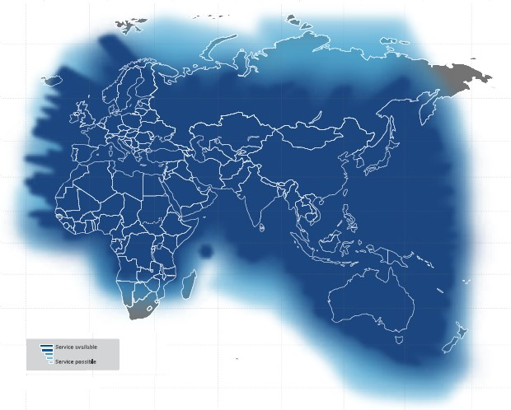

Thuraya GSM Roaming

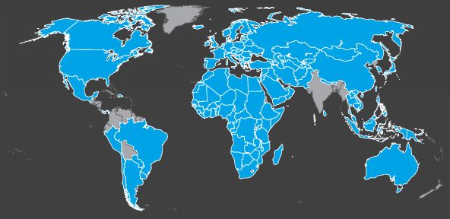

SIM Cards
- The ICC-ID holds all service provisioning:
  - The MSISDN (telephone number), fax, data, GmPRS
  - IP services and APN (Thuraya IP)
  - Network features such as CLI
  - Commercial package
  - The ICC-ID and MSISDN are details asked by the support teams
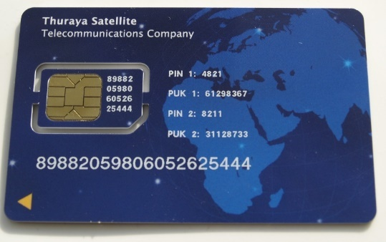

Voice Service
From Thuraya to e.g. +1 234 4567 8910
  - 00 - Country Code - Area Code - Subscriber number:
    - 00 outgoing prefix, can be replaced by a ‘+’ on newer technologies
    - 1 country code – North America
    - 234 area code – Ohio
    - 4567 8910 destination number
  - The leading ‘0’ of the area code may or may not be omitted depending on the specific country’s dialling plan.
  - Regardless whether in Sat or GSM mode
To Thuraya to e.g. +88216 12345678
  - 00 - 88216 - Subscriber number:
    - 00 international prefix, country dependent eg. 011 in North America
    - 88216 Thuraya ‘country code’
    - 12345678 Subscriber number
The Terminals

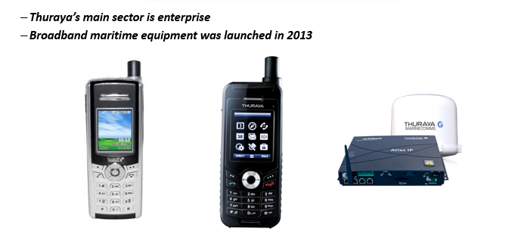

Thuraya XT Dual
  - IP64/IK03: splash resistance, no ingress of dust and shock proof
  - Glare resistant screen
  - GPS capabilities (incl. GPS navigation)
  - Data 9.6 or GmPRS with USB data cable.
  - Menu in 12 languages
  - Roaming to GSM network
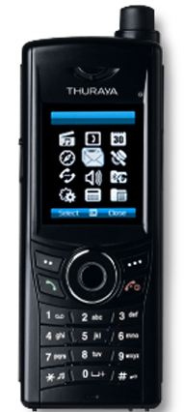

Thuraya SatSleeve
  - iPhone adapter for SatCom
  - Requires 2 SIM card:
    - 1 for GSM – located in the iPhone
    - 1 for Thuraya – located in the SatSleeve
  - Works over Bluetooth
  - Extend iPhone battery lifetime
  - Requires the free app

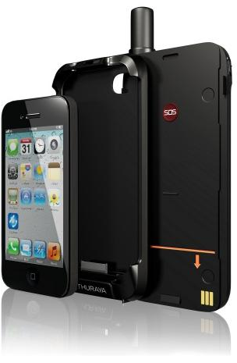

Thuraya Connection Steps

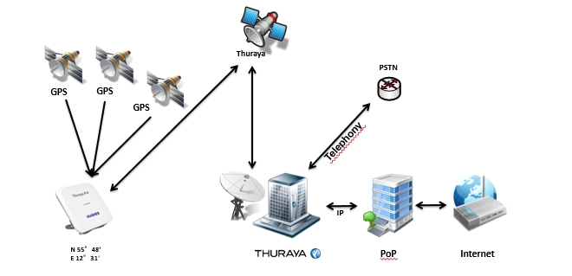

VALUE ADDED SERVICES
To get more from the chosen connectivity service, Marlink offers a number of digital solutions and tools:
  - XChange: Centralized IT and communications management platform to optimize security, enable remote access and deliver various applications including Wi-Fi, Media, BYOD and Telemedicine.
  - Portal 360: Central online management tool to monitor and manage satellite communications and value added services the smarter way.
  - Data Manager: Accelerate web browsing, set firewall-filters, administrate account profiles & select traffic priorities.
  - Interconnect: Connect your mobile satellite terminal to your corporate network in total security.
  - SMARTConnect: Our portfolio of low latency, high bandwidth multicarrier solutions to provide high quality connectivity anytime, anywhere.
  - SkyFile® Mail: Reliable, secure and cost-efficient data transmission via email, e-fax and SMS.
  - SkyFile® Anti Virus: Full protection from malicious software such as viruses, spyware etc.
  - Universal Card™: Prepaid voice calling, SMS, email & web usage – all in one card.
  - Terravox: Choice of cost-efficient VoIP calling service
  - Terravideo: Secure, easy-to-use video conferencing service.

Marlink Xchange FX - XFX

- What is XChange FX?
  - Inmarsat Soft NSD V 1.5 hosted on XChange device (replacing Cisco hardware)
  - New features / services on top of standard XChange solution
  - Still requiring XC Base or Power (separate hardware)
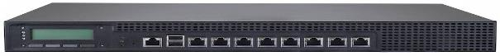
  - Why XChange FX?
  - Replace Cisco Hard NSD (standardize onboard equipment to Marlink only)
  - Offering better support tools and more features
  - Creating differentiation versus competition

What is Xchange ?
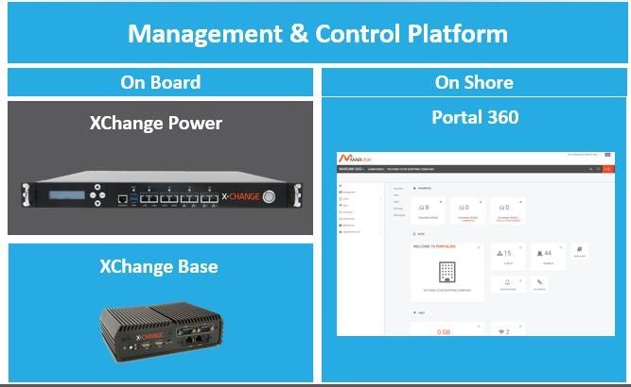

Xchange – Backup Devices

  - Fleet Broadband
    - Cobham (Thrane) 150/250/500
    - JRC 250/251/500/501
    - Furuno 250/500
    - Intellian 250/500
  - Fleet One
  - Iridium Open Port / Pilot
  - 3rd party connectable terminals
    - 3G/UMTS, WiMax, other FB's in passive mode like Skipper 150 etc.

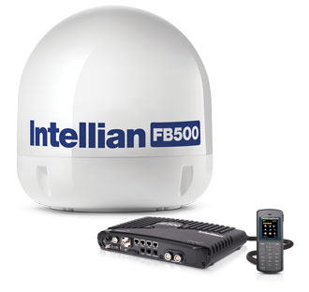
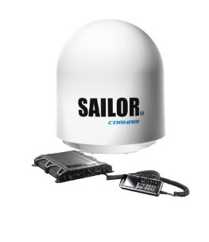
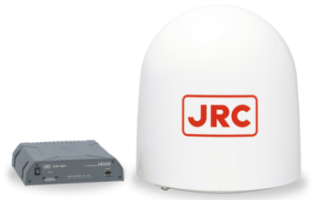
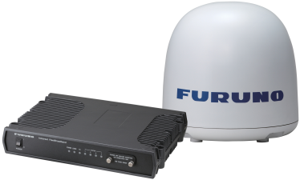
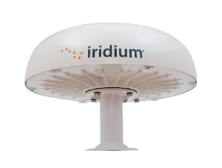

Xchange – BYOD
Allow crew to stay online at sea - just like at home
  - Diversity of news, reports, sports news and magazine
  - Works with all devices: Compatible with laptop, smartphone, tablet, TVs
Smartphone Interface
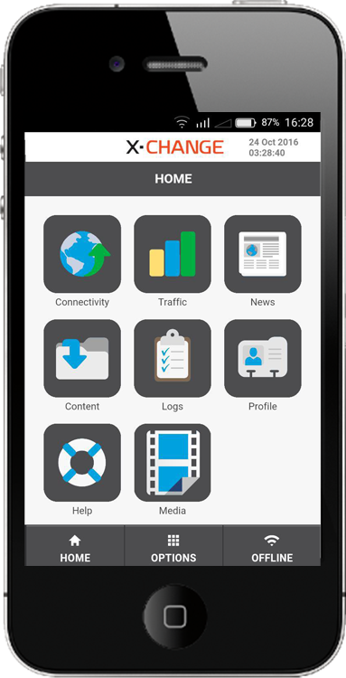

URA – Universal Remote Access
  - Fully automated remote access to control entire onboard network
  - User friendly software for shore administrators
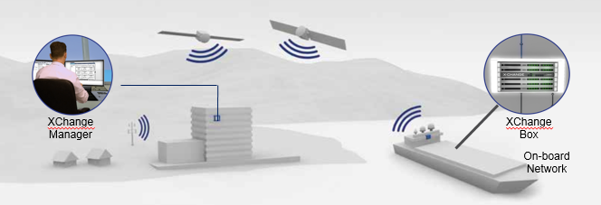

Xchange – Portal 360
  - Online XChange management platform
  - General XChange Box profile information
  - Create new user and new user groups
  - Daily analysis of traffic & credit logs
  - Shore based administration
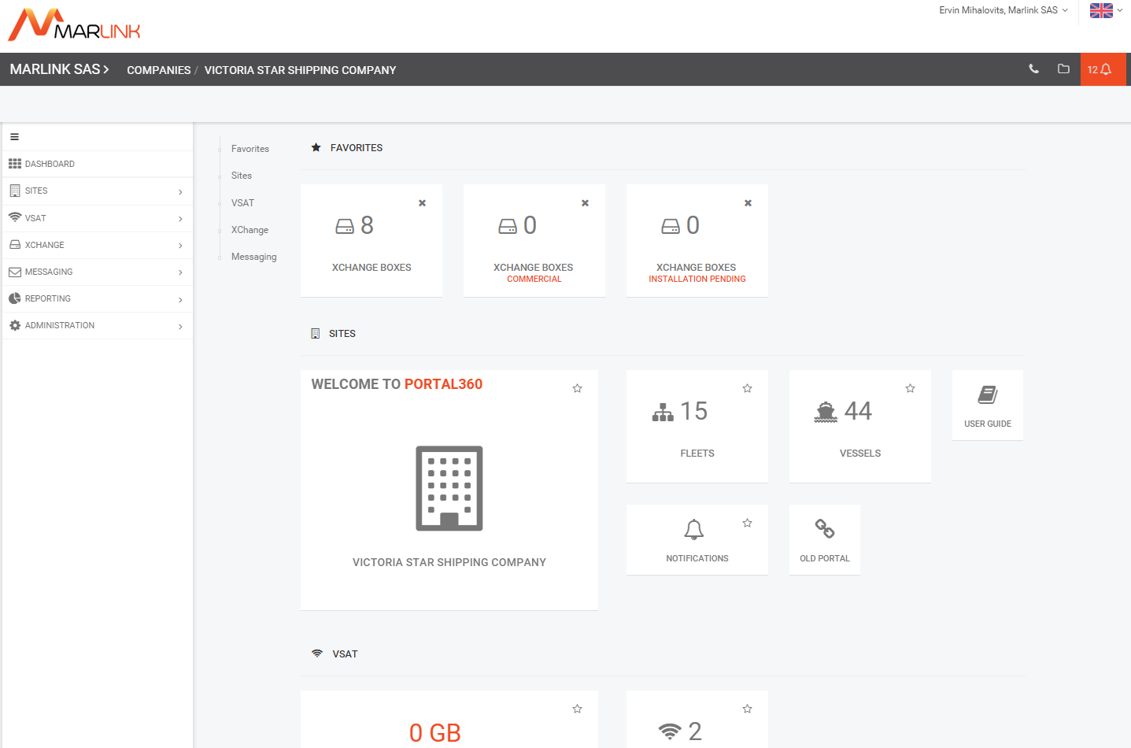
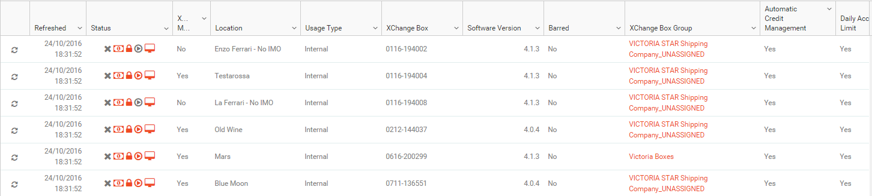


Manage your crew’s health & medical emergencies efficiently
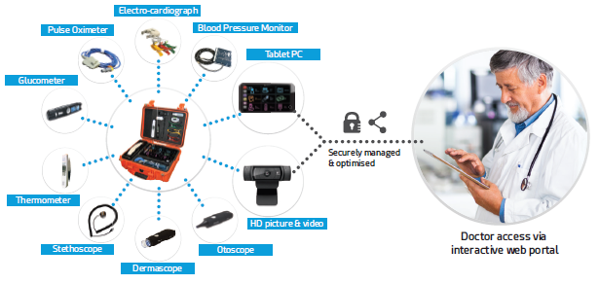

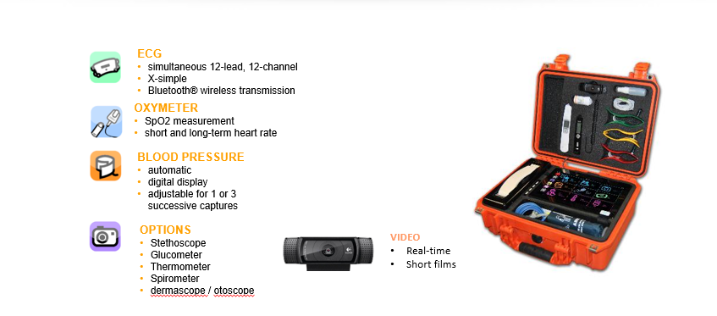


Connect your crew to the world of news and entertainment
  - Diversity of news, reports, sports news and magazine
  - Works with all devices: Compatible with laptop, smartphone, tablet, TVs
  - Fully integrated in Xchange
  - Crew does not need to be connected to Internet to view files
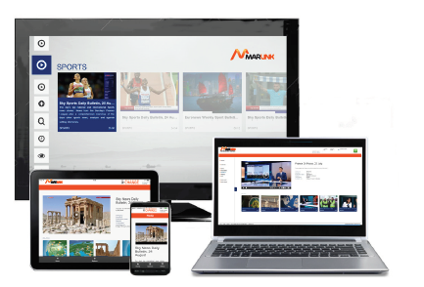
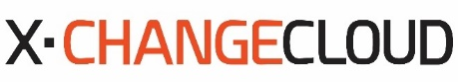
Share your files with your entire fleet
  - Dedicated solution for automated file transfer and data
  - No file type or file size limits!
  - Available as from XChange version 4.3
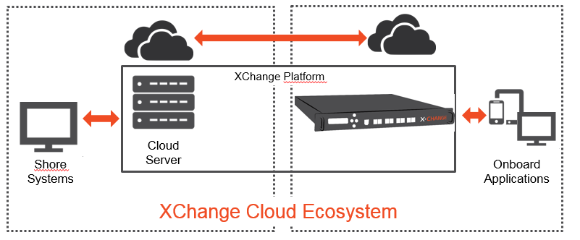

Benefits of XChange
Security
      - 3rd party servers don’t need to be connected
Reliability
      - Data integrity is guaranteed
Efficiency
      - No limitation on file size
      - Compression and “resume” function
      - “Best carrier”
Monitoring
      - Track file transfer


- Chat service for crew and their friends or families
- Live voice, video and instant messaging
- Free app (Google Play)
- Compressed videostream
- Appropriate XChange preconfiguration via VT Group
- Separate credit and rating on XChange
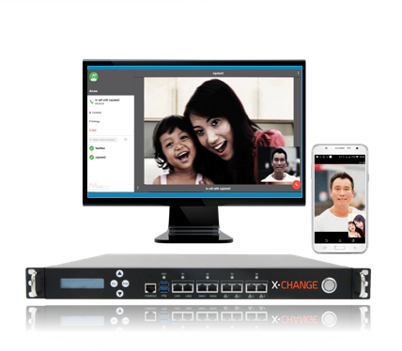

Universal Cards
A convenient way to stay in touch with friends and family.
Private calls, Internet, SMS and emails from a single credit.
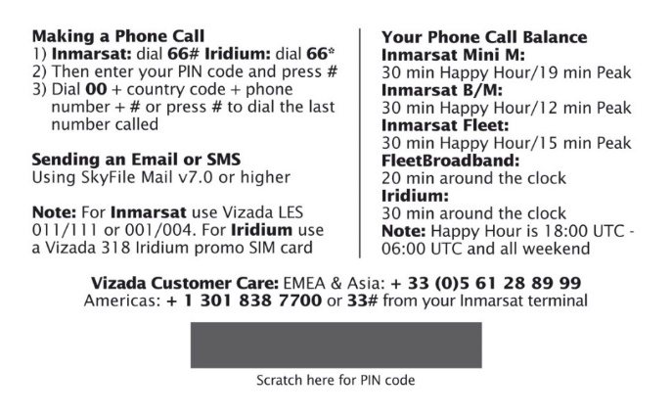

4G Services
- Marlink’s 4G Services comprises a portfolio of low latency, high bandwidth multicarrier solutions to provide high quality connectivity anytime, anywhere.
- Comprising of offshore Tampnet LTE and Global4G terrestrial services, the solution is designed to complement our Sealink™ VSAT services, and further secure the reliability and high bandwidth needs for vessel and fleet management.
- Based on the user’s predefined parameters, Marlink’s hybrid connectivity offer seamlessly combines multiple communication carriers (SatCom and terrestrial) to provide the best available link.
- Thus ship owners maintain full control of how communication is routed via a management interface, allowing them to set priorities according to their own requirements and preferences at any given time.
Global 4G
- Cost-efficient communications provided through the latest terrestrial 3G & 4G technologies
- Data rates of up to 100 Mbps(4G)
- One SIM that can be used in >100 countries around the world
- Attractive money allowance packages to suit all business and leisure needs
Tampnet LTE
- Tampnet low-latency LTE service up to 50 Mbps
- Available in North Sea & Gulf of Mexico
- Near Coastal WiFi
Optional WiFi
- Connect to wireless networks with bandwidth up to 100 Mbps when ports are within reach

Collaboration and Messaging: SkyFile Family
- SkyFile Mail:
Suitable for users at sea and on land, provides reliable and cost-effective email, fax and SMS, on VSAT and MSS terminals.
- SkyFile eNOAD:
Enable users to comply with the US Coast Guard regulations.
- SkyFile-C:
Enables you to send and receive emails as well as short messsages (SMS) via an Inmarsat C or Mini C terminal.
- SkyFile Antivirus: Protects your remote computer assets from potentially harmful viruses.

Portal 360 - URL: https://www.portal-360.com

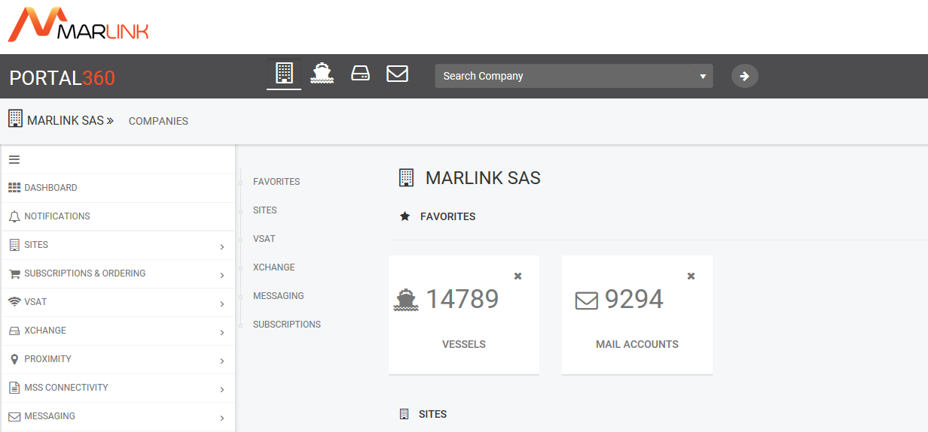

- Free, flexible and 24/7 online: Portal360 is our new advanced online management tool enabling you and your customers to manage satellite communications and value added services the smarter way.
- Portal360 provides direct access to a variety of information such as account and subscription information, electronic invoices, service usage and much more.
- You can proactively and efficiently manage your customers – and stay in full control of their accounts and business.
- With a secure, intuitive interface the portal features a ‘dashboard view’ providing key information at a glance. Usage and settings can be monitored and managed at your fingertips.
- Key information can be instantly filtered or downloaded. Using your administrator’s accounts, you can create access for your customers and manage their user rights.
- What they can see and do is entirely up to you.

Portal 360 - Benefits
- 24/7 online management of satcom business
- One access – multiple management options
- User-friendly interface allows intuitive navigation and individual adjustment
- Modern dashboard: alerts users to key information and gain quick access through widgets
- Advanced filtering & search options offer simple access to specific information and a streamlined approach to service settings
- Flexible user creation and rights administration
- Users have the option to organise their information display by vessel or fleet

Portal 360 - Features
VSAT:
- Monitor Sealink Allowances usage and manage top-ups for allowance packages
- Management of Sealink Business Subscriptions
Xchange:
- View and monitor XChange boxes
- Download usage and credit logs for further analysis and processing
- Manage price matrixes, data synchronisation and software updates
- Remotely manage onboard XChange user accounts and their local allowance credit
SkyFile:
- View and manage SkyFile Mail accounts and their configurations
- Monitor SkyFile Mail traffic
- Handle messages in quarantine and download usage logs
- Check SkyFile Anti Virus subscriptions
SIM cards:
- View IOP and IDP SIM card details and information on which vessel they belong to.

Data manager URL: https://datamanager.marlink.com
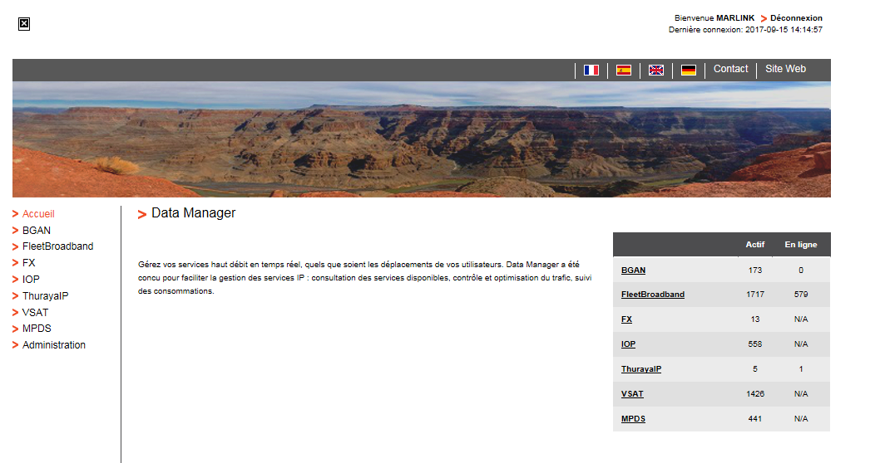
- Data Manager enables you to manage your data solutions and services through a secure and simple online portal. It combines complex and powerful IP capabilities with administrative simplicity for secure communications.
- Data Manager provides a variety of versatile features to make managing data traffic more efficient, including: Web compression, Web filtering, advanced Firewall and many more.

Data manager - Benefits
- Data Manager combines complex and powerful IP-capabilities with administrative simplicity.
- Easy access: around-the-clock secure access via https://datamanager.marlink.com with intuitive navigation
- Multilingual: available in English, French and German
- All-in-one solution: central online interface to manage all IP-based solutions
- Flexibility: customise Data Managers features like Firewall, Web Compression or Web Filtering
- Simplicity: easy-to-use, with no installation required; all standard web browsers supported
- Security: full security package to protect your terminals from internet attacks and only allows selected communication from the Internet
- Multi-level users: available for mobile users, large customers and service providers
- Unique support: on-demand professional support from Marlink’s technical teams

Data manager - Features
- Data Manager minimizes the workload associated with managing satellite data communications and optimizes everyday business in the field, at sea or in the air.
- Status Profile: provides a real-time overview of subscribed features and terminal status (ie. actually allocated IP addresses)
- Enhanced firewall: customize Data Manager firewall to meet your individual requirements and allow only desired data traffic
- Web compression: reduces significantly the size of visited pages by compressing, blocking or removing heavy content like pictures, advertising, videos, etc
- Web filtering: your personal web access gatekeeper – combined with web compression, it does not only reduce the volume of visited pages but also prevents undesired web pages or related content from being accessed or downloaded
- Consumption details: retrieves in near real-time an exact overview of terminal traffic for previous 90 days
- Satellite-independent: manage all Marlink’s broadband satellite services with a single tool

Data Manager - Web Interface

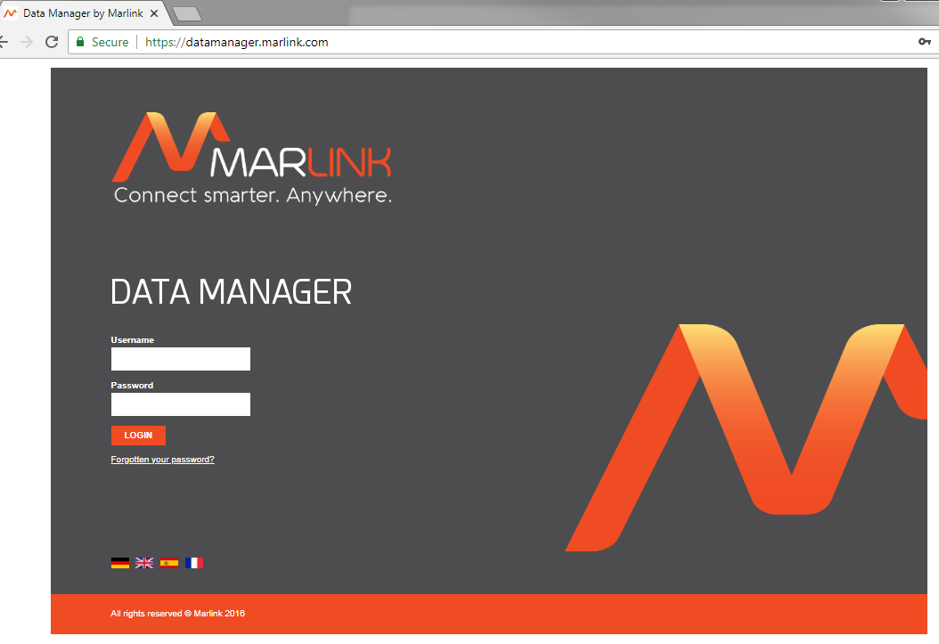

Proximity
- Proximity is a global M2M monitoring and management solution providing complete visibility and control of all fixed and mobile satellite M2M and tracking terminals in a single multi-device platform.
- From low data rates to high-speed IP terminals, Proximity manages all M2M devices operating in remote locations across multiple connectivity networks.
- The system provides real-time terminal monitoring and helps keep operations running smoothly for quicker decision-making and enhanced operational efficiency.

- Proximity is built on a unique infrastructure based on a single-protocol data access, compatible with all M2M applications and systems. M2M terminals are seamlessly integrated into a single platform to avoid separate operations of various satellite operator systems.
Proximity is available as a Customer Web Portal and as Web Services API:
- Web Portal for remote terminal management, location-based services and bidirectional messaging, including advanced reporting, multi-user management structure.
- Web Services API for quick and seamless integration of satellite M2M terminals into existing applications

Proximity - Features
Proximity provides advanced features to localize and monitor, manage and administrate your fleet of M2M terminals worldwide.
- Monitoring
- Remote terminal management
- Alert management
- Notifications by email or SMS
- Bidirectional messaging
- Tracking
- Geofencing
- Management of your Points of Interest (POI)

Proximity - Benefits
- State-of-the-art technology to meet even the most demanding M2M applications
- Single multi-device platform for complete monitoring of all satellite M2M and tracking terminals
- Future-proof infrastructure with unique standard protocol to combine M2M devices from multi-networks into one platform
- Real-time data at all times via data polling and event-driven alert notifications
- End-to-end solution including M2M terminals, global satellite connectivity services, real-time monitoring tools, and 24/7 customer care

Proximity - Applications
- Oil & Gas: Pipeline monitoring
- Utility: Smart grid
- Transport & Logistics: Asset tracking & protection
- Maritime: Vessel & buoys monitoring
- Environmental: wind and solar emission readings
- Financial: remote ATM

Online Management: Proximity
Monitoring and management platform for complete visibility and control of fixed and mobile M2M satellite terminals
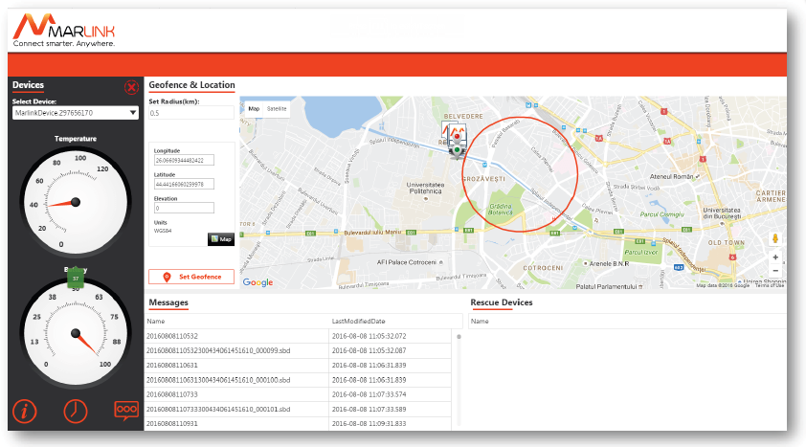
Web Portal
- Live tracking & monitoring
- Remote management
- Bidirectional messaging
- Security system to visualize all alarms sent from terminals
- Administration & reporting

The Source URL: https://thesource.vizada.com

- The Source® is a complete account management tool which enables our Service Providers to track and manage end-user accounts and perform everyday account management tasks.
- With The Source®, you can access our database services 24 hours a day, seven days a week with an easy-to-navigate, point-and-click menu system.
- You can also track the activity of Inmarsat, Thuraya IP and Iridium services, as well as prepaid traffic and manage these services including fixed-to-mobile calling – all via the Internet.

The Source - Features
- Account management: access real-time user account information 24-hours a day.
- Service administration: manage activation of Inmarsat I-4, Iridium and Thuraya services as well as a variety of our value-added services.
- Simplicity: track and manage accounts via a user-friendly, simple web interface.
- Financial control: reduce and manage credit exposure.
- Secure: password protected access with Secure Socket Layer (SSL) encryption.

The Source - Benefits
- Call monitoring: complete traffic information at a click
- Usage & payments: access and download account and billing information according to various search criteria
- Call barring: bar calls to or from individual terminals or SIM cards, review activation and barring histories and annotate account records
- Traffic limits & alerts: set automatic limits for individual or groups of postpaid SIM cards and terminals and receive email alerts
- Prepaid: order, activate and recharge our prepaid calling cards and accounts. View account balances and call logs
- Fixed-to-Mobile: activate new accounts and manage Calling Line Identification options
- Access to Data Manager for management of IP-based services
- Standardized VSAT solutions: order service, call monitoring, etc

