Classroom Management Plan
Mr. Knetter
8th Grade PLTW – STEM
E-mail: dknetter@sdwd.k12.wi.us
Phone: (608) 253 – 1153 or (608) 234 – 0652
Class Webpage: www.quia.com/pages/knetter25/ga

School – Wide Guidelines for Success:

The following is our School’s Mission Statement. The Mission Statement acts as a compass or a guide for student success in our school and my Classroom.

“The Spring Hill Way”
At this school…..
We Show Respect
We Have Responsibility
We Model Positive Attitude
We Strive for Successful Achievements

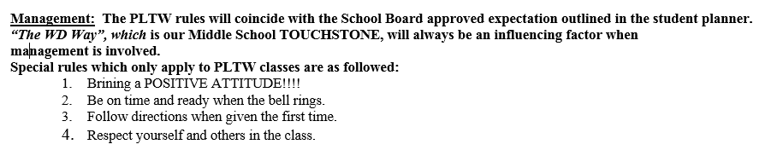
My Posted Classroom Rules:

My Attention Signal:

To begin class or after a classroom transition from activity to another, I will do the following to bring the class back in to a large group.

I will raise my voice and say “Please finish your conversation in the next ten seconds.” I will than begin to walk around the class and begin a slow count down from 5 to 0. By the time I get to 0, I expect that all students are silent, and show me respect by looking at me and being prepared to listen.

Champs Plans:

My Champs Plans are guidelines that I have created to help students understand what my expectations are for various classroom activities. Please visit www.quia.com/pages/knetter25/ga for further expectations.

Students will be taught the following Champs Activity. These will also be reviewed with students periodically at appropriate times:

-Group work
-Teacher Lead Instruction
-Individual Work
-Test/Quiz Day

My Encouragement Procedures:

I will always encourage my students to do their very best on every task and assignment and will promote an environment of MUTUAL RESPECT from student to student and students to teacher.

Students will be given positive verbal feedback for positive actions and achievements. In addition, students may receive the following from me throughout the year:

-Positive Postcards Home
-Positive Parent Contacts (phone calls, e-mails, and or letters)

Correction Procedures for Misbehavior and Disrespect:

