Alternative Assembly
- Complete your “Monkey Bar” assembly and Save as.

- Now, open a new “iam” file and construct the following….then Save as.
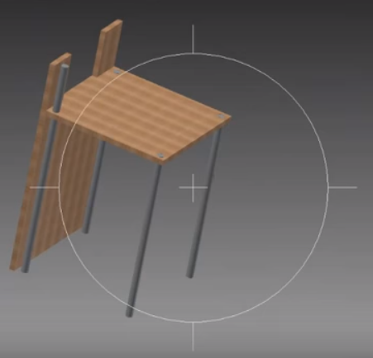

Also place and insert all your wall
handles

Main Pole

Main Pole

Insert a long pole here and offset it to -27.
Main Pole

- Continue working on the same “iam” file and construct the following:
Step 2: Mate the 7.75 side of the Tri to the back of the climbing wall
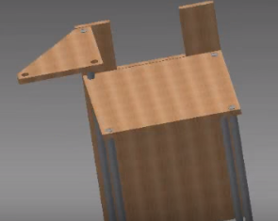
Step 1: Insert align the end of the Long pole to the Tri-Platform.
Step 3: Insert align the Long Pole
Finally, insert and align a Short Pole

