Pegboard Toy
Printing expectations:
- Copy paste a thumbnail picture of each of your part files….7 INDIVIDUAL PARTS CREATED.
- Copy paste a picture of your final assembly.
- Copy paste a picture of your final presentation.
- Be sure to label your part files, assembly file, and presentation file.
- Place your name and STEM Hour.
FULL NAME AND STEM HOUR
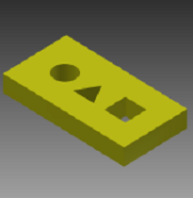
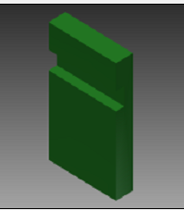
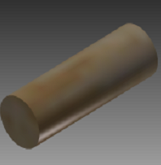
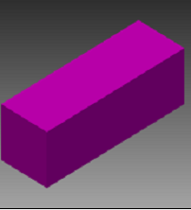
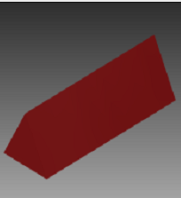
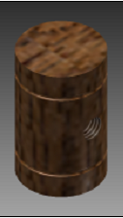
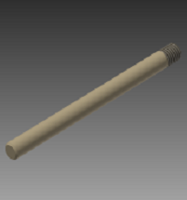
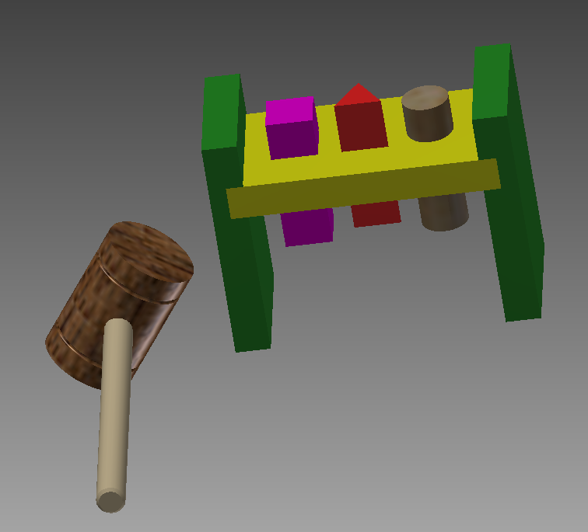
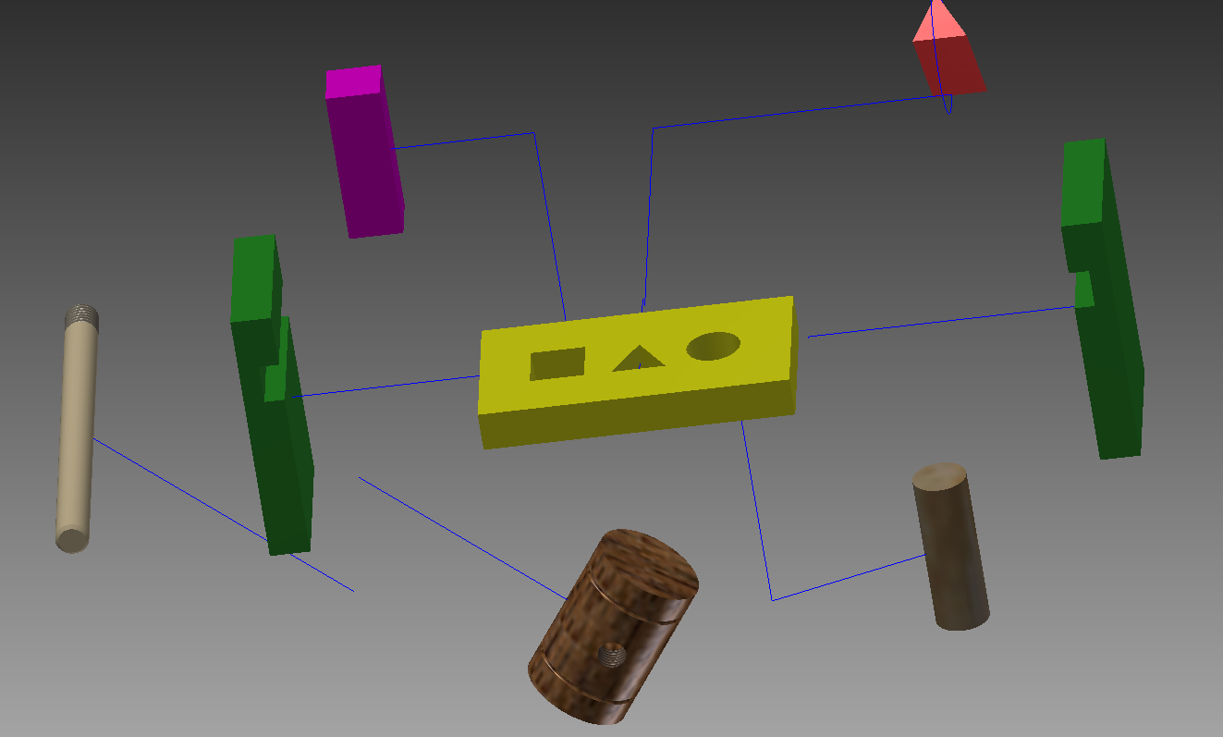
“ipt – files”
“ipn – file”
“iam – file”

