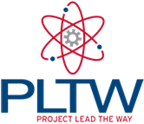
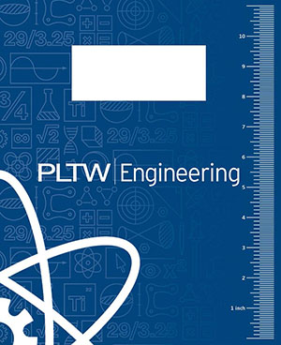
Syllabus: 7th Grade PLTW

Mr. Knetter

Home Phone #: (608) 253-1153
Cell Phone #: (608) 234-0652
Class Homepage: http://www.quia.com/pages/knetter25/pltw
**my e-mail address can be accessed from this page**

WHAT IS PLTW:
Project Lead The Way is a United States non-profit organization that develops hands-on, project-based science, technology, engineering and math curricula for use by elementary, middle, and high schools

PLTW UNITS TAUGHT THIS YEAR:
- Science Inquiry and Problem Solving
-students develop knowledge and understanding of scientific ideas, as well as an understanding of how scientists study the natural world.
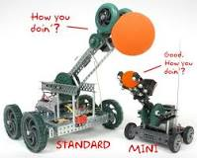
- Design and Modeling
-What is engineering?
-Design Process
- Measurement
-Sketching and Dimensioning
- Designing for Production
- Automation and Robotics
-What is automation and Robotics?
-Working with Mechanical Systems
-Working with Automated Systems

SUPPLIES: Students will need the following materials:
- Pen and pencils
- Texas Instruments TI-30XA calculator
- FLASHDRIVE (2Gb will work)

GRADING: Grading is an area of concern for students, parents, teachers, and administrators. There is no perfect way to assess student achievement; however, I WILL BE GRADING ALL MY 7TH GRADE PLTW COURSES AS A PASS / FAIL.

1. Unit test and quizzes: (Quizzes can be announced and unannounced!!!)
**80% OR GREATER IS PASSING

- Homework: classroom assignments, lab reports, group projects, and student PLTW lab books
**ASSIGNMENT IS FINISHED OR NOT FINISHED
-I WILL ACCEPT LATE WORK THRU THE END OF THAT CURRENT QUARTER

- Performance: correct use of the STUDENT AGENDA, lab safety, group cooperation during projects, and modeling of the “The WD Way.”
**COOPERATES OR NOT

STUDENT ATTENDANCE: Please refer to your student planner.

STUDENT TARDIES: Please refer to your student planner. My expectation is….you must be in my room when the bell starts to ring.

Management: The PLTW rules will coincide with the School Board approved expectation outlined in the student planner.
“The WD Way”, which is our Middle School TOUCHSTONE, will always be an influencing factor when
management is involved.
Special rules which only apply to PLTW classes are as followed:
- Brining a POSITIVE ATTITUDE!!!!
- Be on time and ready when the bell rings.
- Follow directions when given the first time.
- Respect yourself and others in the class.

CONSEQUENCES: Class consequences will also coincide with the School Board approved expectations outlined in your student planner. Protocol will be the following for behavioral issues:
- Simple warning
- Classroom detention served with the teacher during lunch (30 minutes)
- Parent contact and two classroom detentions served with the teacher (30 minutes a piece)
- Administrative intervention

The following are expectations that I have deemed fair and reasonable for 7th grade PLTW. If you agree with my philosophy, both of you may sign at the bottom and return to Mr. Knetter by Tuesday, September 5th. If there is part of this syllabus, which you do not agree with, please feel free to contact me at the above phone number or send me an e-mail regarding your concern. I look forward to having a great year with all of you!!!

Student Signature: _________________________ Date: ________

Guardian/Parent Signature: _______________________ Date: __________

