I prepared the document as a model for my students to follow. I explained that while there are particular requirements that must be in the portfolio and in a particular sequence (for my sanity during the review process), this was a reflection of them and their accomplishments. Creativity and personalization are allowed.

Cut, paste, add, delete…. whatever you feel will be most beneficial for your students.

This is a great way to find out what they enjoyed and how they grew during the year.

I’ll be adding an exit interview portion to this assignment. I’ll have the student share and present their portfolios and then ask them questions.

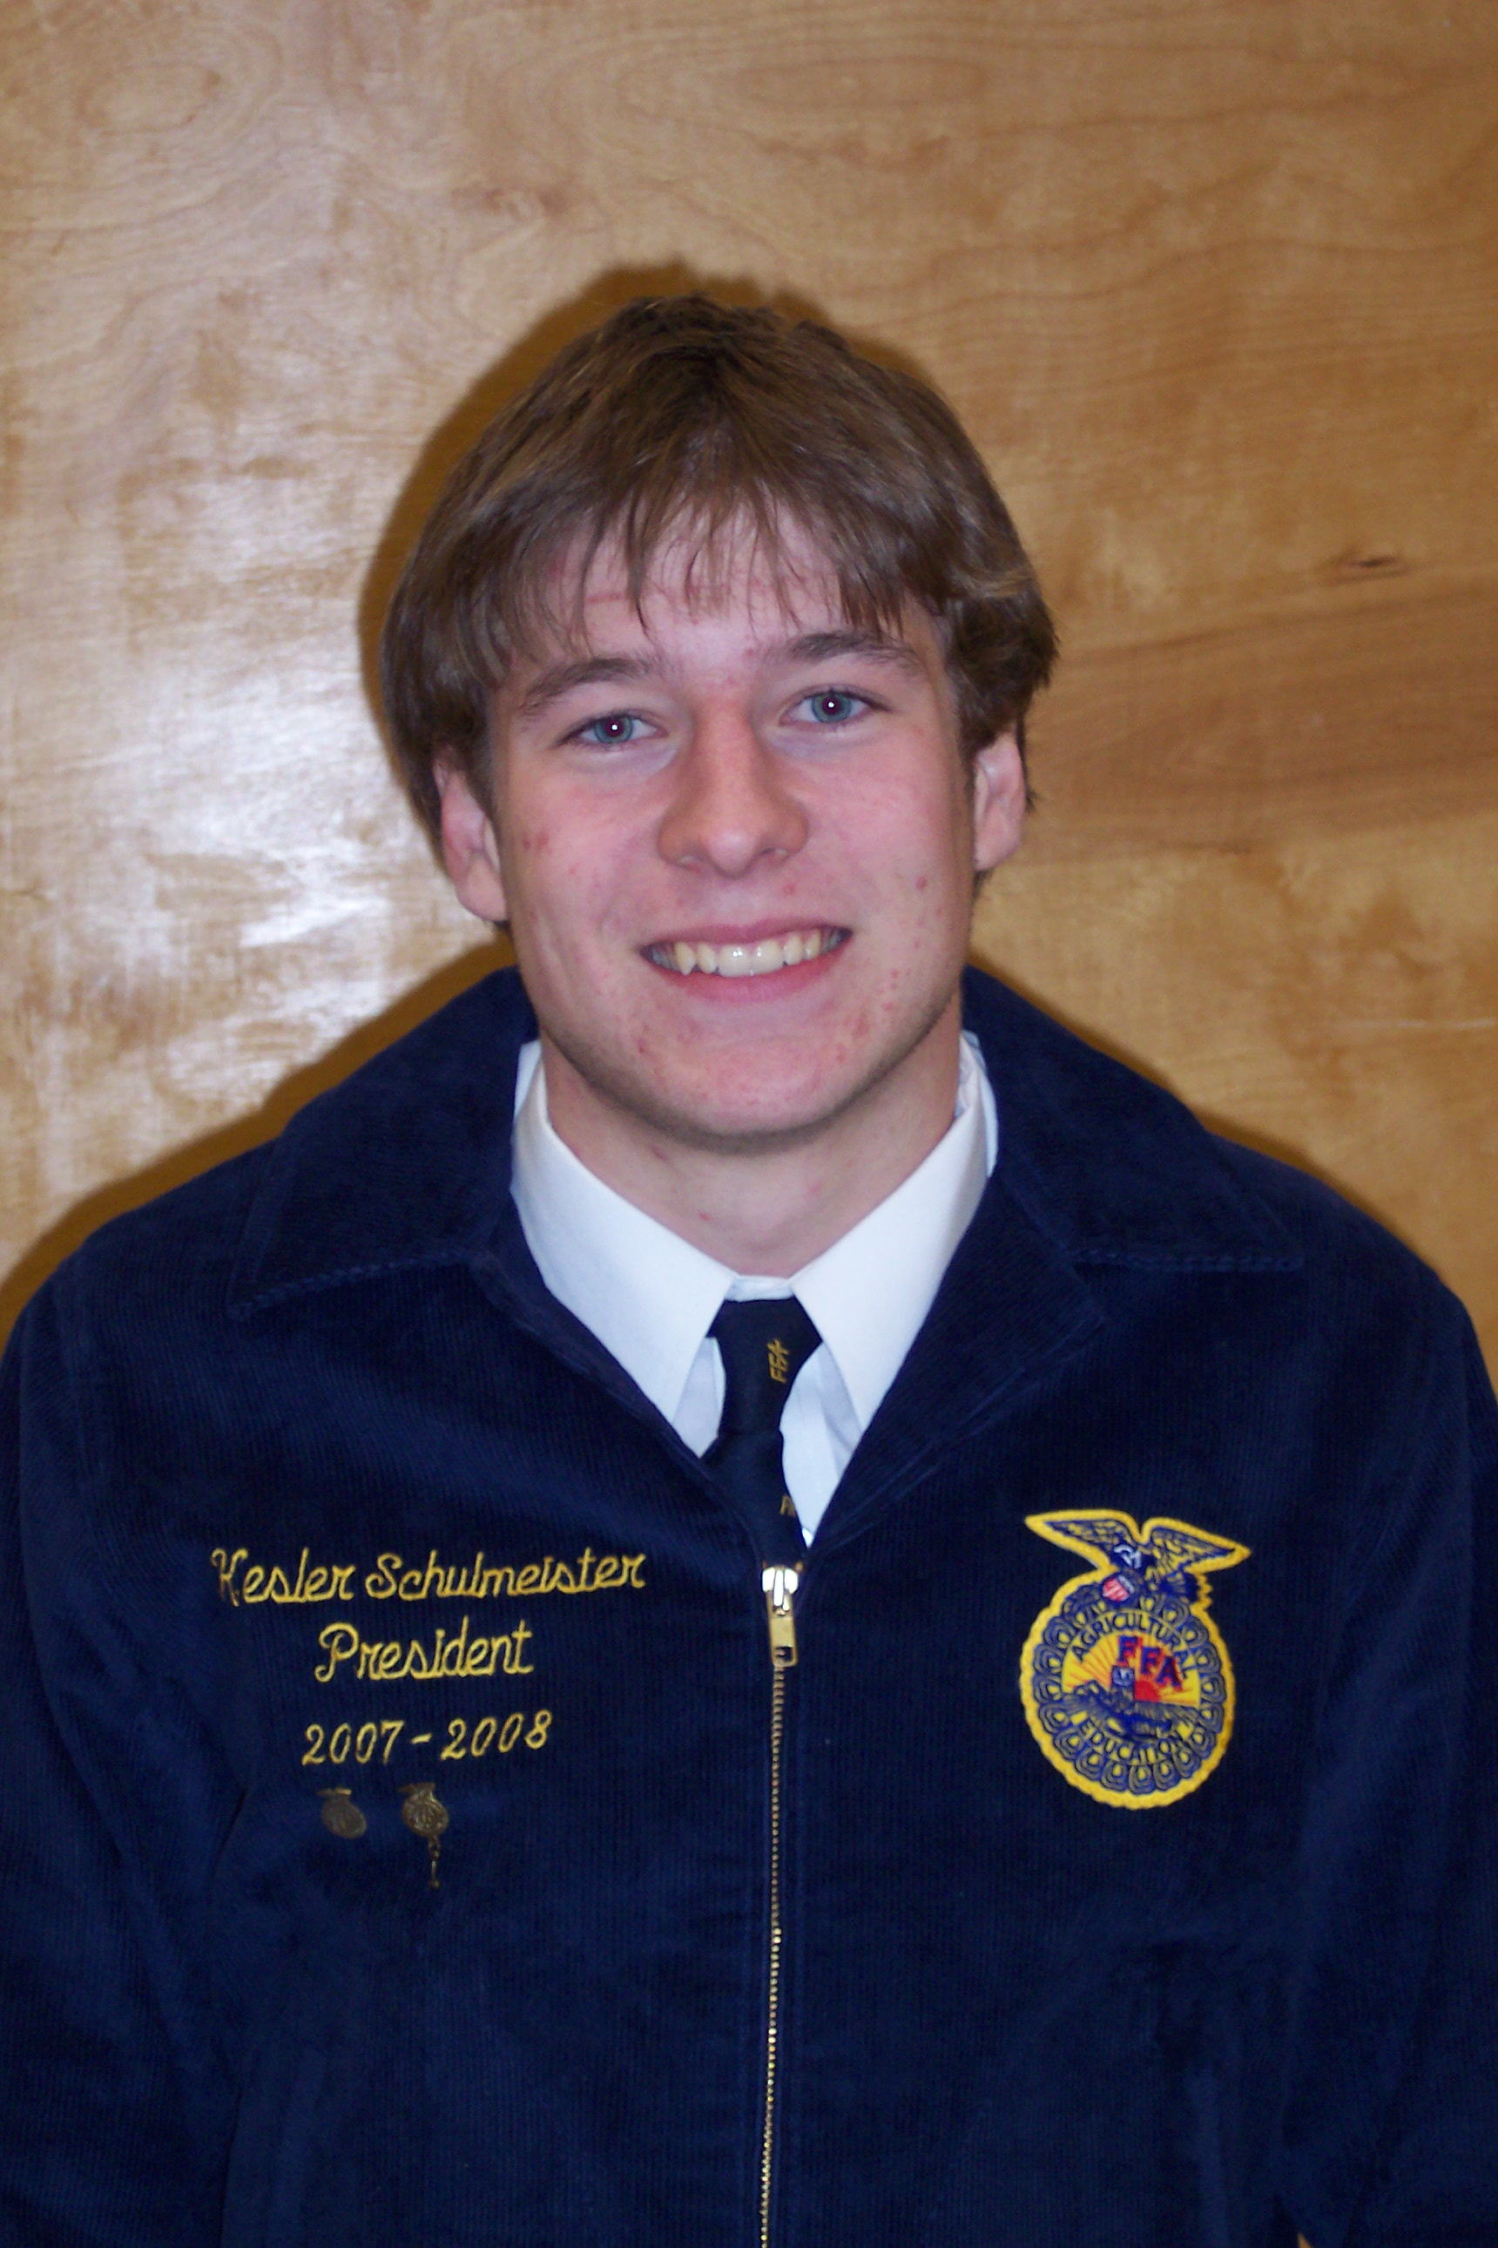

Kesler Schulmeister

Introduction to Agricultural Science

Contents
Goals
Resume
Interest Survey

“My Agricultural Education & SAE Experience” Essay
Class Artifacts
Agricultural Career Exploration

SAE Records
Competency Checklist
Activities

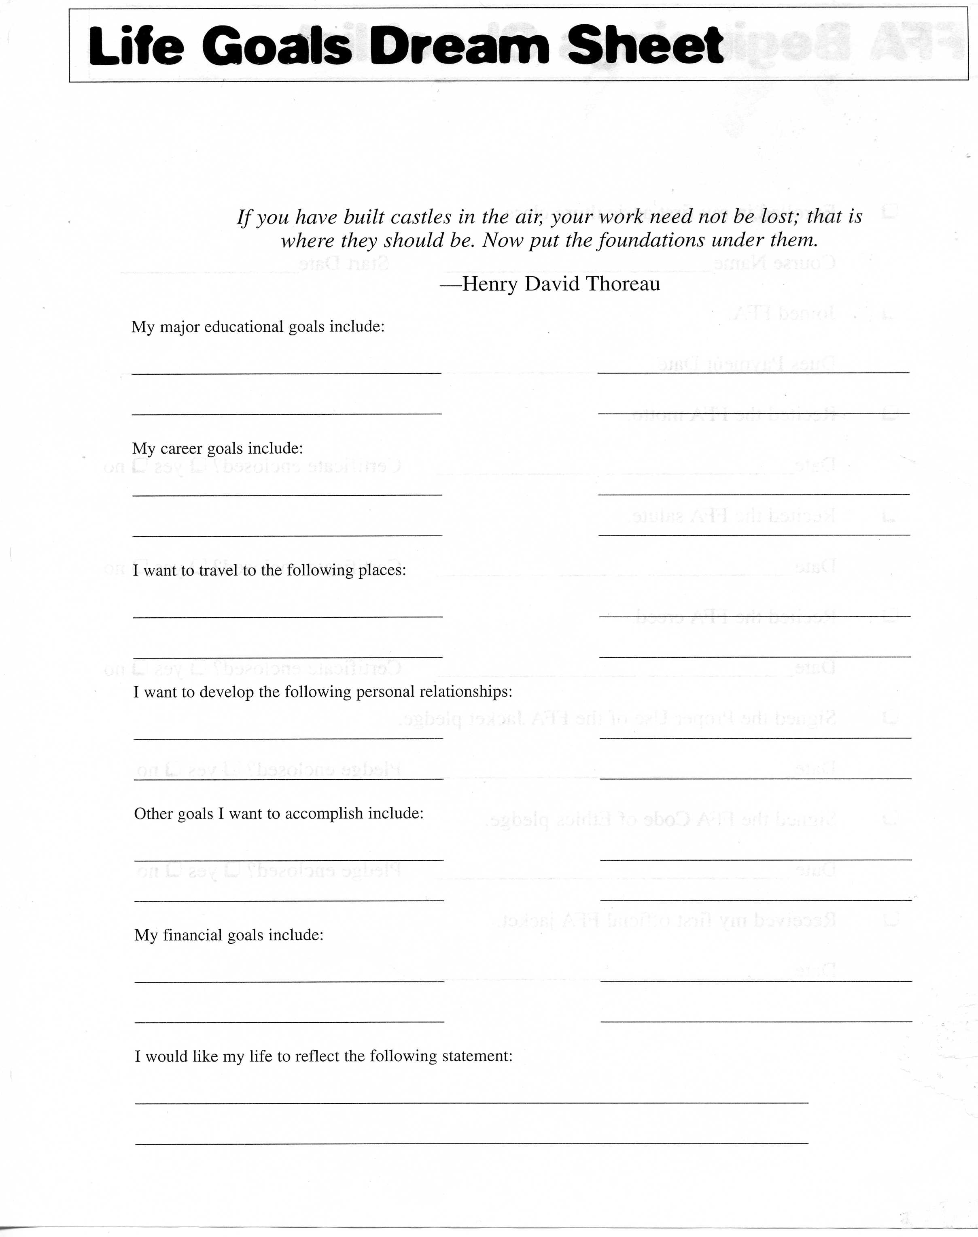

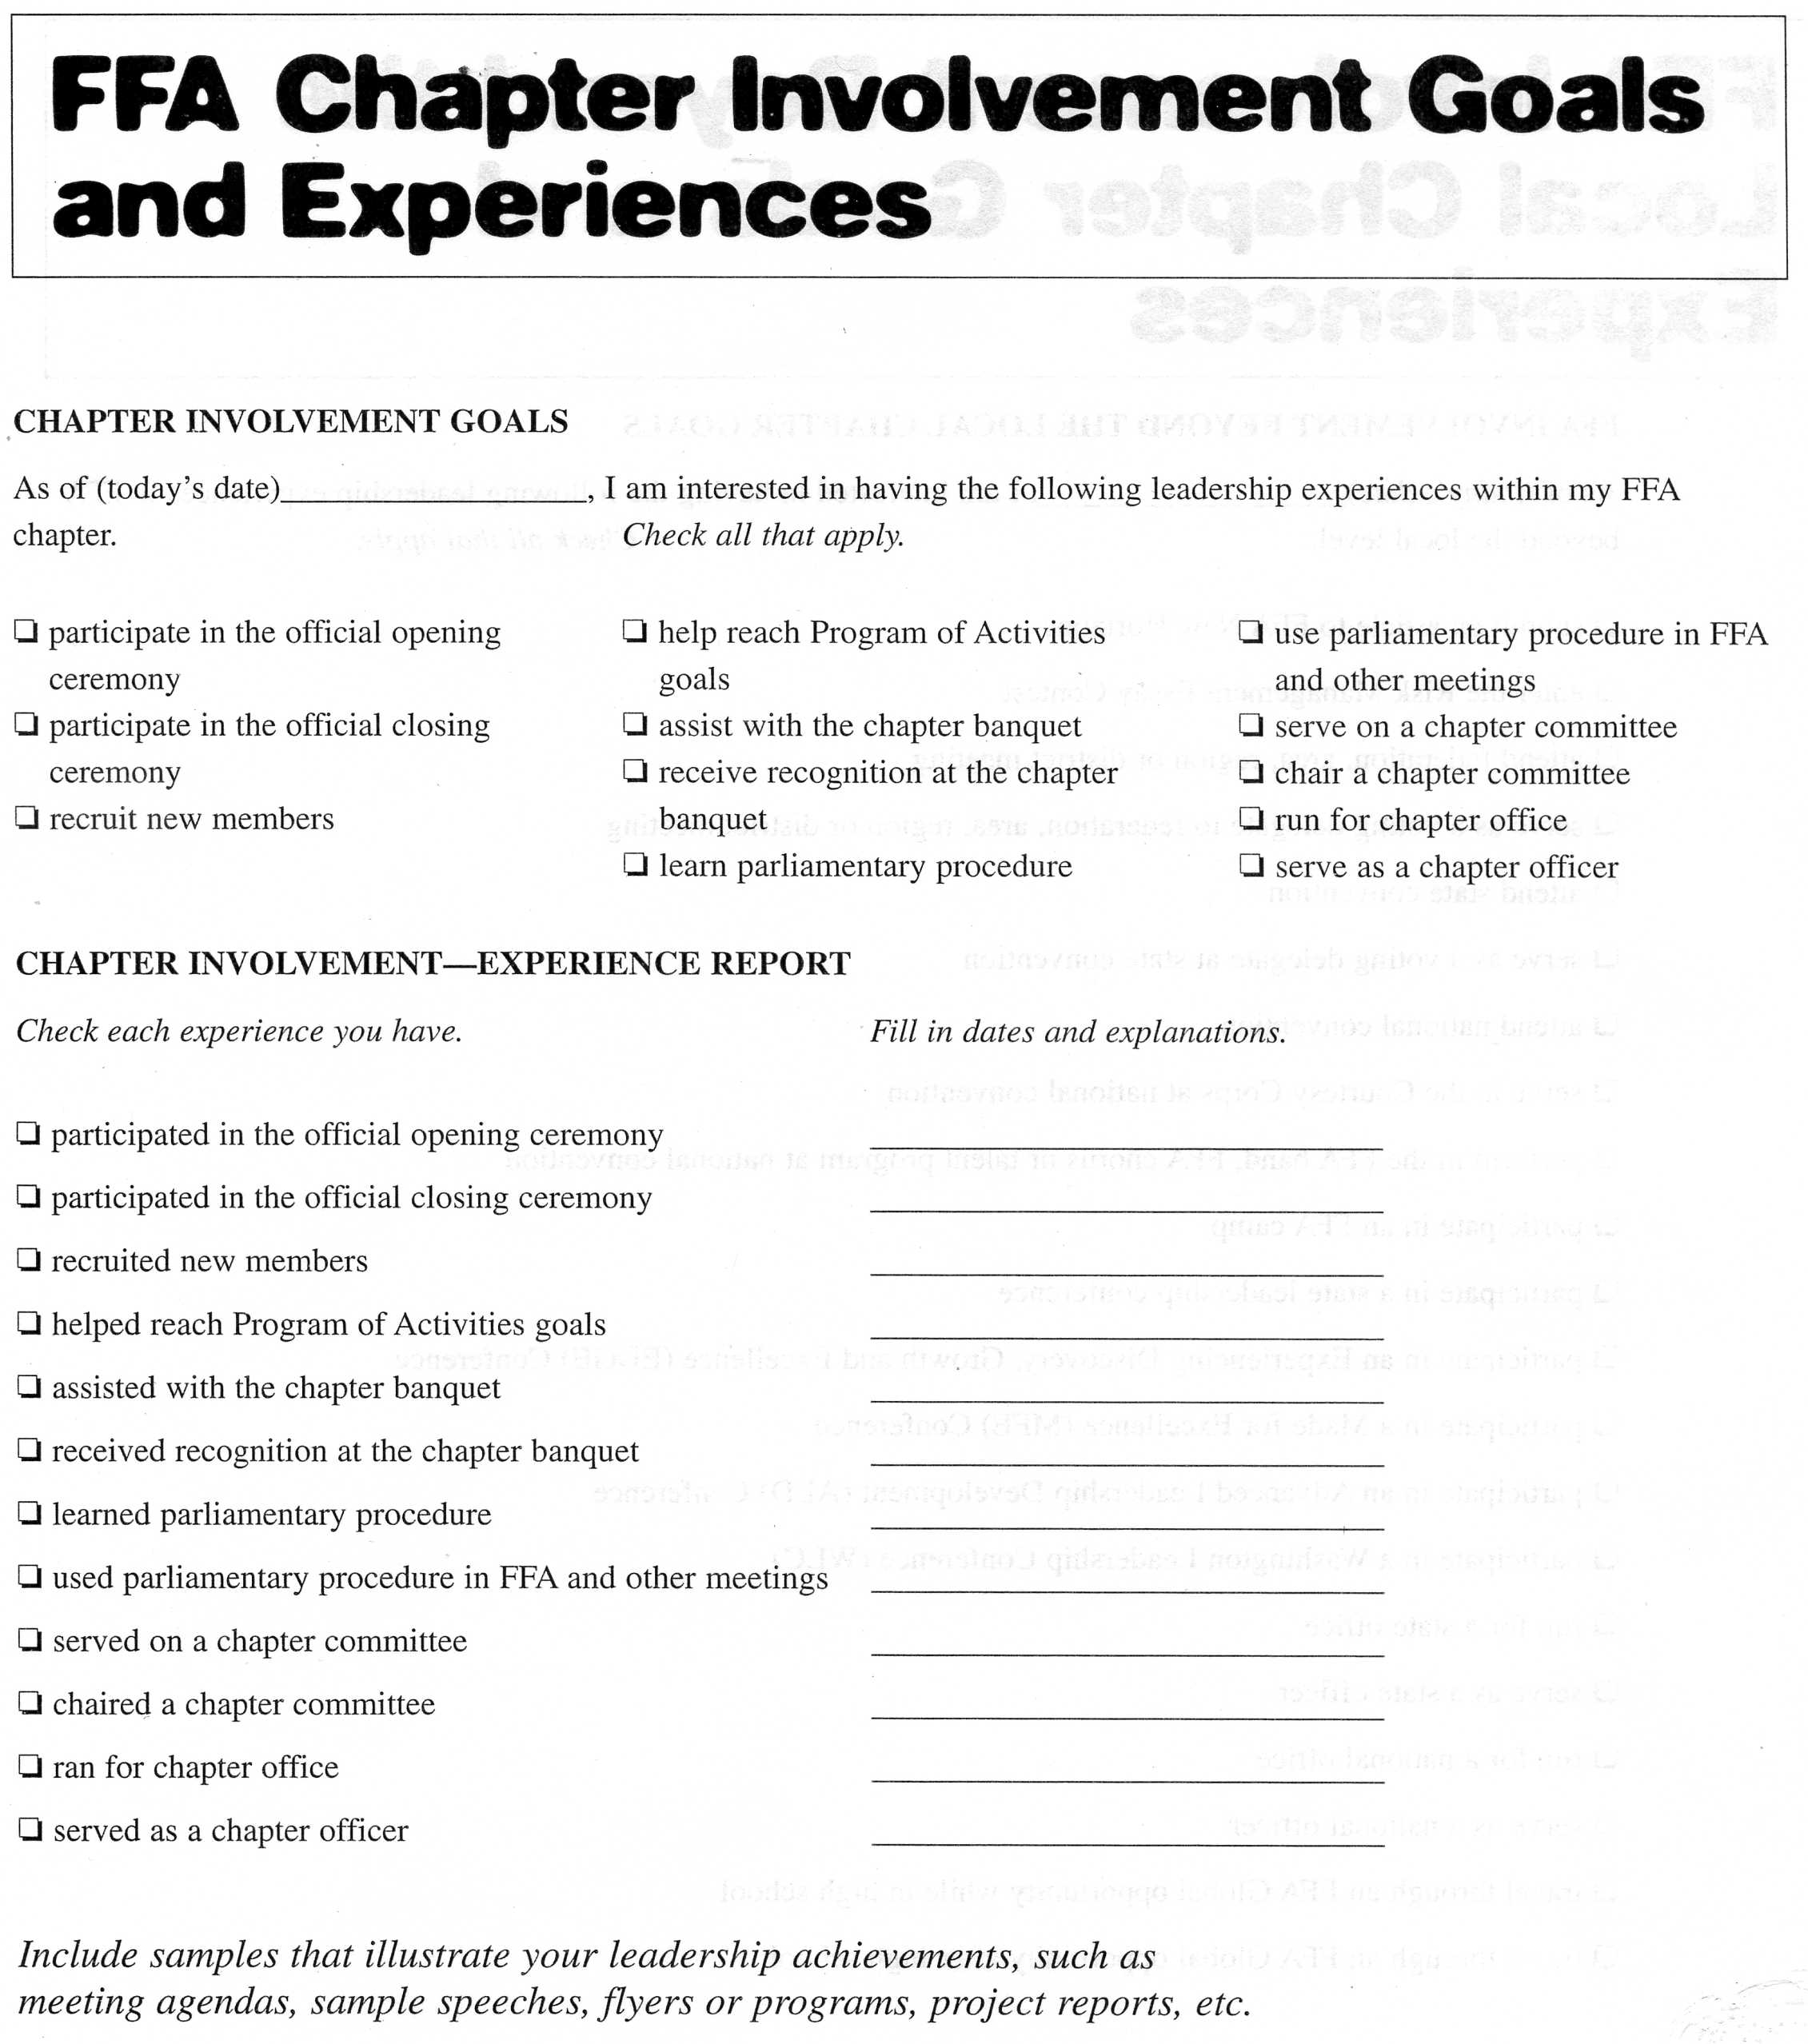

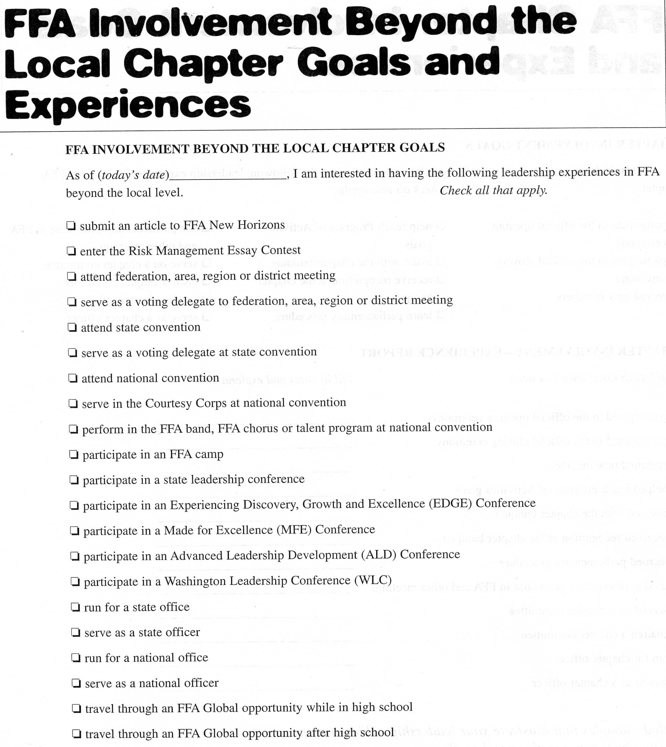

2029 Hampshire Ave  Shueyville, IA 55555 | Phone 555-555-5555  E-mail minniedollars@yahoo.com
Minnie Dollars
Areas of study | [ Click here and enter information. ]
Education | 19xx - 19xx [ Company/Institution Name ] [ City, State ]  [ Degree/Major ]  - [ Details of position, award, or achievement. ]
Work experience | 19xx - 19xx [ Company/Institution Name ] [ City, State ]  [ Job Title ]  - [ Details of position, award, or achievement. ]
Volunteer experience | [ Click here and enter information. ]
References | [ Click here and enter information. ]
Extracurricular activities | [ Click here and enter information. ]

My Agricultural Education & SAE Experience
[Intro paragraph] I have enjoyed my year in Introduction to Agricultural Science. This experience has been great. My eyes were opened to a whole new world that I didn’t know existed. Our trip to Pioneer’s Johnston, Iowa facility was of particular interest to me. I really enjoy my science classes but never considered that I could combine my interest in agriculture and science. The facilities were amazing and I began to realize that agriculture was much more than I initial thought.

[P #2 : Discuss your ag class experience. What benefits did you receive? What was the best part?]

[P#3: Describe this year’s SAE. What were your goals? What went well? What needs work? What changes will you make?]

[P#4: Summarize your experiences overall. Have you changed as a student? How so?]

FFA
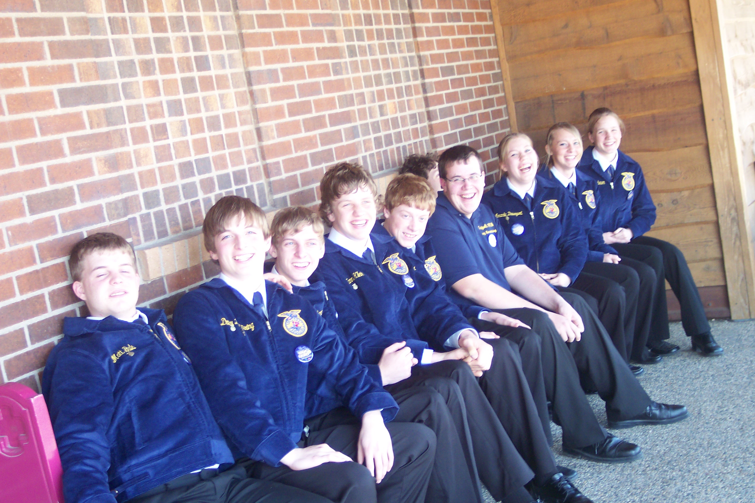
Everyone is “all smiles” after eating a Hickory Park during our State FFA Leadership trip.

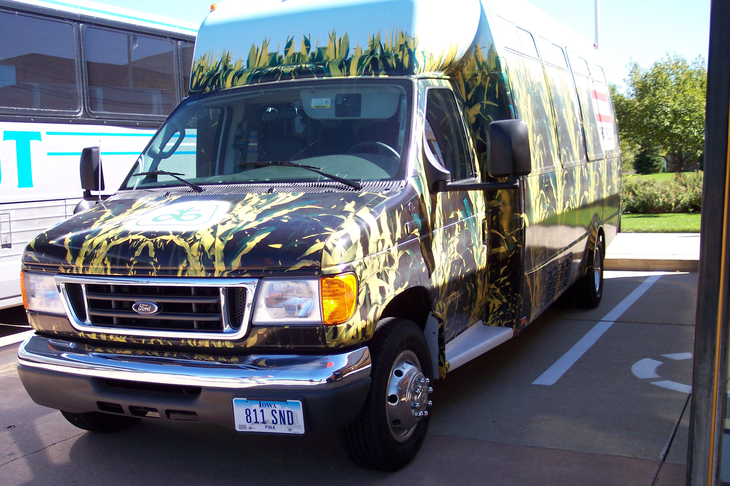
On our Pioneer fieldtrip we thought this corn mobile was awesome! I really enjoyed learning about the all the different career opportunities within Pioneer.

4-H

National Honor Society

