1. _______________ How often must a Catholic receive the Eucharist? (Handout)
2. _______________ How often must a Catholic participate in the celebration of the Eucharist? (YOUCAT 219)
3. Two "dispositions", or conditions, must be present before a person may receive Holy Communion. They are freedom from (3) _______________________ and a(an) (4) _________________ of one hour. (Handout)
5. ______________(True/False) The sign of the Sacrament of Holy Orders is the laying on of hands by the bishop. (Handout)
6. _______________(True/False) The three degrees of ordination are episcopate (bishop), presbyterate (priest), and diaconate (deacon). (Handout)
7. ________________ Those who choose the "consecrated life" of a religious brother, sister, or priest live by the three "evangelical counsels" of:
(a) faith, hope, and love.
(b) peace, humility, and joy.
(c) chastity, poverty, and obedience.
(d) guidance, math, and science.
8. ________________ The vocation of the ______ involves bringing Christ into the world of business, government, education, mass media, and so forth.
(a) laity
(b) bishops
(c) religious
(d) priesthood
9. ________________ The Sacrament of _____ confers an indelible spiritual character , which means it cannot be repeated and it lasts forever.
(a) Matrimony
(b) Holy Orders
(c) Reconciliation
(d) Anointing of the Sick.
10. ________________ The primary tasks of a married couple are:
(a) making lots of money.
(b) to live happily ever after.
(c) assisting the pastor of the local parish.
(d) mutual love and the procreation and education of children.
11. _______________ When did Christ institute the Eucharist?
(a) Good Friday
(b) Easter Sunday
(c) Holy Thursday
(d) Holy Saturday
Enter a caption for each illustration
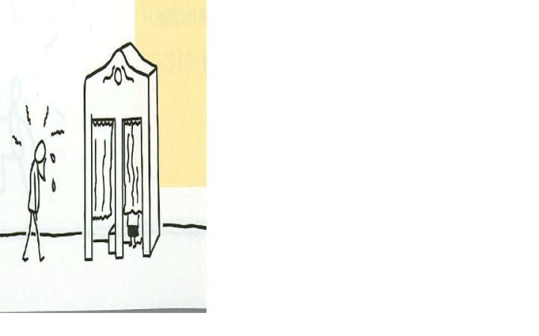 | 12. Caption:
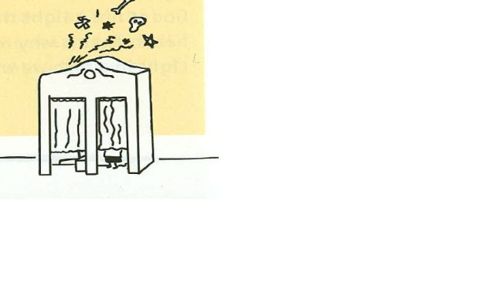 | 13. Caption:
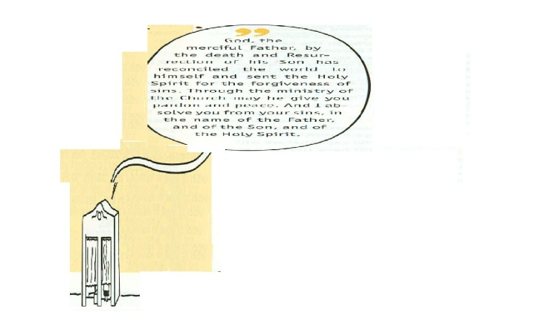 | 14. Caption:
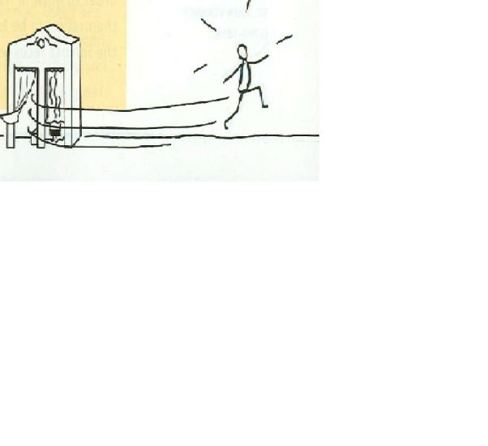 | 15. Caption:

Fill-in the best word in the blank space in each sentence that gives the gist of the YOUCAT question.
16. What is Baptism? (YOUCAT 194)
Baptism is the way out of the kingdom of ___________ into the Life, the gateway to the ____________, and the beginning of a lasting communion with __________.
17. How is Baptism administered? (YOUCAT 195)
The classical form of administering Baptism is the threefold immersion of the candidate in the ____________. ... while the minister of the sacrament speaks the words, "N., I baptize you in the name of the ___________, and of the ________, and of the ____________".
18. Who can be baptized, and what is required of a candidate? (YOUCAT 196)
Any person who is not yet baptized can be baptized. The only prerequisite for Baptism is ____________, which must be professed __________ at the Baptism.
19. Why does the Church adhere to the practice of infant Baptism? (YOUCAT 197)
From antiquity the Church has practiced infant Baptism. There is one reason for this: before we decide on God, God has __________ on us.....Believing parents who want what is best for their child want Baptism aols, in which the child is freed from the influence of _______________________ and the power of ______________.
20. Who can administer Baptism? (YOUCAT 198)
Normally a ____________, a ___________, or a ________ administers the sacrament of Baptism. In an emergency, any ______________....., can baptize by pouring water over the __________ of the recipient and pronouncing the baptismal formula, "N., I baptize you in the name of the ___________, and of the ________, and of the ____________".
21. What happens in Baptism? (YOUCAT 200)
In Baptism we become members of the Body of ___________, ___________ and _________ of our Redeemer, children of God. We are freed from ____________, snatched from death, and destined from then on for a life in the joy of the redeemed.
22. What is the significance of receiving a name in Baptism? (YOUCAT 201)
Through the name that we receive in Baptism God tells us: "I have called you by _______, you are mine."
23. Why should Christians choose the names of saints at Baptism? (YOUCAT 202)
There are no better examples than the __________ and no better helpers. If my namesake is a __________, I have a friend with ________.
Short Answers:
24. How does the Anointing of the Sick work? (YOUCAT 245)

25. What is meant by Viaticum? (YOUCAT 247)

26. How is the universal priesthood of all the faithful different from the ordained priesthood? (YOUCAT 259)

27. What are sacramentals? (YOUCAT 272)

28. What are the Stations of the Cross? (YOUCAT 277)

29. YOUCAT 277. You are writing the scene for the fourth station of the cross where Jesus meets his sorrowful Mother. (You observe Jesus meeting his sorrowful Mother. In your own words develop this scene. Who was meeting? Where did they meet? When did they meet? Why did they meet? How did they look? How were they dressed? How did they feel? What did they verbally say? What did they non-verbally say?
30, How was sickness viewed in the Old Testament? (YOUCAT 240)

31. What is the significance of Jesus’ compassion for the sick? (YOUCAT 241)

32. What is the attitude of the Church toward the sick? (YOUCAT 242)

33. Who can receive the sacrament of the anointing of the sick? (YOUCAT 243)

34. What is Viaticum? (YOUCAT 247)

35. What are the sacraments at the service of communion and mission? (YOUCAT 272)

36. What is the sacrament of Holy Orders and why is it called Holy Orders? (YOUCAT 248)

37. What is the office confided to a Bishop in a particular Church? (YOUCAT 252)

38. Who can confer the sacrament of Holy Orders and who can receive this sacrament? (YOUCAT 252, 254, 255)

39. What are the effects of the sacrament of Holy Orders? (YOUCAT 249)

40. Respond in your own words after you read and reflect on YOUCAT questions 250: How does the Church understand the sacrament of Holy Orders?

41. What is the name of the bishop-elect for the Diocese of Pensacola-Tallahassee?

42. What is the name of the Pope of the Catholic Church?

43. From Father Michael's talk on Marriage and the Compendium, how does Catholic marriage imitate the relationship of the Most Holy Trinity as well as Christ and the Church?

44. For what end has God instituted Matrimony? (YOUCAT 260)

45. Why is the Christian family called a domestic church?

46. Why is there a sacrament of Reconcilliation after Baptism? (YOUCAT 200)

47. When did Christ institute the Sacrament of Reconcilliation? (YOUCAT 227)

48. What are the essential elements of the sacrament of Reconcilliation? (YOUCAT 232)

49. What are the acts of the penitent? (YOUCAT 232)

50. Why can venial sins also be the object of sacramental confession? (YOUCAT 235)

51. Compare and contrast the terms forgiveness, reconciliation, repentance, conversion, and confession. Respond to this question in your own words after you read and reflect on the YOUCAT questions 224 to 230 and their responses. (YOUCAT 224-230)

52. Respond in your own words after you read and reflect on "To love a person means to see him as God intended him" (Dostoyevshy, 1821-1881).

53. Respond in your own words after you read and reflect on "To love someone means to be the only-one to see a miracle that is invisible to others " (Mauriac 1885-1979).

54. Respond in your own words after you read and reflect on "One drop of love is more than an ocean of understanding" (Pascal, 1588-1651).

55. List the five (5) forms of prayer. (YOUCAT 483)
a..__________________________________
b.__________________________________
c. _________________________________
d. _________________________________
e. _________________________________
56.. The Acts of the Apostles mainly address the missions of Peter and Paul. Little is stated about John, James, Andrew, Philip, Thomas, Bartholomew, Matthew, James the son of Alphaeus, Simon the Zealot, Judas the son of James, and Matthias the replacement for Judas who betrayed Jesus. Jesus told the Apostles, "But you shall receive power when the Holy Spirit has come upon you; and you shall be my witnesses in Jerusalem and in all Judea and Samaria, and to the end of the earth" (Acts 1:8). Identify one the Apostles, not Peter or Paul, who you will research to find what part of the earth tradition has your apostle witnessing. Enter the name of the apostle you will research.

57. The two main apostles studied in the Acts of the Apostles are

58. The Gospels inform us about Jesus and the Acts of the Apostles inform us about the activity of the ________ _________ in the early Church
59. Describe and comment on life among the believers as recounted in Acts 2:43-47.
60. How do we imitate the early believers who attended temple together and then had breaking bread in their homes (Acts 2:46-47)?

