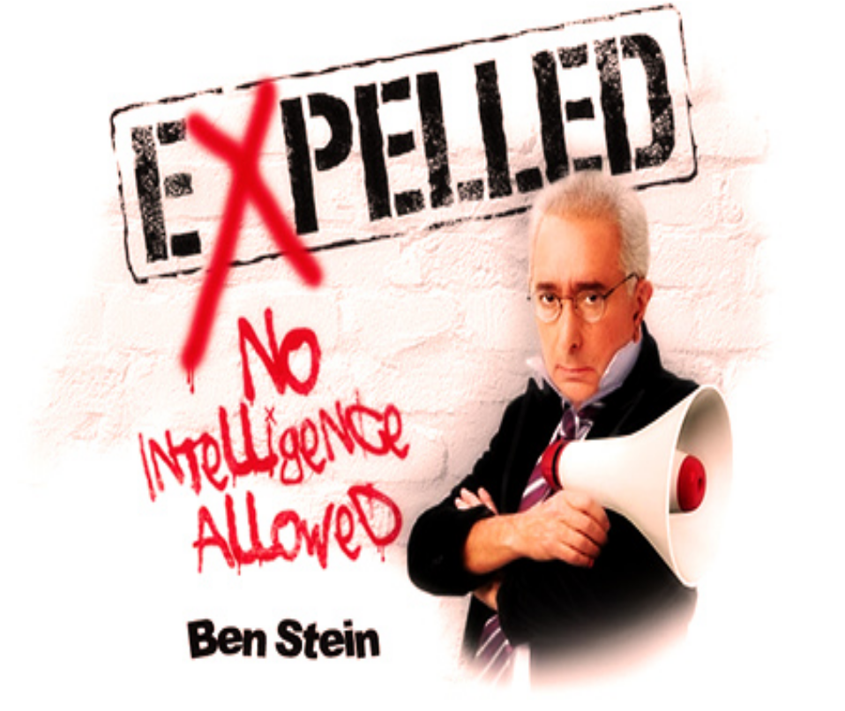
Part 1 Questions
- How is the scientific community limiting freedom according to Ben Stein? Do you agree that our freedoms are being threatened?
- What are the different ways that evolution can be defined? Do Intelligent Design advocates affirm some aspects of evolution? If so, what aspects?
- What is the difference between Creationism and Intelligent Design?
- Why do you think the scientific elite are excluding Intelligent Design from the discussion?
- How does the phrase “beware of the sound of one hand clapping” relate to this debate?
- What is your personal experience with evolution, Creationism and Intelligent Design?
- Can you believe in both Intelligent Design and evolution at the same time? Why or why not?
- Why do people not believe in evolution according to Richard Dawkins? Do you agree? Why or why not?

Part 2 Questions
- Discuss the naturalistic origin of life theories proposed in this segment. Do any of these theories seem plausible to you? Why or why not?
- How do new insights into the nature of the cell raise questions about Darwinism? Do you think Darwin might have altered his theory if he knew then what we know now?
- What checkpoints must be cleared when communicating new scientific information to the public? Why is Intelligent Design theory not widely understood by the general public?
- Why are many naturalistic scientists willing to talk about the problems with Darwinism in private, but not in public?
- Why do some Christians endorse evolution while others fight it with all their might?
- Are science and religion really at war? Discuss the different ways that Oxford professors Richard Dawkins and Alister McGrath answer this question.
- Why does Dawkins think that evolution and religion are incompatible? Can you spot any fallacies in Dawkins’s thinking?
- Explain how this battle is fundamentally a worldview conflict.
Part 3 Questions
- What worldview does Will Provine of Cornell University hold?
- How do the atheistic conversion stories of Provine, Dawkins, and Myers compare to Christian conversion stories you’ve heard?
- What do you think of the following statements: “Religion is just fantasy,” “God is about as likely as fairies and hobgoblins,” and “Religion is like knitting”?
- How did Darwinian thought influence the decisions of Nazi leadership? How might Hitler have thought he was helping the human race?
- What is Eugenics? How is Eugenics connected to Darwinian thinking?
- In what ways has Darwinism contributed to the devaluation of human life in contemporary society?
- What origin of life theory does Richard Dawkins suggest at the end of this film? Why do you think Dawkins is open to an intelligent designer as long as that designer is not God?
- Do you think Science and Religion are ultimately irreconcilable? Why or why not?
- Discuss the fallacies you noticed in this segment.

