COABE 2016
Dallas, TX

Connecting Collaborative Classroom Language and Workplace Soft Skills

Donna Price
dprice@sdccd.edu

Donna’s PowerPoint presentation and handout for this workshop can be found at:
http://www.quia.com/pages/donna/workshops

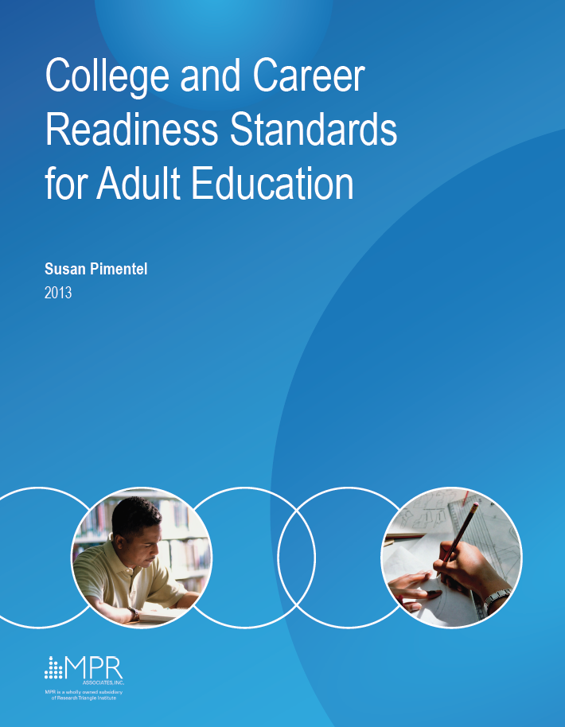
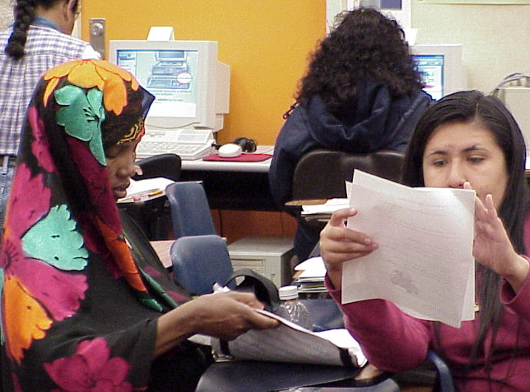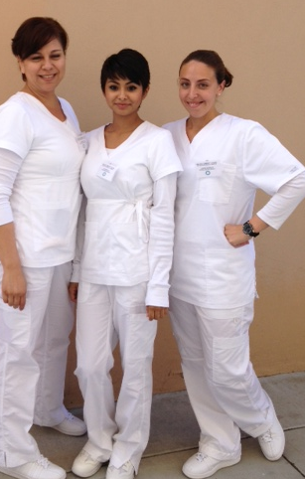

Introduction to the College and Career Readiness Standards

The College and Career Readiness (CCR) Standards are the Office of Career, Technical and Adult Education’s (OCTAE) response to the Common Core State Standards (CCSS), a K-12 Initiative. OCTAE’s mission is to transition students to postsecondary and career readiness programs. The CCR Standards consist of ten reading anchor standards, nine writing standards, six standards for speaking and listening and six for language skills (a total of 31 anchor standards). Also included are reading and language foundation anchor standards. The CCR anchor standards are broad answers to the question: What skills do our students need to be college and career ready?

1. Who developed the College and Career Readiness Standards? Where did the CCR Standards come from?
The CCR Standards (College and Career Readiness Standards) were developed by OCTAE (Office of Career and Technical Adult Education) to help prepare adult students for college and career readiness.

2. What do the CCR Standards consist of?
The CCR Standards have four major strands. The CCR strands are: reading, writing, speaking and listening, and English language arts. Each strand has several anchor standards. Most anchor standards have five level specific strands.

3. What is the purpose of the CCR Standards?
The CCR is a set of standards that OCTAE has developed to guide instructors as they assist students in developing the skills needed for college and career readiness. It is not a curriculum. It’s not a lesson plan.

4. What are the three instructional shifts in the English Language Arts strand?
There are three (3) major instructional shifts in the English Language Arts strand of the CCRS. They are in text complexity (using more academic language in reading, writing and speaking), using citation of evidence, and in reading of informational texts to develop content knowledge.

The complete College and Career Readiness Standards can be accessed at:
http://lincs.ed.gov/publications/pdf/CCRStandardsAdultEd.pdf

College and Career Readiness Standards Covered in this Workshop

CCR Reading Anchor 1: Read closely to determine what the text says explicitly and to make logical inferences from it; cite specific textual evidence when writing or speaking to support conclusions drawn from the text.
CCR Reading Anchor Standard 5: Analyze the structure of texts. Reading Standard 5B: Use text features and search tools (e.g., key words, sidebars, hyperlinks) to locate information relevant to a given topic efficiently.
CCR Writing Anchor 8: Gather relevant information from multiple print and digital sources, assess the credibility and accuracy of each source, and integrate the information while avoiding plagiarism.
CCR Speaking and Listening Anchor 1: Prepare for and participate effectively in a range of conversations and collaborations with diverse partners, building on others’ ideas and expressing their own clearly and persuasively.
CCR Speaking and Listening Anchor 4: Present information, findings, and supporting evidence such that listeners can follow that the line of reasoning and the organization, development, and style are appropriate to task, purpose, and audience.
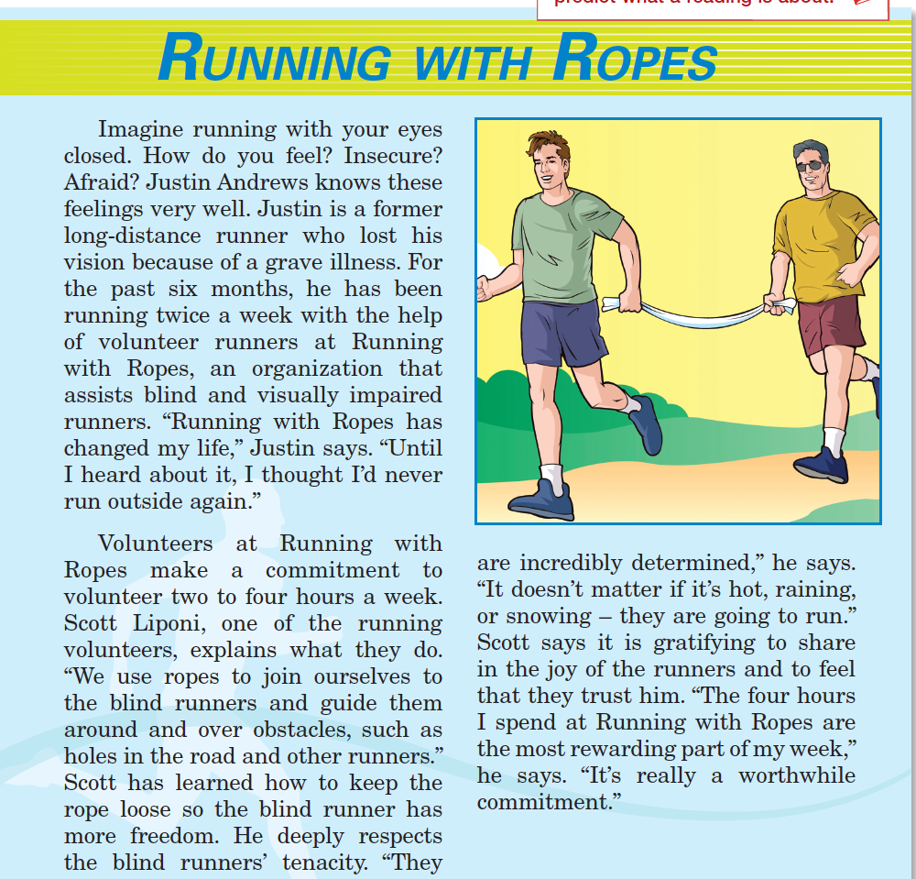

Source:

Ventures Book 4, 2nd Ed
Unit 5, Lesson D

A Worthwhile Commitment: Reading Mixer Questions
Text Dependent Questions (Ventures 4, 2nd Edition)
Who is Justin Andrews? | What is Running with Ropes? | According to the article, how is Justin able to run?
Who is Scott Liponi? | How does Scott feel about his volunteer commitment? | What is the time commitment for volunteers at Running with Ropes?
Describe in your own words why Scott says Running with Ropes is the most rewarding part of his week. | Describe what the running volunteers do as stated in the article. | What is a synonym for tenacity? Go back to the reading and find the word that means the same thing.
How did Running with Ropes change Justin’s life? | Why does Scott keep the rope loose when he runs with blind runners? | In the first paragraph, what word tells you that Justin had a serious medical condition?

A Worthwhile Commitment: Reading Mixer Questions
Non-Text Dependent Questions
Have you ever felt insecure? Describe the experience. | In your opinion, what is something that takes tenacity? | Based on your experiences, describe something that was gratifying for you.
What do visually impaired people use to help them? | What organization would you volunteer for if you had time? | Describe a rewarding experience.
Have you or anyone you know had a grave illness? Briefly describe what happened. | Look at the title. Describe one of your worthwhile commitments. | What do hearing impaired people use to help them?

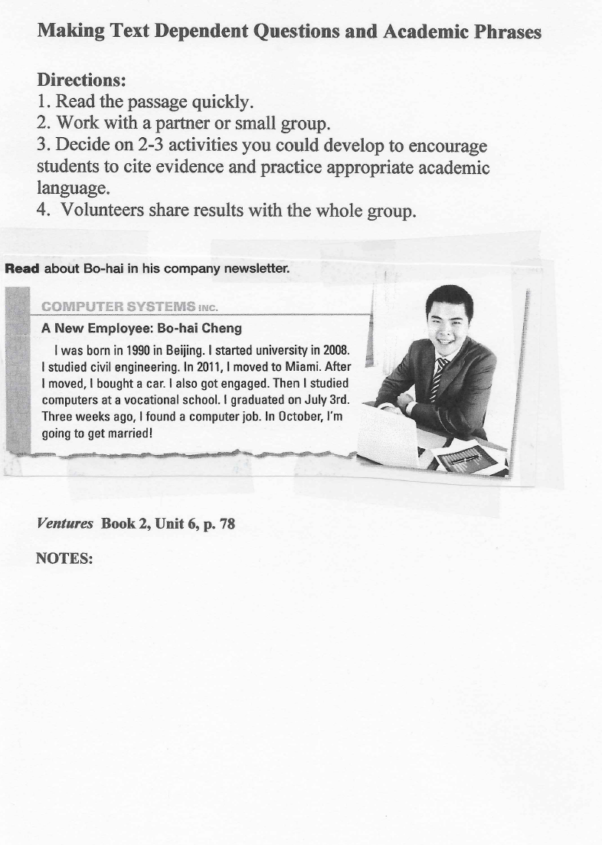

Planning the Career in My Future:
Collaborative Group Activity*

Students decide on a career they want to have in the future. Collaborating in teams, they brainstorm a list of questions to research about a particular job, and record the information on a guided note-taking template. Student groups give oral presentations in front of the class. During the presentations, they cite references. Other class members take notes using the same guided note-taking template. Based on the information shared, class members evaluate /discuss career preferences.
Goal Setting Phase:
- Survey
  - Survey the class and determine which job each student wants to have in five to ten years. List the jobs on the board.
  - Group students in teams by future job preference (likeability groups).
- Brainstorm
  - Groups work collaboratively developing a list of questions they want to investigate about a particular job. Each group selects a reporter to take notes.
    - How much is the pay per hour?
    - How many years of school do I need to attend to get the job?
Research Phase:
- Guided Note-Taking Template
  - Collaborative groups go online to investigate the answers to their questions.
  - Provide students with a list of helpful/level appropriate websites.
    - O*Net OnLine http://www.onetonline.org
    - My Skills My Future http://www.myskillsmyfuture.org
  - Teach students note-taking skills: e.g. record only the key words, take notes in the space provided next to each question, etc.
  - Each student takes notes on their own handout.
- Preparing for the Oral Report
  - Groups work together to summarize/analyze/evaluate the information gathered and decide how to present the information in their oral reports.
  - Group members write presentation scripts on note cards. They create posters showing the job name, yearly income, pictures of people on the job. etc.
Oral Presentation Phase:
- Presenting the Oral Report: Student Groups present their oral reports. Each group member participates in the presentation.
- Citation of Evidence: Students give evidence-based presentations in which they use academic language and cite evidence based on informational texts they’ve read and analyzed. They use academic language such as:
According to…..
The author states that……
I read about this in……
- Note-Taking: Class members take notes on the presentations using the Note-Taking Template.
- Career Discussions: Student groups discuss the presentations they’ve heard and reflect on their own career preferences.
* A similar lesson can be found at http://calpro-online.org/VirtualWorkroom/default.asp
Lesson created by Ronna Magy
My Future Job

- Name of Job

- Job Description
- Hourly Wage
- Yearly Wage
- Education Required
- Training Required
- Local Job
- Why I want this job

I read this information at the ___________________________________website.

A similar lesson can be found at http://calpro-online.org/VirtualWorkroom/default.asp

The Career in My Future at Beginning Level

At Beginning Level, the teacher guides students working in likeability groups through the steps of the Career in My Future Activity using level-appropriate language. Students research information on the Internet and record notes on a guided note-taking template. The activity culminates with student groups presenting oral reports in front of the class.

- The teacher teaches students the names of occupations using occupational picture cards.

- The teacher surveys students to find out which occupations they want to research.

- Students are grouped by occupational interest.

- The teacher provides groups with a short list of five (5) questions to investigate on the Internet (occupational name, hourly pay, yearly salary, working conditions, education needed) and a guided note-taking template on which to record the information.

- The teacher guides student groups to the O-Net Online Website for information gathering http://www.onetonline.org using the note-taking template

- The teacher supplies a paragraph frame for student reporting of information, and models how to fill in the paragraph with the class.

We researched information about _________________(job). You go to school
for ________years to get a __________________(certificate, diploma). On this job you work in a ______________(school, hospital, factory, store). Most of the time you work ______________(standing up and walking around, sitting down). Your pay is _______________ per hour. We read about this in __________________________________.

- Student groups write a report using the paragraph frame, and present the report to the class. During the report, students cite text-based evidence, naming their source of information.

This information can be found on the ONET website.

Lesson created by Ronna Magy.

Important Things to Remember about Giving a Speech!

Make Eye Contact

Use Expression in your Voice
Speak Loudly, Slowly, Clearly

Make it Interesting to the Listener
---___
Use Note Cards to Focus

Try to Relax
_____________________________________________________________

Listener Response Sheet

Speaker __________________ Listener’s Signature ______________
Listen and evaluate the speech using the following focus questions.

Comments:
1. Was there good ‘Eye Contact’?

2. Did he/she speak loudly enough?

3. Did he/she speak slowly enough?

4. Did he/she speak clearly enough?

5. Did he/she use inflection the voice (go up and down)?
6. Did he/she use note cards to help keep focus?
7. Did you understand the ideas in the speech?
8. Do you have any suggestions to help improve the speech?
When you have finished filling out this evaluation, return it to the speaker. Go over each question and explain your responses. Share any suggestions you have to improve the speech.

Useful Phrases in Academic Settings

Phrases to cite evidence:
According to the author, . . .
______pointed out that…
The author states that….
In the text, ______states that...
_______indicated that…
_______emphasized that...
_______concluded that…

Phrases to describe personal experience:
Based on my experience ________
From my perspective _________
In my opinion ___________

Phrases to ask an opinion:
How do you see it?
What is your point of view?
What are your thoughts on this issue?
What are some of your ideas?

Phrases to express an opinion:
In my opinion ________
Based on my experience ________
From my perspective ______

Phrases to report the group’s idea:
We decided that _____
We concluded that _____
We agreed that _____
We have come to a consensus that _____

Phrases to ask for clarification:
Could you explain what you mean by_____ ?
Could you provide another example of _____?
I don’t quite understand (the directions, the task).

Phrases for leave-taking: (It’s always nice to say good-bye to your partner(s) politely!)
It was nice talking to you.
Thank you for your time.
I learned a lot from our discussion.
I look forward to working with you again soon.
It was a pleasure to work with you.

Adapted from Kinsella, 2012 and Zwiers, 2009.

References and Websites (all websites retrieved in March 2016)

References
Bitterlin, G., Johnson, D., Price, D., Ramirez, S., & Savage, K. L. (2014). Ventures 2nd Edition. New York: Cambridge University Press.

Kinsella, K. Cutting to the Common Core: Communicating on the Same Wavelength.
http://languagemagazine.com/?page_id=5381

Kinsella, K. Disrupting Classroom Discourse: Preparing English Learners for Common Core Academic Language Demands. 2012 OELAS Conference Keynote. http://www.azed.gov/english-language-learners/files/2012/11/kinsella_az_oelas_keynotehandout.pdf

Morgan, S. 2005. Help Wanted: Smyth County, Virginia. https://www.quia.com/pages/donna/workshops

Phani, C. (2007). The Top 60 Soft Skills at Work.
http://www.rediff.com/getahead/2007/jan/08soft.htm

Pimentel, S. (2013). College and Career Readiness Standards for Adult Education. Retrieved http://lincs.ed.gov/publications/pdf/CCRStandardsAdultEd.pdf

Zwiers, J., & Crawford, M. (2009). How to start academic conversations. Educational Leadership, 66(7), 70-73. http://www.ped.state.nm.us/QualityAssuranceSystemsIntegration/dl09%20/ELL%20

Summit/How%20to%20Start%20Academic%20Conversations.pdf

Websites
Academic Word List: http://www.nottingham.ac.uk/alzsh3/acvocab/

Making Connections: https://www.youtube.com/watch?v=uql0IIIMJDY

Career Exploration Websites
Federal Department of Labor ONet: Easy to use career exploration website: http://www.onetonline.org/

There are descriptions of many jobs our students are interested in. Click Allied Health.
http://explorehealthcareers.org/en/home

EDD Labor Market Information for Job Seekers includes tips, articles & links: http://www.labormarketinfo.edd.ca.gov/customers/job-seekers.html

There are short videos (captioned) on many professions our students might be interested in. http://www.careeronestop.org/Videos/CareerandClusterVideos/career-and-cluster-videos.aspx

I Seek: Career videos 3-5 minutes long; all are closed-captioned.
http://www.iseek.org/careers/careervideos.html

