Master the Modern French Language

Passé Composé versus Imparfait
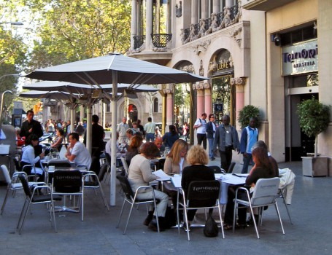
In this lesson, I am not going to go over the constructions of Passé-Composé or Imparfait, but I will concentrate on their uses and differences. To drill on the verb forms, use my French Verb Drills. To me, understanding when to use these tenses is probably one of the most difficult thing for an English speaker, since they cannot translate literally from English. You need to understand it's mostly a question of background/specific event, and develop an ear for it.

1 – You can not translate literally
“I was singing” or verbs in past progressive are going to be imperfect. For those, you can rely on translation 90% of the time.
The problem is “I sang” or verbs in the perfect tense… they can be translated as “je chantais” or “j’ai chanté”: it is the rest of the sentence that tells, so there is no way you can just translate.

2 – Some expressions are usually followed by the imperfect.
le lundi (on MondayS), le soir, le matin… tous les lundis (tous les matins, soirs, jours…), chaque jour (mois, année…), tous les jours, d’habitude, habituellement, généralement, en général, normalement, parfois, quelques fois, de temps en temps, rarement, autrefois (in the past, formerly – pretty formal). Memorize them, it’s a big help.

3 – Main differences
I suggest you learn by heart the 2 sentences below. Don’t think in term of actions, actions can be in both PC or imperfect.
- Imparfait = what was happening all around you (including you), background. Also ongoing events, habits, what used to be.
- Passé composé = what took place at that very moment: a specific event or a succession of specific events, the main storyline.

Now let’s be more specific:

A – Habits versus specific events
The imperfect describes habitual actions in the past. The PC describes what took place, specific events.
Le lundi, je dînais chez ma soeur / Un lundi, nous avons dîné au restaurant.
On Mondays, I used to have dinner at my sister’s / One Monday, we dined in a restaurant.
In this case, what you need to look for are the time setting words : “le lundi” (habit) versus “un lundi”(specific).

B – When you are telling a story
The passé composé describes actions that constitute the storyline. It tells the series of specific events that took place. Some expressions of time tend to be followed by the PC in a story ; d’abord, puis, ensuite, enfin, finalement, soudain, tout à coup, tout de suite… since they usually introduce specific events. Memorize them, they’re a big help.
The imperfect describes the background, it sets the scene:
- the date, the time of the day, the weather, the scene (what people were doing)….. external circumstances,
- age, appearance, physical traits, physical condition, feelings, attitudes…. personal circumstances.

C – In the same sentence
- The Imparfait describes ongoing background actions, what was happening at that time (often with a “to be + ing” construction in English) – these actions had started before, and may continue after.
The PC will describe a specific action that took place at a precise time as the background action was going on:
Ils sont entrés (specific even – short in lenght) pendant que nous dormions (ongoing action – longer in lenght). They came in as we were sleeping.
- Sometimes, the same tense is used for the 2 actions if they are of same length:
- 2 actions that went on for some time:
Pendant que j’etudiais, tu regardais la télé. While I was studying, you were watching TV.
- or 2 specific shorter actions:
Tu es rentrée quand je suis sortie. You came in as I was going out.

4 – Here is a typical story with the explanation for the tenses
C’était le 3 juillet (background). Il faisait beau (background). Les oiseaux chantaient (background), le soleil brillait (background). J’avais vingt ans (background) et je me promenais dans Paris (background). Généralement (habit so imparfait will follow), je passais mes vacances avec mes parents. Mais cette année-là (specific time so PC will follow), je suis allée à Paris avec des amis. Je ne parlais pas très bien français (background), et j’étais un peu timide (background).
Il était midi (background), et j’avais faim (background). Je suis entrée dans un café, et je me suis assise à une table (succession of specific events/storyline). C’était un petit café typiquement parisien (background). On entendait un air de musique à la radio (background). Quelques personnes déjeunaient et parlaient tranquillement (background). Le serveur est venu à ma table, et j’ai placé ma commande (succession of specific events/storyline).
Pendant que j’attendais mon repas (ongoing event), j’ai commencé à me sentir mal (specific event). Soudainement (introduces PC), je me suis évanouie et je suis tombée par terre (succession of specific events, storyline). Le serveur a téléphoné aux pompiers (specific event, storyline). Ils sont arrivés très vite (specific event, storyline). Je me suis réveillée (specific event), mais je me sentais encore faible (ongoing). Alors, les pompiers ont décidé (specific event/storyline) de m’emmener à l’hôpital…
Master the Modern French Language

