Name: _________________________ Period: ________
History of the Atom
“The atom is one of science’s greatest achievements. The idea, born in the mind of a Greek man many years before the birth of Christ, now dominates the science and technology that surrounds us. With this idea scientists can explain nearly all the phenomena of nature. With this idea technicians have developed TV, radio, computers; they’ve probed the human body and mind, and the farthest reaches of outer space. On this IDEA we trust our lives.
From a simple beginning the idea has grown, contorted, rebelled, exploded, lay dormant, baffled and confused, surprised and enlightened. The idea has been down many roads, some rough, some smooth, some of them dead ends. The trek along the road lays open to all of us and now to you. Not so that you may join the masses that know what the IDEA is, but so you may join the faithful who know why it is, how it came to be. The power comes from understanding the idea, knowing its strengths and weaknesses, and how it can be used. Satisfaction comes from mastering the most sophisticated idea in all of nature. The joy and misery come from the mysteries that lie within, the idea, the atom.” (Author Unknown)
Instructions: Below you will find the names of several individuals and groups of people that helped advance the model of the atom. Your job is to describe the model developed at each stage, to answer any specific questions included. Use the information that you can find in your text, your notes, and at the websites listed to complete this task.
I. The first documented model of the atom came from the Greeks.
Aristotle was a leading philosopher of the time and did not believe in the atomic theory proposed by Democritus. Describe the main points of both men's theories. Why do you suppose that Democritus’ ideas were not taken seriously for another 2000 years?
When did Democritus develop his ideas? ___________  Who was Democritus’ teacher that influenced his  development of the atom concept? ____________________________________  List the main points to Democritus' theory of atoms 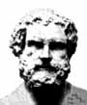 | Describe how Aristotle's ideas were different from Democritus' ideas and what he thought everything was made of (describe his "elements")  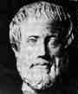
Democritus l  http://www.funsci.com/fun3_en/democritus/democritus.htm | Aristotle  http://members.tripod.com/~Killashandra/Page2.html  http://galileo.phys.virginia.edu/classes/252/atoms.html
III. John Dalton developed the first comprehensive Atomic Theory. http://antoine.frostburg.edu/chem/senese/101/atoms/dalton.shtml http://www.chemheritage.org/classroom/chemach/periodic/dalton.html
In what year did Dalton develop his atomic theory? ____ What was Dalton's scientific area of study? ___________
State the 4 points of his theory, and note whether or not each point is still believed to be valid today.
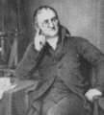
John Dalton
Fun fact - what disease that John Dalton had and studied is now called "Daltonism"?__________________
IV. The first subatomic particle to be discovered was credited to JJ Thomson. http://www.aip.org/history/electron/jjhome.htm ; http://www.chemheritage.org/EducationalServices/chemach/ans/jjt.html
A. Which particle did he find, how did he find it, and what did his model of the atom look like?
B. What was Thomson's 1904 model called? _______________________________________.
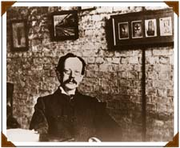
JJ Thomson (follow this link to hear JJ Thomson speak about the electron http://www.aip.org/history/electron/jjsound.htm )
V. Ernest Rutherford played an enormous role in the development of modern chemistry and physics. His most famous work, however, was an experiment called the Gold Foil Experiment. http://www.howstuffworks.com/atom6.htm ;http://micro.magnet.fsu.edu/electromag/java/rutherford/
A. How did this experiment enlighten our understanding of the atom? Describe the experiment and the new model thoroughly.
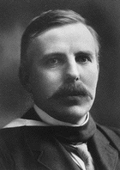
Ernest Rutherford
B. What was the fatal flaw in this 1911 model?
VI. Next came the discovery of the neutron and the proton. Learn about them at; http://www.dpgraph.com/janine/twins.html;
A. Who first postulated the existence of and named the proton? ________________
B. Who discovered the neutron? ___________________
C. Where are these particles located, and what are their charges?

VII. At last we arrive at the development of the model that you are most familiar with - the Bohr Model of the atom. Bohr was a student of Rutherford and continued his work on the atom. Spend a little time with this - it's important information despite the fact that his model has been modified.
A. Describe his model, as well as the evidence for and against this model. http://www.pbs.org/wgbh/aso/databank/entries/bpbohr.html; http://www.upscale.utoronto.ca/GeneralInterest/Harrison/BohrModel/BohrModel.html
B. How did Neils Bohr overcome the problem with the Rutherford Model of the Atom?
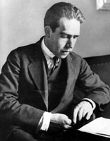
Niels Bohr
C. What other 'data' did Bohr use in order to formulate his hypothesis?

D. You will notice that the photon of light is emitted when electrons 'jump' from one energy level to another. Write the formula (http://scienceworld.wolfram.com/biography/Planck.html) in the space provided that relates the Energy of the emitted Photon and the various Energy Levels.
VIII. Though Bohr considered his model a "quantized" atom, it failed to explain all of the energy level changes exhibited by atoms. The current Quantum Mechanical Model of the atom was developed by Schroedinger who built upon the work of Heisenberg and de Broglie. http://www.howstuffworks.com/atom8.htm
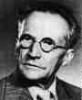 | 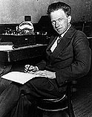
Erwin Schrodinger | Heisenberg
A. Heisenberg said: (State his principle)
B. Describe, as best you can, Schrodinger's model of the atom.

