NAME: PERIOD:

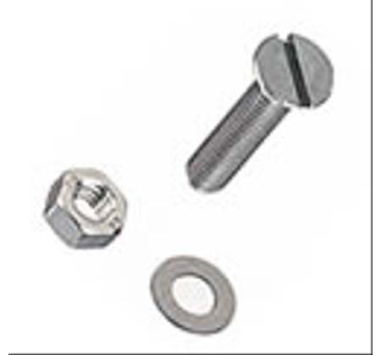

Nuts, Bolts, Washers

Directions: Each individual nut, bolt, and washer represents an atom. Different types of objects represent different elements. For each station, complete the chart to the left, then sketch the contents of the dish in the blank box. Then match them to the best description in the matching section on the back.

STATION 1
Total # of atoms
# of different Elements
# of different types of compounds
Total # of molecules
Is it a pure substance?

STATION 2
Total # of atoms
# of different Elements
# of different types of compounds
Total # of molecules
Is it a pure substance?

STATION 3
Total # of atoms
# of different Elements
# of different types of compounds
Total # of molecules
Is it a pure substance?

STATION 4
Total # of atoms
# of different Elements
# of different types of compounds
Total # of molecules
Is it a pure substance?

STATION 5
Total # of atoms
# of different Elements
# of different types of compounds
Total # of molecules
Is it a pure substance?

STATION 6
Total # of atoms
# of different Elements
# of different types of compounds
Total # of molecules
Is it a pure substance?

STATION 7
Total # of atoms
# of different Elements
# of different types of compounds
Total # of molecules
Is it a pure substance?

STATION 8
Total # of atoms
# of different Elements
# of different types of compounds
Total # of molecules
Is it a pure substance?

STATION 9
Total # of atoms
# of different Elements
# of different types of compounds
Total # of molecules
Is it a pure substance?

STATION 10
Total # of atoms
# of different Elements
# of different types of compounds
Total # of molecules
Is it a pure substance?

STATION 11
Total # of atoms
# of different Elements
# of different types of compounds
Total # of molecules
Is it a pure substance?

STATION 12
Total # of atoms
# of different Elements
# of different types of compounds
Total # of molecules
Is it a pure substance?

MATCHING: FILL IN THE APPROPRIATE STATION # IN THE BLANK NEXT TO EACH DESCRIPTION

- A mixture of three different monatomic elements.

- A mixture of two monatomic elements and a triatomic element.

- A mixture of a monatomic element and a diatomic element.

- A compound and a pure substance.

- A mixture of three different compounds.

- A mixture of a monatomic element and two diatomic elements.

- A triatomic molecule. Also a pure substance. Not a compound.

- A mixture of two different compounds.

- A mixture of a compound and two monatomic elements.

- A mixture of two diatomic elements.

- A monatomic element. Also a pure substance.

- A diatomic element. Also a pure substance.

