NAME: PERIOD:
PHYSICAL / CHEMICAL TEST REVIEW

A. Matching – place the letter of the correct definition in the blank next to its corresponding vocabulary term

1. Acidity
2. Density
3. Ductility
4. Flammability
5. Malleability
6. Solubility
7. State
8. Conductivity
9. Radioactivity
10. Reactivity

A. The ability to be pounded into sheets
B. Solid, Liquid, or Gas
C. The decay of an atom’s nucleus
D. pH; measures how acidic or basic a substance is
E. Measures mass per unit volume
F. Ability to burn/combust
G. Ability to dissolve
H. Ability to contain/transfer heat and/or electricity
I. Ability to change chemical composition/ engage in a chemical reaction
J. Ability to be stretched into wire

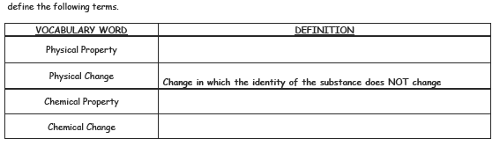
B.

C. Fill in the physical and chemical properties in the reaction below.
 | 2 H₂ (hydrogen) + | O₂ (oxygen) | = 2H₂O (water)
PHYSICAL
PROPERTIES
CHEMICAL
PROPERTIES

D. Explain the process of the electrolysis of water. Is the process chemical or physical?

How does this process support the Law of Conservation of Matter?

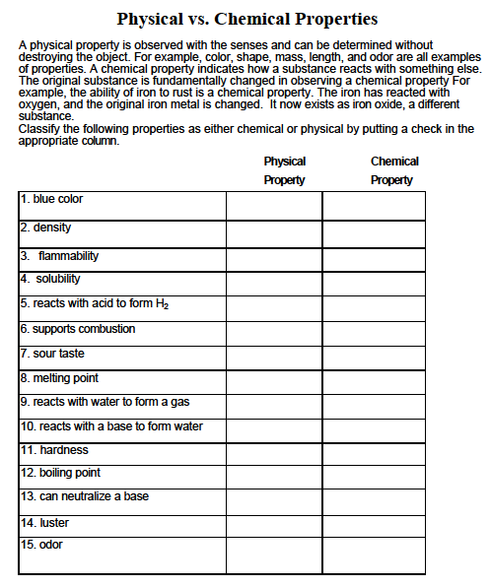
D.

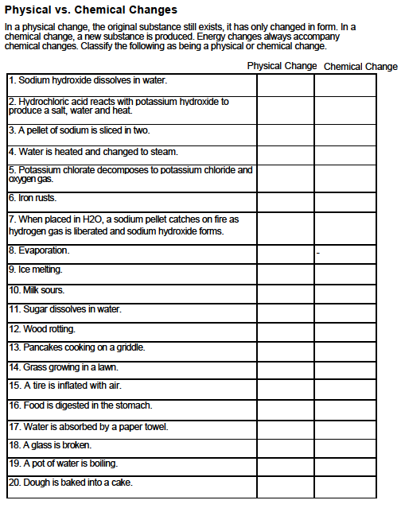
E.

F. Chemical Reaction – Yes or No?

Each of the following items describes two substances combining. Decide whether or not you are reading a description of a chemical reaction. Explain your reasoning for each example. This means you support your answer even if it is not a chemical reaction.

1. Substance A is added to substance B. The freezing point of B is lowered by 9 degrees C.

2. When substance X and substance Y are mixed together, a magnet can remove particles of substance X.

3. Particles of substance B are suspended in substance T.

4. When substance X and substance Z are heated together in test tube, drops of substance B form on the inside of the test tube.

5. When substance Q is added to substance R, substance R tastes salty.

6. When solid substance Y is added to liquid substance R, there is a violent explosion. The resulting matter has less mass than the combined masses of Y and R.

List 10 physical properties of matter: Give 10 examples of physical changes

1. 1.

2. 2.

3. 3.

4. 4.

5. 5.

6. 6.

7. 7.

8. 8.

9. 9.

10. 10.

List 5 examples chemical properties Give 6 examples of chemical changes.

1. 1.

2. 2.

3. 3.

4. 4.

5. 5.

6.

What is meant by a closed vs. open system?

Which system is necessary to demonstrate the Law of Conservation of Matter?

With respect to the Labs in this unit:

What evidence suggests a chemical reaction took place?

What gas was formed with Sodium bicarbonate and Calcium Chloride? How do you know?

What gas was formed in the demo with Hydrogen peroxide and Manganese dioxide? How do you know?

