Chemistry - Classification of Matter and Properties

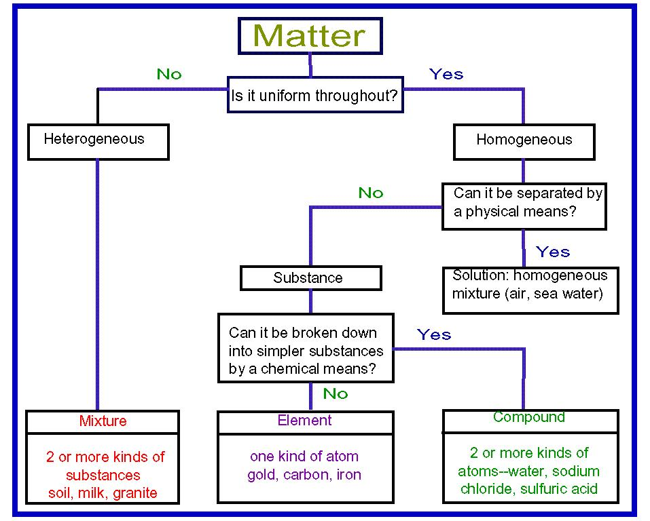

Provide the best, complete, detailed, and NEATLY written response to each of the following questions. Your response should in essence contain a restatement of the question AND be written in complete sentences.
e.g. Q – What is the color of the sky? Answer by writing: The color of the sky is blue. (The questions has been restated in the response
- Define matter in a complete sentence.
- List the three common states (phases) of matter:
  - What do we call these common phases for water?
- Which state of matter has:
  - no definite shape, nor definite volume
  - no definite shape, but definite volume
  - definite shape and definite volume
- How do you change a solid into a liquid? Give an example.
- How do you change a gas into a liquid? Give an example.
- Use your answers from the two problems above to explain why phase changes are "reversible".
- List three physical properties of matter.
- When matter undergoes a physical change, has its physical properties changed? Give an example.
- What do we mean when we speak of a substance's "composition"? Use your prior knowledge of atoms, molecules, elements, compounds and mixtures.
- When matter undergoes a physical change, does the composition of the matter change? Give an example.
- List two chemical properties of matter.
- After a chemical change has the physical and chemical properties of a substance changed? Give an example.
- Give two examples of common items that use chemical change.

Identify the following as a chemical or physical change:
- mixing salt and pepper 15. magnetizing a piece of steel
- freezing water 16. dissolving sugar in water
- cutting a marshmallow
- toasting a marshmallow
- burning wood
- adding chocolate syrup to milk
- iron rusting
- melting sugar
- breaking glass
- boiling water
- melting wax
- burning wax
- hammering gold into a thin foil
- pouring molten gold into a mold

Chemistry: Classifying Matter

Classify each of the materials below. In the center column, state whether the material is a pure substance or a mixture. If the material is a pure substance, further classify it as either an element or compound in the right column. Similarly, if the material is a mixture, further classify it as solution (homogeneous)or heterogeneous mixture in the right column. Write the entire word in each space to earn full credit.

Material | Pure Substance  or Mixture | Element, Compound,  Solution (homogeneous mixture), Heterogeneous mixture
concrete
sugar + pure water
(C₁₂H₂₂O₁₁ + H₂O)
iron filings (Fe)
limestone (CaCO₃)
orange juice (w/pulp)
Pacific Ocean
air inside a balloon
aluminum (Al)
magnesium (Mg)
acetylene (C₂H₂)
tap water in a glass
soil
pure water (H₂O)
chromium (Cr)
Chex mix
salt + pure water
(NaCl + H₂O)
benzene (C₆H₆)
muddy water
brass
(Cu mixed with Zn)
baking soda (NaHCO₃)

Chemistry: Properties
Recall that physical properties can be observed without producing new substances. Chemical properties describe how a substance interacts with other substances to produce new substances. Extensive properties depend upon the amount of matter in the sample; intensive properties are independent of the amount of matter present.

Directions, Part 1: Classify each of the properties listed below as extensive or intensive. Then classify each property as physical or chemical.

Property | Extensive or Intensive  Property | Physical or Chemical  Property
color
combustibility
hardness
density
mass
melting point
ductility
volume
reactivity with acid
odor
weight
malleability
tendency to corrode

Identify the following methods of separating mixtures including when they are used.

- Physical/hand separation –

- Distillation –

- Crystallization –

- Chromatography (discuss all types of chromatography) –

- Filtration –

Directions, Part 2: Some measurements or descriptions of properties are listed below. Write which property is being described in each case. Select properties that are listed in the table from Part 1.

A. 15 dm³ A. ______________________
B. can easily be hammered into sheets B. ______________________
C. 2.8 g/cm³ C. ______________________
D. burns when heated in the presence of O₂ D. ______________________
E. shiny metal forms a chalky white E. ______________________
layer on its surface
F. can be scratched by a diamond F. ______________________
G. 500ºC G. ______________________

H. can easily be drawn into a wire H. ______________________

Solve the following problems showing ALL EQUATIONS, WORK, UNITS, and LABELS!!!

What is the percentage composition of the following compounds?

a.) magnesium iodide, MgI₂

b.) lithium phosphate, Li₃PO₄

c.) ferric chlorate, Fe(ClO₃)₃

d.) What is the percentage composition of a compound formed from the complete reaction of 5.50 g of potassium with 4.99 g chlorine?

If 7.86 g of magnesium burns in air (combining with oxygen) to form a 13.04 g of magnesium oxide product, how much oxygen reacted with the magnesium?

If 11.5 g of sulfur burns completely with 0.715 g of hydrogen, how much hydrogen sulfide (H₂S) is formed?

Chemistry - Classification of Matter and Properties ANSWER KEY

Provide the best, complete, detailed, and NEATLY written response to each of the following questions. Your response should in essence contain a restatement of the question AND be written in complete sentences.
e.g. Q – What is the color of the sky? Answer by writing: The color of the sky is blue. (The questions has been restated in the response
1. Define matter in a complete sentence.
Matter is anything having mass and volume (occupying space).
2. List the three common states (phases) of matter:
  - What do we call these common phases for water?
The three common phases of matter are solids, liquids, and gases
Water’s phases are ice, water, and steam.
3. Which state of matter has:
a. no definite shape, nor definite volume
Gases have neither definite shape nor definite volume; they assume the shape and volume of their container.
  - no definite shape, but definite volume
Liquids have a definite volume but no definite shape; they assume the shape of their container.
  - definite shape and definite volume
Solids have both definite shape and definite volume; therefore, there independent of their container.
4. How do you change a solid into a liquid? Give an example.
Solids are changed into liquids through the process of melting. Usually, this is accomplished by heating.
- How do you change a gas into a liquid? Give an example.
Changing a gas or vapor into a liquid would generally be done by cooling or removing heat causing the gas/vapor to condense.
- Use your answers from the two problems above to explain why phase changes are "reversible".
If one heats a liquid, assuming it does not decompose, it will eventually boil,, becoming a gas or vapor. The chemical composition (identity) of the liquid would be preserved.
If one cools a liquid, it will eventually freeze or solidify, becoming a solid. The chemical composition (identity) of the liquid would be preserved.
- List three physical properties of matter.
Density, color, specific heat capacity, boiling point, melting point, electrical conductivity, etc .
- When matter undergoes a physical change, has its physical properties changed? Give an example.
Matter undergoing a physical change may have its physical properties such as shape, size, phase, etc. changed. However, chemical composition remains the same.
e.g. water freezing to form ice or a large crystal of cupric sulfate being pulverized into a fine powder
- What do we mean when we speak of a substance's "composition"? Use your prior knowledge of atoms, molecules, elements, compounds and mixtures.
A substance’s composition refers to its chemical make-up. What atoms are present, and if a compound, in what ratio or proportion. It also includes which atoms are actually bonded together.
- When matter undergoes a physical change, does the composition of the matter change? Give an example.
The composition of matter never changes during a physical change. Water changing from liquid to water vapor through boiling remains H₂O chemically.
- List two chemical properties of matter.
Rusting, oxidizing, flammability, tarnishing, rotting, reacting with halogens, etc. are all chemical properties.
- After a chemical change has the physical and chemical properties of a substance changed? Give an example.
Chemical changes result in the alteration of the identities of the reactants as new substance(s) are formed. These new substance(s) have their own composition and their own unique set of properties. When a piece of carbon burns it combines with oxygen to form carbon dioxide.
C_{(s)} + O_{2(g)} ---------------> CO_{2(g)}
Carbon - Carbon is a soft, dull gray or black.
The density of carbon as graphite is 2.267 g/mL. It will melt at 3,823 K and it will boil at 4.098 K.
Carbon dioxide – Colorless, odorless gas. Density of 1.977 g/L . Melting point of
216.6 K and a boiling point of 194.7 K.
- Give two examples of common items that use chemical change.
The human body or any living organism uses chemical change to produce energy, new compounds, new cells, etc. Batteries produce electrical energy through chemical reactions (chemical change). Internal combustion engines utilize the oxidation of petro fuels in order to operate and run.

Identify the following as a chemical or physical change:
1.mixing salt and pepper physical change
2. freezing water physical change
3. cutting a marshmallow physical change
4. toasting a marshmallow chemical change
5. burning wood chemical change
6. adding chocolate syrup to milk physical change
7. iron rusting chemical change
8. melting sugar physical change
9. breaking glass physical change
10. boiling water physical change
11. melting wax physical change
12. burning wax chemical change
13. hammering gold into a thin foil physical change
14. pouring molten gold into a mold physical change
15. magnetizing a piece of steel physical change
16. dissolving sugar in water physical change

Chemistry: Classifying Matter

Classify each of the materials below. In the center column, state whether the material is a pure substance or a mixture. If the material is a pure substance, further classify it as either an element or compound in the right column. Similarly, if the material is a mixture, further classify it as solution (homogeneous)or heterogeneous mixture in the right column. Write the entire word in each space to earn full credit.

Material | Pure Substance  or Mixture | Element, Compound,  Solution (homogeneous mixture), Heterogeneous mixture
concrete | mixture | heterogeneous mixture
sugar + pure water  (C₁₂H₂₂O₁₁ + H₂O) | mixture | solution
iron filings (Fe) | pure substance | element
limestone (CaCO₃) | pure substance | compound
orange juice (w/pulp) | mixture | heterogeneous mixture
Pacific Ocean | mixture | heterogeneous mixture
air inside a balloon | mixture | solution
aluminum (Al) | pure substance | element
magnesium (Mg) | pure substance | element
acetylene (C₂H₂) | pure substance | compound
tap water in a glass | mixture | solution
soil | mixture | heterogeneous mixture
pure water (H₂O) | pure substance | compound
chromium (Cr) | pure substance | element
Chex mix | mixture | heterogeneous mixture
salt + pure water  (NaCl + H₂O) | mixture | solution
benzene (C₆H₆) | pure substance | compound
muddy water | mixture | heterogeneous mixture
brass  (Cu mixed with Zn) | mixture | solution
baking soda (NaHCO₃) | pure substance | compound

Chemistry: Properties
Recall that physical properties can be observed without producing new substances. Chemical properties describe how a substance interacts with other substances to produce new substances. Extensive properties depend upon the amount of matter in the sample; intensive properties are independent of the amount of matter present.

Directions, Part 1: Classify each of the properties listed below as extensive or intensive. Then classify each property as physical or chemical.

Property | Extensive or Intensive  Property | Physical or Chemical  Property
color | Intensive Property | Physical Property
combustibility | Intensive Property | Chemical Property
hardness | Intensive Property | Physical Property
density | Intensive Property | Physical Property
mass | Extensive Property | Physical Property
melting point | Intensive Property | Physical Property
ductility | Intensive Property | Physical Property
volume | Extensive Property | Physical Property
reactivity with acid | Intensive Property | Chemical Property
odor | Intensive Property | Physical Property
weight | Extensive Property | Physical Property
malleability | Intensive Property | Physical Property
tendency to corrode | Intensive Property | Chemical Property

Identify the following methods of separating mixtures including when they are used.

- Physical/hand separation – Heterogeneous mixtures – visually identifiable components.

- Distillation – Separating a mixture of liquids based upon differences in boiling points. Or, separating a solid solute from a liquid solvent.

- Crystallization – Separating a solid solute from a liquid solvent by cooling the solution or evaporating solvent after hitting the saturated condition.

- Chromatography (discuss all types of chromatography) – Paper or TLC chromatography. Separate mixture components on a stationary phase of paper or coated plate. Mobile phase movement caused by capillary action. Separation of components based upon varying degrees of attraction for the stationary phase.

Column chromatography uses a packed column. The mixture to be separated is poured into the top of the column. Additional eluent (mobile phase) is added. It draws the components down through the column. Those components attracted to the stationary phase (packing) move more slowly than those less attracted.

GC – an instrumental type of column chromatography using a “carrier gas” such as helium to move the components through the packed column. Separation depends upon attraction to the packing in the column (stationary phase).

HPLC – an instrumental form of column chromatography using liquid solvents to “drag” the mixture components over the surface of the packing. Separation depends upon the component attraction to the stationary phase in comparison to the mobile phase.

- Filtration – Used to separate a suspension; solid from a liquid or solid from a gas. Utilizes a filtering agent (filter paper, diatomaceous earth, activated charcoal, etc.) which has a porosity the will trap or capture the suspended solid but allow the liquid or gaseous solvent to pass.

Directions, Part 2: Some measurements or descriptions of properties are listed below. Write which property is being described in each case. Select properties that are listed in the table from Part 1.

A. 15 dm³ A. ___volume______________
B. can easily be hammered into sheets B. _malleability______________
C. 2.8 g/cm³ C. _density__________________
D. burns when heated in the presence of O₂ D. _combustibility____________
E. shiny metal forms a chalky white E. _tendency to corrode______
layer on its surface
F. can be scratched by a diamond F. _hardness________________
G. 500ºC G. _melting point____________

H. can easily be drawn into a wire H. _ductility________________

Solve the following problems showing ALL EQUATIONS, WORK, UNITS, and LABELS!!!

What is the percentage composition of the following compounds?

a.) magnesium iodide, MgI₂

b.) lithium phosphate, Li₃PO₄

c.) ferric chlorate, Fe(ClO₃)₃

d.) What is the percentage composition of a compound formed from the complete reaction of 5.50 g of potassium with 4.99 g chlorine?

Mass of compound = Mass of K + Mass of Cl
= 5.50 g K + 4.99 g Cl = 10.49 g of compound

% K = mass of K x 100 = 5.50 g K x 100 = 52.4 % K
Masss of comp’d 10.49 g comp’d

% Cl = mass of Cl x 100 = 4.99 g Cl x 100 = 47.6 % Cl
Masss of comp’d 10.49 g comp’d

If 7.86 g of magnesium burns in air (combining with oxygen) to form a 13.04 g of magnesium oxide product, how much oxygen reacted with the magnesium?

2 Mg_{(s)} + O_{2(g)} --------------> 2 MgO_{(c)}

Law of conservation of mass – mass of reactants must equal mass of products

Mass of oxygen = Mass of MgO compound - Mass of Mg

= 13.04 g MgO - 7.86 g Mg

= 5.18 g oxygen

If 11.5 g of sulfur burns completely with 0.715 g of hydrogen, how much hydrogen sulfide (H₂S) is formed?

S_{8(s)} + 8 H_{2(g)} --------------------> 8 H₂S_{(g)}

Law of conservation of mass – mass of reactants must equal mass of products

Mass of H₂S = Mass of sulfur + Mass of hydrogen

= 11.5 g S + 0.715 g H

= 12.215 g H₂S

