Honors Chemistry Worksheet – Electronic Structure of Atoms
Provide the best, complete, yet concise response to each of the following questions or problems.

- In the Bohr model of the hydrogen atom, when the electron is in the ground state, it orbits the nucleus at a specific radius of 0.53 Å. In the quantum mechanical model description of the hydrogen atom, the most probable distance of the electron from the nucleus is 0.53 Å. Why are these two statements different?

- In the quantum mechanical model description of the hydrogen atom, what is the physical significance of the square of the wave function, ψ²?

- a) For n = 4, what are the possible values of l?
b) For l = 2, what are the possible values of m_{l}?

4. How many possible values for l and m_{l} are there for shells with:
a) n = 3
b) n = 5
What are these values?

- Give the values for n, l, and m_{l} for:
a) each orbital in the 2p energy subshell
b) each orbital in the 5d energy subshell

- Which of the following are permissible sets of quantum numbers for an electron in a hydrogen atom:
a) n = 2; l = 1; m_{l} = 1
b) n = 1; l = 0; m_{l} = -1
c) n = 4; l = 2; m_{l} = -2
d) n = 3; l = 3; m_{l} = 0
For those combinations that are permissible, write the appropriate designation for the energy sublevel to which the orbital belongs (e.g. 1s, etc.)

- Give the values for n, l, and m_{l} for:
a) each orbital in the 5f energy subshell
b) each orbital in the n = 4 shell

8. Which of the following sets of quantum numbers are allowed for an electron in a
hydrogen atom:
a) n = 2; l = 2; m_{l} = -2
b) n = 4; l = 3; m_{l} = -1
c) n = 1; l = 0; m_{l} = 0
d) n = 6; l = 3; m_{l} = -4
For those combinations that are allowed, write the appropriate designation for the energy subshell to which the orbital belongs (e.g. 1s, etc.)

- Sketch the shape AND orientation of the following types of orbitals:
a) s b) p_{z} c) d_{xy}

- Sketch the shape AND orientation of the following types of orbitals:
a) p_{x} b) d_{z}2 c) d _{x2 – y2}

- a) What are the similarities and differences between a hydrogen atom’s 1s and 2s orbitals? b) In what sense does a 2p orbital have directional character? Compare the directional character of the p_{x} orbital and the d _{x2 – y2} orbitals (that is, in what direction or region of space is the electron density concentrated?) c) What can you say about the average distance from the nucleus of an electron in a 2s orbital as compared with a 3s orbital? d) For the hydrogen atom, list the following orbitals in order of increasing energy (that is, most stable ones first): 4f; 6s; 3d; 1s;2p

- Which quantum numbers must be the same in order for orbitals to be degenerate: (a) in a hydrogen atom and (b) in a many electron atom?

- In a multi-electron atom: (a) for any given major quantum number, how does the effective nuclear charge vary for electrons in the s, p, d, and f sublevels? (b)How does the effective nuclear charge vary among the d orbitals of the same major quantum number n?

- a) What are the possible values of the electron spin quantum number? b) What piece of experimental equipment can be used to distinguish electrons that have different values of the spin quantum number? c) Two electrons in an atom both occupy the 1s orbital. What quantity must be different for the two electrons? What principle governs the answer to this question {c)}?

- The Pauli exclusion principle is, in an important sense, the key to understanding the periodic table. Explain why.

- What is the maximum number of electrons that can occupy each of the following energy sublevels (subshells):
  - 3d
  - 4s
  - 5f
  - 2p

- What is the maximum number of electrons in an atom that can have the following quantum numbers:
  - n = 2 and m_{s} = -1/2
  - n = 5 and l = 3
  - n = 4 ; l = 3; and m_{l} = -3
  - n = 4 ; l = 1; and m_{l} = 1

- List the possible values of the four quantum numbers for a 2p electron in beryllium.

- Assign values of the four quantum numbers to each electron in a ground state carbon atom.

Honors Chemistry Worksheet – Electronic Structure of Atoms ANSWERS
Provide the best, complete, yet concise response to each of the following questions or problems.

- In the Bohr model of the hydrogen atom, when the electron is in the ground state, it orbits the nucleus at a specific radius of 0.53 Å. In the quantum mechanical model description of the hydrogen atom, the most probable distance of the electron from the nucleus is 0.53 Å. Why are these two statements different?

The Bohr model attempts to clearly define the exact position or location of the electron while the quantum mechanical model on indicates the most probable region for finding the electron. It does not attempt to further predict its path or location.

- In the quantum mechanical model description of the hydrogen atom, what is the physical significance of the square of the wave function, ψ²?

The value of the wave function squared is used because there can’t be a negative probability. It is therefore, used to determine the probability of the points for which the Schrödinger equation has been solved.

- a) For n = 4, what are the possible values of l?
l = o to (n – 1) = 0 to (4 – 1) = 0,1,2,3
b) For l = 2, what are the possible values of m_{l}?
m_{l} = - l to +l including zero = -2 to +2 = -2, -1, 0, +1, +2

4. How many possible values for l and m_{l} are there for shells with:
a) n = 3 “n” number of l values, therefore 3 (l = 0, 1, 2) and n² orbitals per
energy level, therefore, 9 m_{l} values m₀ = 0; m₁ = -1, 0 +1; and m₂ = -2,
- 1, 0, +1, +2
b) n = 5 “n” number of l values, therefore 5 (l = 0, 1, 2, 3, 4) and n²
orbitals per energy level, therefore, 25 m_{l} values m₀ = 0; m₁ = -1, 0 +1; m₂ = -2, - 1, 0, +1, +2; m₃ = -3, -2, -1, 0, +1, +2, +3; and m₄ = -4,-3, -2, -1, 0, +1, +2, +3, +4

What are these values?

5. Give the values for n, l, and m_{l} for:
a) each orbital in the 2p energy subshell n = 2; l = 1; m_{l} = -1, or 0, or +1
b) each orbital in the 5d energy subshell n = 5; l = 2; m_{l} = -2, or -1, or 0, or +1, or +2

- Which of the following are permissible sets of quantum numbers for an electron in a hydrogen atom:
a) n = 2; l = 1; m_{l} = 1 Permissible 2p
b) n = 1; l = 0; m_{l} = -1 Not permitted
c) n = 4; l = 2; m_{l} = -2 Permissible 4d
d) n = 3; l = 3; m_{l} = 0 Not permitted

- Give the values for n, l, and m_{l} for:
a) each orbital in the 5f energy subshell n = 5; l = 3; m₃ = -3, -2, -1, 0, +1, +2, +3
b) each orbital in the n = 4 shell n = 4; l = 0,1,2,3; m₀ = 0; m₁ = -1, 0 +1; m₂ = -2, - 1, 0, +1, +2; m₃ = -3, -2, -1, 0, +1, +2, +3; and
m₄ = -4,-3, -2, -1, 0, +1, +2, +3, +4

8. Which of the following sets of quantum numbers are allowed for an electron in a
hydrogen atom:
a) n = 2; l = 2; m_{l} = -2 Not allowed
b) n = 4; l = 3; m_{l} = -1 Allowed 4f
c) n = 1; l = 0; m_{l} = 0 Allowed 1s
d) n = 6; l = 3; m_{l} = -4 Not allowed
For those combinations that are allowed, write the appropriate designation for the energy subshell to which the orbital belongs (e.g. 1s, etc.)

- Sketch the shape AND orientation of the following types of orbitals:
a) s b) p_{z} c) d_{xy}

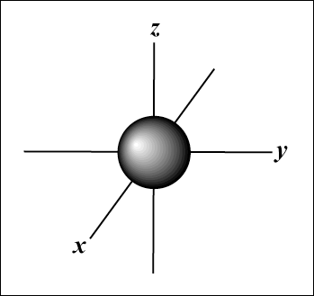 s 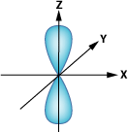 p_{z}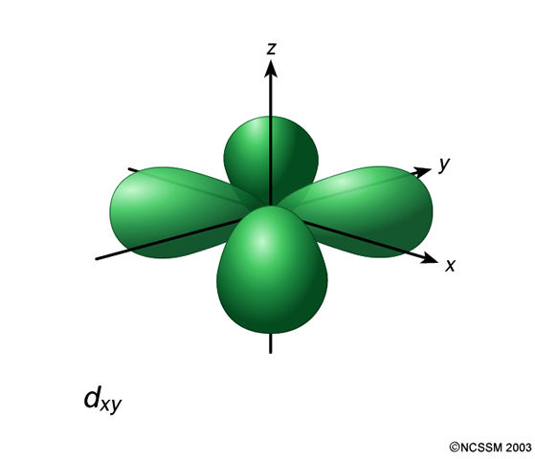 d_{xy}

- Sketch the shape AND orientation of the following types of orbitals:
a) p_{x} b) d_{z}2 c) d _{x2 – y2}

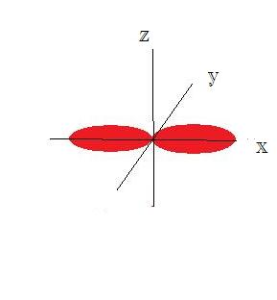p_{x} 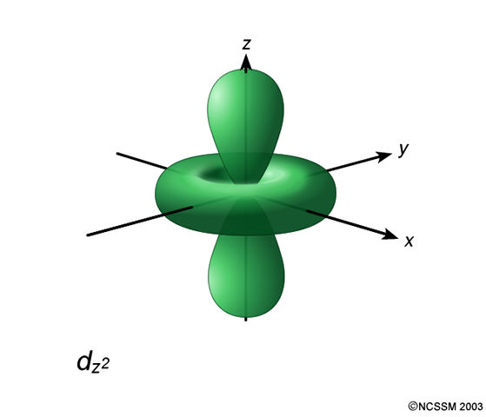 d_{z}2 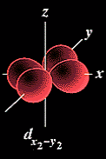 d_{x}2 – _{y}2

- a) What are the similarities and differences between a hydrogen atom’s 1s and 2s orbitals? b) In what sense does a 2p orbital have directional character? Compare the directional character of the p_{x} orbital and the d _{x2 – y2} orbitals (that is, in what direction or region of space is the electron density concentrated?) c) What can you say about the average distance from the nucleus of an electron in a 2s orbital as compared with a 3s orbital? d) For the hydrogen atom, list the following orbitals in order of increasing energy (that is, most stable ones first): 4f; 6s; 3d; 1s;2p

The 1s, 2s, and 3s are all spherical orbitals and represent the lowest energy orbital for each of their energy levels. These orbitals primarily differ in size and energy, increasing as you go from 1s to 2s to 3s.

The p orbitals have a directional character as each lies along one of the Cartesian axes. The p_{x} orbital has antinodal regions (or cloud density) located along the x axis. The d_{x}2 _{- y}2 orbital has charge density located along the x and y orbitals.

The average distance between the nucleus and the 2s electron is shorter than the average distance between the nucleus and 3s electron.

1s < 2p < 3d < 6s < 4f

- Which quantum numbers must be the same in order for orbitals to be degenerate: (a) in a hydrogen atom and (b) in a many electron atom?

For hydrogen, the only quantum number that needs to be the same is the principal quantum.
For multiple electron atoms, degenerate orbitals require the same n and l quantum numbers.

- In a multi-electron atom: (a) for any given major quantum number, how does the effective nuclear charge vary for electrons in the s, p, d, and f sublevels? (b) How does the effective nuclear charge vary among the d orbitals of the same major quantum number n?

The effective nuclear charge attempts to describe the actually nuclear attraction acting on an electron considering various factors. Generally, the effective nuclear charge decreases according to the s > p > d > f for any given energy level.

The effective nuclear charge acts on the d orbitals equally.

- a) What are the possible values of the electron spin quantum number? b) What piece of experimental equipment can be used to distinguish electrons that have different values of the spin quantum number? c) Two electrons in an atom both occupy the 1s orbital. What quantity must be different for the two electrons? What principle governs the answer to this question {c)}?
The possible values for the magnetic spin quantum number are +1/2 and
– 1/2.

While Stern and Gerlach used inhomogeneous magnetic field, the actual machine used to indicate such spin orientations is an NMR (nuclear magnetic resonance) which causes extremely short lived electron spin flips as part of its analytical ability.

The magnetic spin quantum number for the two electrons occupying the same orbital must be different (+1/2 and – 1/2) in order to follow the Pauli Exclusion Principle which states that no two electrons may have the exact same four quantum numbers.

- The Pauli exclusion principle is, in an important sense, the key to understanding the periodic table. Explain why.

The Pauli exclusion principle limits the maximum number of electrons occupying an orbital to two. Therefore, in essence determining when a new row of elements need start on the periodic table.

- What is the maximum number of electrons that can occupy each of the following energy sublevels (subshells):
  - 3d 10
  - 4s 2
  - 5f 14
  - 2p 6

- What is the maximum number of electrons in an atom that can have the following quantum numbers:
  - n = 2 and m_{s} = -1/2 8
  - n = 5 and l = 3 102
  - n = 4 ; l = 3; and m_{l} = -3 70
  - n = 4 ; l = 1; and m_{l} = 1 36

- List the possible values of the four quantum numbers for a 2p electron in beryllium. n = 2; l = 1; m₁ = -1, 0, +1, m_{s} = +1/2 or - 1/2

- Assign values of the four quantum numbers to each electron in a ground state carbon atom.

Electron | n | l | m_{l} | m_{s}
1st electron | 1 | 0 | 0 | +1/2
2nd electron | 1 | 0 | 0 | - 1/2
3rd electron | 2 | 0 | 0 | + 1/2
4th electron | 2 | 0 | 0 | - 1/2
5th electron | 2 | 1 | +1 | + 1/2
6th electron | 2 | 1 | 0 | + 1/2

