Honors Chemistry Worksheet – The Quantum Mechanical Atom
Provide the best, complete, neatly written responses to the following questions and problems. For calculations, provide equations, units, significant figures, and all work.

1. Describe the Bohr model of the hydrogen atom. How does the Bohr model differ from Rutherford’s model?

2. What is the importance of Rydberg’s spectral measurements to the Bohr model of the atom?

3. What is meant when it is said that the possible energies of the electron in an atom are quantized?

4. Using the Bohr model, what is the expression for the energy of the electron in the ion Be⁺³? What is the expression for the radius of the n = 1 circular orbit?

5. How does the Bohr model of the atom differ from the quantum mechanical model? How are the two similar?

6. Distinguish between energy levels (shells), energy sublevels (subshells), and orbitals.

7. What can be determined about the location of an electron using the quantum mechanical model of the atom?

8. Identify the four quantum numbers used in the quantum mechanical model of the atom and identify what each describes.

9. a) State Hund’s Rule of Multiplicity.
b) Indicates the groups in the representative elements of the periodic table where Hund’s
Rule must be used to determine the correct electronic structures.

10. Sketch the shapes of an s orbital, a p orbital and two possible shapes for a d orbital.

11. Identify the energy sublevel (subshell) in which electrons with the following quantum numbers are found:
a) n = 3; l = 0 b) n = 3; l = 2 c) n = 2; l = 1
d) n = 7; l = 4 e) n = 4; l =3

12. What type of orbital is occupied by an electron with the quantum numbers n = 5; l = 2? How many degenerate orbitals of this type are in an atom?

13. Write the quantum numbers for each electron found in a nitrogen atom. For example, the quantum numbers for the first 2s electron will be n = 2; l = 0; m₀ = 0; m_{s} = +1/2.

Honors Chemistry Worksheet – The Quantum Mechanical Atom Page 2

14. The quantum numbers that describe the electron in the lowest energy level of the hydrogen atom (ground state) are: n = 1; l = 0; m₀ = 0; m_{s} = +1/2 . Excitation of the electron can promote it to energy levels described by other sets of quantum numbers. Which of the following sets of q.n. CANNOT exist in a hydrogen atom?

a) n = 2; l = 1; m₁ = -1; m_{s} = +1/2
b) n = 2; l = 0; m₀ = 1; m_{s} = +1/2
c) n = 7; l = 3; m₃ = 0; m_{s} = -1/2
d) n = 3; l = 3; m₃ = -2; m_{s} = -1/2
e) n = 4; l = 2; m₂ = 3; m_{s} = +1/2
f) n = 3; l = 2; m₂ = -1; m_{s} = +3/2

15. Using the electron configuration (1s²2s²2p⁶, etc.) predict the electron distribution for each of the following atoms and classify each as a representative element, noble gas, transition element (metal), or inner transition element.

a) ¹⁹F b) ²⁴Mg c) ³¹P d) ⁴⁰Ar e) ⁵¹V f) ⁹⁶Mo
g) ⁹⁹Tc h) ²⁰⁸Pb i) ¹⁴⁴Nd j) ²²²Rn

16. Using the electron configuration, predict the electronic structure of the following ions:

a) Na⁺ b) Si⁺² c) P³⁻ d) Cl⁻¹ e. Ti⁴⁺ f) Tl⁺
g) La³⁺

17. Define each of the following terms as it applies to the periodic table.
a) period b) group c) transition series d) noble gas
e) inner transition series f) representative elements g) metal
h) nonmetal i) metalloid

Problem
#1. Light that looks green has a frequency of 5.22 x 10¹⁴ /s. What is the wavelength of green light in centimeters AND angstroms. What is the energy of a quantum of green light in joules?

#2. Does the quantum of green light described in #1 have enough energy to excite the electron in hydrogen atom from the K shell (n = 1) to the L shell (n = 2)? {Hint: look at handout(s) you received or below}

#3. Calculate the amount of energy in joules and electron volts required (absorbed) to pull an electron in the hydrogen atom from the energy level (shell) closest to the nucleus to the third energy level (M shell or n = 3).

Honors Chemistry Worksheet – The Quantum Mechanical Atom Page 3

#4. Consider a collection of hydrogen atoms with electrons randomly distributed in either the n = 1, 2, 3, 4, or 5 shells. How many different wavelengths of light will be emitted by these atoms as the electrons fall into the lower energy states?

#5. Calculate the frequencies and wavelengths of the light produced by the transitions described in Problem #4.

Energies below are in electron volts.
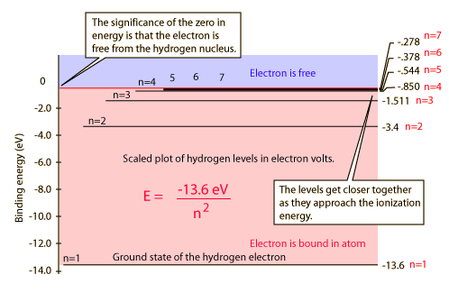

Honors Chemistry Worksheet – The Quantum Mechanical Atom ANSWER KEY
Provide the best, complete, neatly written responses to the following questions and problems. For calculations, provide equations, units, significant figures, and all work.

1. Describe the Bohr model of the hydrogen atom. How does the Bohr model differ from Rutherford’s model?

2. What is the importance of Rydberg’s spectral measurements to the Bohr model of the atom?

Rydberg mathematically explained the observed emission spectrum of hydrogen. However, in order to explain its relationship physically to the hydrogen atom, it was Bohr’s concept of quantized energy levels or orbits that tied the two together.

3. What is meant when it is said that the possible energies of the electron in an atom are quantized?

The electron may not possess an infinite range of energies within the atom. Instead, the electron is allowed to possess only certain energies. It may jump up or down between allowed energy states, but the range of energies it is permitted are limited.

4. Using the Bohr model, what is the expression for the energy of the electron in the ion Be⁺³? What is the expression for the radius of the n = 1 circular orbit?

E_{n} = - R_{H} Z²__ = - 2.179 x 10⁻¹⁸ J (4²) = 3.486 x 10⁻¹⁷ J
n² 1²

Radius of n = 1 in Be⁺³ = n² a₀/Z = (1²) (0.529 Å)/4 = 0.132 Å

5. How does the Bohr model of the atom differ from the quantum mechanical model? How are the two similar?

Both the Bohr model and the quantum mechanical model are based upon the quantization of the atom; or its electron(s). However, Bohr is considered to have employed “old quantum mechanics” as compared to the quantum mechanical model present today.

Bohr’s model indicated that electron movement was predictable as the electrons traveled about in the fixed pathways called orbits. However, the quantum mechanical model indicators the electron path is unpredictable, instead it indicates the presence of electron(s) based upon probabilities within given regions about the nucleus.

6. Distinguish between energy levels (shells), energy sublevels (subshells), and orbitals.

Energy levels or shells indicate the relative size and energy of the orbitals; or at least of the electrons which inhabit them.
An energy sublevel or subshell describes a set of collective orbitals. The energy sublevels or subshells within an energy level vary in energy.

Orbitals describe a specific volume about the nucleus in which the electron is energetically permitted to exist and which there is a probability of finding an electron.

7. What can be determined about the location of an electron using the quantum mechanical model of the atom?

8. Identify the four quantum numbers used in the quantum mechanical model of the atom and identify what each describes.

Principal quantum number – n – energy level or energy shell
Azimuthal (angular) quantum number – l – energy sublevel (subshell) or orbital type
Orientation or magnetic quantum number – m_{l} – the orientation of the orbitals in space about the nucleus. It also indicates the number of orbitals per energy sublevel.

Magnetic spin quantum number – m_{s} – indicates the relative spin (clockwise or counterclockwise) on the electron

9. a) State Hund’s Rule of Multiplicity.
b) Indicates the groups in the representative elements of the periodic table where Hund’s
Rule must be used to determine the correct electronic structures.

Hund’s rule of multiplicity states that orbitals of an energy sublevel (subshell) are degenerate; they are of equal energy. Therefore, each orbital of an energy sublevel must receive one electron before any receives two electrons (forms an electron pair).

10. Sketch the shapes of an s orbital, a p orbital and two possible shapes for a d orbital.

s orbital 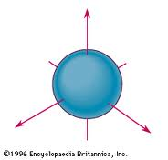

p orbital 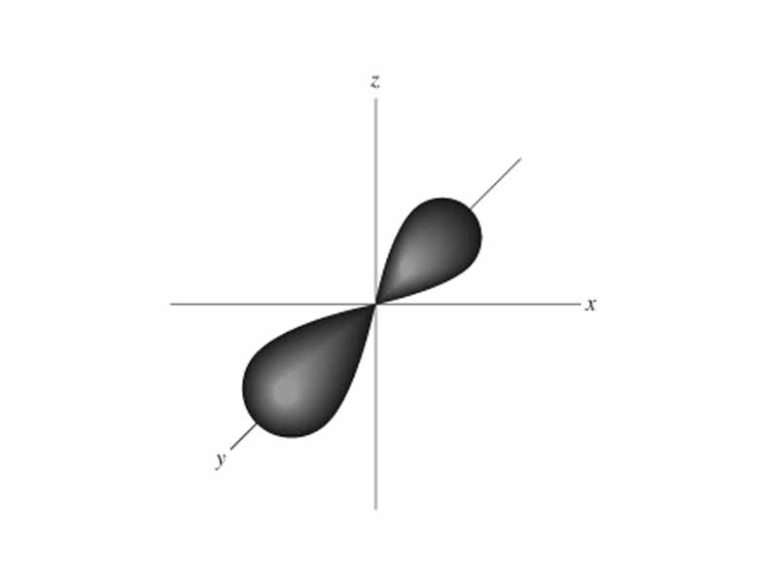

d orbital 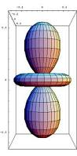 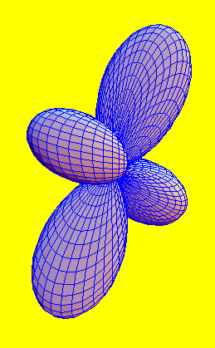

11. Identify the energy sublevel (subshell) in which electrons with the following quantum numbers are found:
a) n = 3; l = 0 3s b) n = 3; l = 2 3d c) n = 2; l = 1 2p
d) n = 7; l = 4 7g e) n = 4; l =3 4f

12. What type of orbital is occupied by an electron with the quantum numbers n = 5; l = 2? How many degenerate orbitals of this type are in an atom?

The 5d electron occupies an orbital indicated by n = 5 and l = 2.
There are five degenerate orbitals in the 5d energy sublevel; 5d_{xy}, 5d_{xz}, 5d_{yz}, 5d_{z}2, and 5d_{x}2 _{– y}2.

13. Write the quantum numbers for each electron found in a nitrogen atom. For example, the quantum numbers for the first 2s electron will be n = 2; l = 0; m₀ = 0; m_{s} = +1/2.
1s¹ n = 1; l = 0; m₀ = 0; m_{s} = +1/2.
1s² n = 1; l = 0; m₀ = 0; m_{s} = -1/2.
2s¹ n = 2; l = 0; m₀ = 0; m_{s} = +1/2.
2s² n = 2; l = 0; m₀ = 0; m_{s} = -1/2.
2p¹ n = 2; l = 1; m₁= -1; m_{s} = +1/2.
2p² n = 2; l = 1; m₁ = 0; m_{s} = +1/2.
2p³ n = 2; l = 1; m₁= +1; m_{s} = +1/2.

Honors Chemistry Worksheet – The Quantum Mechanical Atom Page 2

14. The quantum numbers that describe the electron in the lowest energy level of the hydrogen atom (ground state) are: n = 1; l = 0; m₀ = 0; m_{s} = +1/2 . Excitation of the electron can promote it to energy levels described by other sets of quantum numbers. Which of the following sets of q.n. CANNOT exist in a hydrogen atom?

a) n = 2; l = 1; m₁ = -1; m_{s} = +1/2
b) n = 2; l = 0; m₀ = 1; m_{s} = +1/2 - Can’t exist m₀ = 0 not 1
c) n = 7; l = 3; m₃ = 0; m_{s} = -1/2
d) n = 3; l = 3; m₃ = -2; m_{s} = -1/2 - Can’t exist there is no l = 3 for n = 3
e) n = 4; l = 2; m₂ = 3; m_{s} = +1/2 - Can’t exist m₂ ≠ 3 - cannot be a 3 for m₂
f) n = 3; l = 2; m₂ = -1; m_{s} = +3/2 - Can’t exist there is no + 3/2

15. Using the electron configuration (1s²2s²2p⁶, etc.) predict the electron distribution for each of the following atoms and classify each as a representative element, noble gas, transition element (metal), or inner transition element.

a) ¹⁹F - 1s² 2s² 2p⁵ Representative element and halogen
b) ²⁴Mg - 1s² 2s² 2p⁶ 3s² Representative element and alkaline earth metal
c) ³¹P - 1s² 2s² 2p⁶ 3s² 3p³ Representative element
d) ⁴⁰Ar - 1s² 2s² 2p⁶ 3s² 3p⁶ Representative element and noble gas
e) ⁵¹V - 1s² 2s² 2p⁶ 3s² 3p⁶ 4s² 3d³ Transition metal
f) ⁹⁶Mo - 1s² 2s² 2p⁶ 3s² 3p⁶ 4s² 3d¹⁰ 4p⁶ 5s² 4d⁴ Transition metal
g) ⁹⁹Tc - 1s² 2s² 2p⁶ 3s² 3p⁶ 4s² 3d¹⁰ 4p⁶ 5s² 4d⁵ Transition metal
h) ²⁰⁸Pb - 1s² 2s² 2p⁶ 3s² 3p⁶ 4s² 3d¹⁰ 4p⁶ 5s² 4d¹⁰ 5p⁶ 6s² 4f¹⁴ 5d¹⁰ 6p² Representative element
i) ¹⁴⁴Nd - 1s² 2s² 2p⁶ 3s² 3p⁶ 4s² 3d¹⁰ 4p⁶ 5s² 4d¹⁰ 5p⁶ 6s² 4f⁴ Inner transition element
j) ²²²Rn - 1s² 2s² 2p⁶ 3s² 3p⁶ 4s² 3d¹⁰ 4p⁶ 5s² 4d¹⁰ 5p⁶ 6s² 4f¹⁴ 5d¹⁰ 6p⁶ Representative element and noble gas

16. Using the electron configuration, predict the electronic structure of the following ions:

a) Na⁺ 1s² 2s² 2p⁶
b) Si⁺² 1s² 2s² 2p⁶ 3s²
c) P³⁻ 1s² 2s² 2p⁶ 3s² 3p⁶
d) Cl⁻¹ 1s² 2s² 2p⁶ 3s² 3p⁶
e) Ti⁴⁺ 1s² 2s² 2p⁶ 3s² 3p⁶
f) Tl⁺ 1s² 2s² 2p⁶ 3s² 3p⁶ 4s² 3d¹⁰ 4p⁶ 5s² 4d¹⁰ 5p⁶ 6s² 4f¹⁴ 5d¹⁰
g) La³⁺ 1s² 2s² 2p⁶ 3s² 3p⁶ 4s² 3d¹⁰ 4p⁶ 5s² 4d¹⁰ 5p⁶

17. Define each of the following terms as it applies to the periodic table.
a) period - horizontal row of elements on the periodic table (there are 7)
b) group - vertical column of elements on the periodic table (also called families and there are 18 with headings
c) transition series - these are ten vertical columns in the center of the periodic table representing the filling of the d energy sublevel
d) noble gas – these are gaseous elements found in group 18 or family VIIIA which have low reactivity and a common ns²np⁶ valence excepting helium which is only ns²
e) inner transition series - these are elements from the lanthanide and actinide series often broken out at the bottom of the periodic table and represent the filling of the f energy sublevel; 4f and 5f to be specific
f) representative elements - these are elements from Groups 1,2 and 13 – 18 or Families IA, IIA, and IIIA to VIIIA. They represent almost every “type” of element – active metals, low active metals, noble gases, metalloids, nonmetals, metals, active nonmetals and low active nonmetals
g) metal - these are elements found left of the staircase on the periodic table excepting hydrogen. They generally have fewer than four electrons in their valence shell. They exhibit properties such as malleability, ductility, conductivity, lustre, etc.
h) nonmetal - These are elements found to the right of the staircase on the periodic table. They generally have more than four electrons in their valence shell. They have properties such as insulators, dull, brittle, etc.
i) metalloid – These are elements found adjacent to the staircase on the periodic table excepting aluminum (Al) which is always a metal. They exhibit some degree of metallic character and some degree of nonmetallic character; the most important being their role as semiconductors.

Problem
#1. Light that looks green has a frequency of 5.22 x 10¹⁴ /s. What is the wavelength of green light in centimeters AND angstroms. What is the energy of a quantum of green light in joules?

λ = c/ν = 3.00 x 10⁸ m/s = 3.00 x 10⁸ m x s = 5.75 x 10⁻⁷ m
5.22x 10¹⁴ s⁻¹ s 5.22 x 10¹⁴

5.75 x 10⁻⁷ m x 1 cm = 5.75 x 10⁻⁵ cm
10⁻² m

5.75 x 10⁻⁷ m x 1 Å = 5,750 Å
10⁻¹⁰ m

E = h ν = 6.626 2 x 10⁻³⁴ J-s x 5.22 x 10¹⁴ s⁻

= 3.46 x 10⁻¹⁹ J

#2. Does the quantum of green light described in #1 have enough energy to excite the electron in hydrogen atom from the K shell (n = 1) to the L shell (n = 2)? {Hint: look at handout(s) you received or below}

ΔE = R_{H} (1/n_{i}² - 1/n_{f}²)

= 2.179 x 10⁻¹⁸ J (1/1² - 1/2²)

= 2.179 x 10⁻¹⁸ J (1/1 - 1/4)

= 2.179 x 10⁻¹⁸ J (1 - 0.25)

= 2.179 x 10⁻¹⁸ J (0.75)

= 1.634 25 x 10⁻¹⁸ J

= 1.634 x 10⁻¹⁸ J

No, the green photon does not supply sufficient energy to excite the hydrogen electron from n = 1 to n = 2.

#3. Calculate the amount of energy in joules and electron volts required (absorbed) to pull an electron in the hydrogen atom from the energy level (shell) closest to the nucleus to the third energy level (M shell or n = 3).

ΔE = R_{H} (1/n_{i}² - 1/n_{f}²)

= 2.179 x 10⁻¹⁸ J (1/1² - 1/3²)

= 2.179 x 10⁻¹⁸ J (1/1 - 1/9)

= 2.179 x 10⁻¹⁸ J (1 - 0.111 111 11)

= 2.179 x 10⁻¹⁸ J (0.888 888 89)

= 1.936 888 89 x 10⁻¹⁸ J

= 1.937 x 10⁻¹⁸ J x 1 eV = 12.09 eV
1.602 x 10⁻¹⁹ J

Honors Chemistry Worksheet – The Quantum Mechanical Atom Page 3

#4. Consider a collection of hydrogen atoms with electrons randomly distributed in either the n = 1, 2, 3, 4, or 5 shells. How many different wavelengths of light will be emitted by these atoms as the electrons fall into the lower energy states?

n = 5 to n = 4; to n = 3; to n = 2; to n = 1 (4 wavelengths)
n = 4 to n = 3; to n = 2; to n = 1 (3 wavelengths)
n = 3 to n = 2; to n = 1 (2 wavelengths)
n = 2 to n = 1 (1 wavelength)

Total of 10 possible wavelengths.

#5. Calculate the frequencies and wavelengths of the light produced by the transitions described in Problem #4.

Example calculation – others follow similar calculations

For: n = 5 to n=4

∆E = E_{f} - E_{i}

= - 0.850 eV - (- 0.544 eV) = - 0.306 eV x 1.602 x 10⁻¹⁹ J = - 4.90 x 10⁻²⁰ J
1 eV
ν = E / h = 4.90 x 10⁻²⁰ J = 7.39 x 10¹³ s⁻¹
6.626 2 x 10⁻³⁴J-s

λ = c/ν = 3.00 x 10⁸ m/s = 3.00 x 10⁸ m x 1 = 4.06 x 10⁻⁶ m
7.39 x 10¹³ s⁻¹ s 7.39 x 10¹³ s⁻¹

Energies below are in electron volts.

