Name: _________________________ Standard 6.N.8

6N8: Apply number theory concepts – including prime and composite numbers, prime factorization, greatest common factor, least common multiple, and divisibility rules for 2, 3, 4, 5, 6, 9 and 10 – to the solution of problems.

Print this page if you were not given this worksheet.

The following information is found at: <http://www.vectorkids.com/vkdivisible.htm>

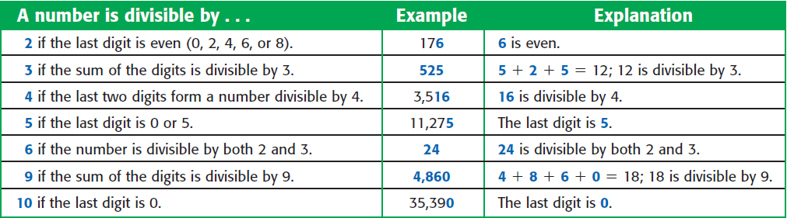

|  |  |  |  |  |  |  |  |
| --- | --- | --- | --- | --- | --- | --- | --- |
| NUMBER | 2 | 3 | 4 | 5 | 6 | 9 | 10 |
| 15 |  |  |  |  |  |  |  |
| 27 |  |  |  |  |  |  |  |
| 36 |  |  |  |  |  |  |  |
| 102 |  |  |  |  |  |  |  |
| 268 |  |  |  |  |  |  |  |
| 4,518 |  |  |  |  |  |  |  |
| 93 |  |  |  |  |  |  |  |
| 144 |  |  |  |  |  |  |  |
| 256 |  |  |  |  |  |  |  |
| 450 |  |  |  |  |  |  |  |
| 4,500 |  |  |  |  |  |  |  |

****************************

Check the given column if the NUMBER is divisible by that number

For more practice, go to <http://www.mathwarehouse.com/arithmetic/numbers/divisibility-quiz.php> and make your own on-line quiz.