Name: __________________________ #
Math 8 Homework: Rotations Day 2

- A. Plot ΔABC with coordinates A(1 , 3) B(5, 3) and C(3,0).
  - Rotate ΔABC 90 about the origin. Call the
image A’B’C’.
A’ ( , )
B’ ( , )
C’ ( , )

  - Translate ΔA’B’C’ four units right and six
units down. Call the image A’’B’’C’’.
A’’ ( , )
B’’ ( , )
C’’ ( , )

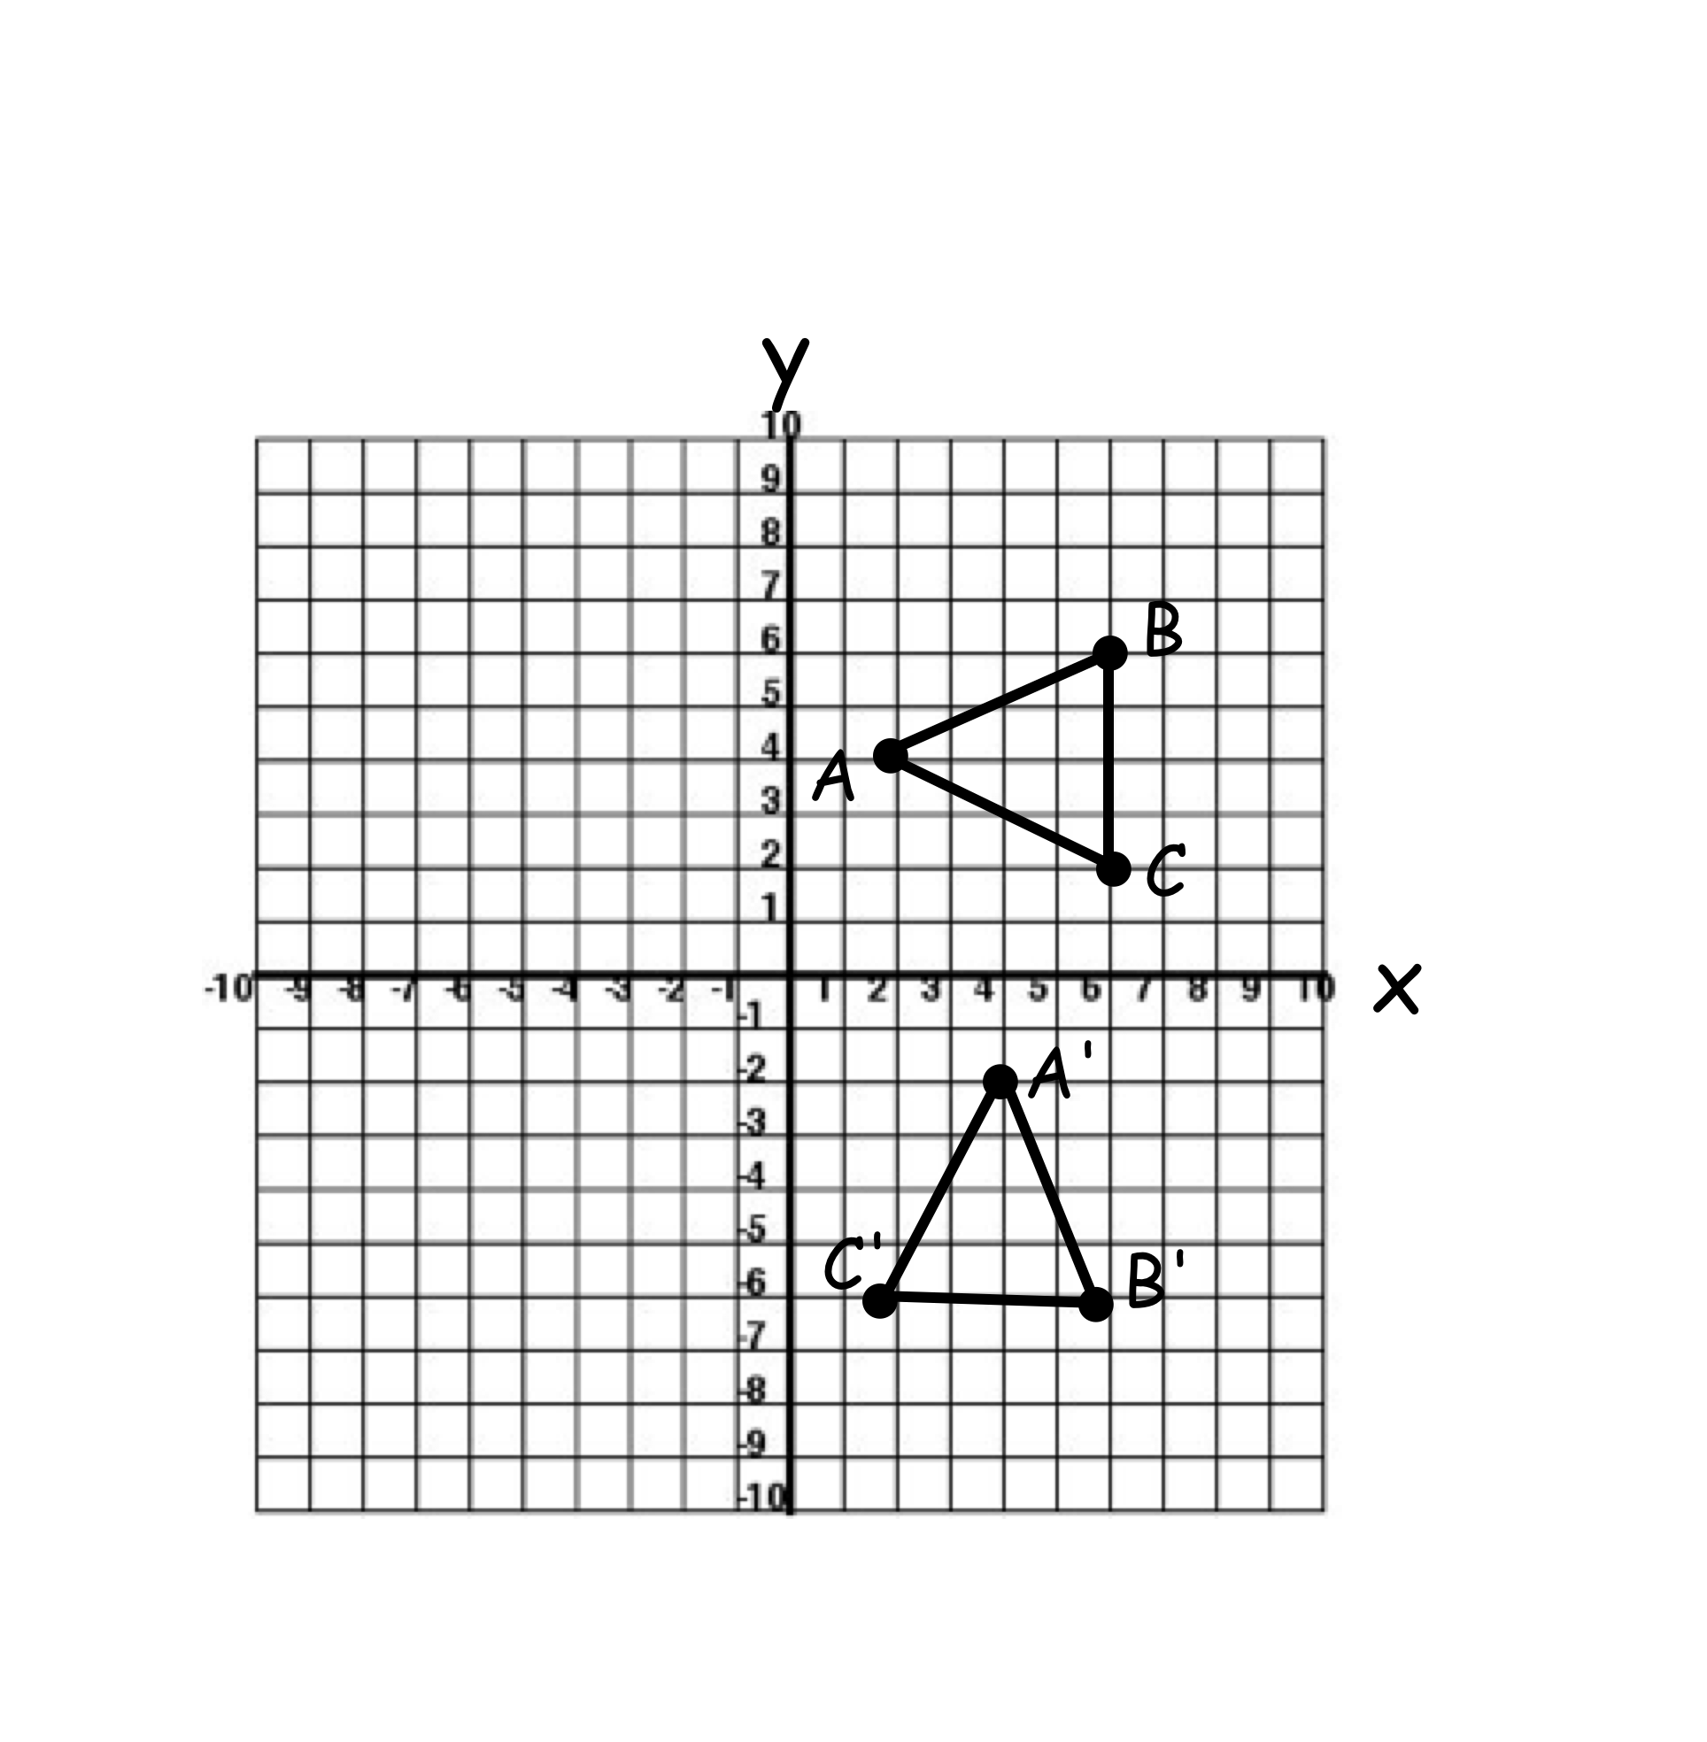

- The transformation shown to the right is best described as
  - A reflection over the x axis
  - A reflection over the y axis
  - A point reflection in the origin
  - A rotation

- If point (3, 8) is reflected in the y-axis, the image is located in what quadrant?

4) Name TWO transformations that lead to the transformation below. (Example: it was reflected and then rotated 90°.)

- a. Graph the line x = -1.

b. Reflect the Δ APT over the line x = -1.

A’ ( , )
P’ ( , )
T’ ( , )

- If a triangle is rotated 180°, which of the following is true?
  - The perimeter of the image will be greater than the perimeter of the pre-image.
  - The image will be congruent to its pre-image
  - The area of the image will be greater than the area of the pre-image.
  - The side lengths of the pre-image will be less than the image.

- A point (2, 5) is translated under the rule (x , y) ⇒ (x – 3, y + 9) . What will be the coordinates of the image?

- a. Graph the line y = x.

b. Reflect rectangle ABCD over the line y = x.
Call the image A’B’C’D’.
A’ ( , )
B’ ( , )
C’ ( , )
D’ ( , )

c. Rotate ABCD 180°. Call the image A’’B’’C’’D’’

A’’ ( , )
B’’ ( , )
C’’ ( , )
D’’ ( , )

REVIEW:

- Solve the system of equations graphically.
y = ½ x – 2
x + 3y = 9

CHECK CHECK

- Find y using similar triangles.

- The mass of the moon is about 8 x 10²² kg. The mass of the sun is about 2 x10³⁰. How many times greater is the mass of the sun compared to the mass of the moon?

- The table below shows the y, number of miles, Ken can drive in his car with x number of gallons of gas. The equation y = 35x shows the number of miles Alyssa can drive her car on x gallons of gas. Who gets better gas mileage?
x | 3 | 6 | 9
Y | 84 | 168 | 252

