Name:________________________________________________________________Date:_________________ P#:______________________
The Scientific Method and Elements of an Experiment ^{8/10 Brown}
Keep this sheet in your binder all year!!!!!!!

1) Identify the Problem and/or Purpose of the Experiment -
Identify the question you are trying to solve or what you are trying to test by doing an experiment.
- You are trying to see whether something affects something else. (These are the IV and the DV.)
- The problem should always be written as a question.
- The problem must include both your independent and dependent variables.
- The problem statement will be used to form a hypothesis that can be tested using an experiment.

Independent Variable (IV) – This is the variable being tested.

Dependent Variable (DV) – This is what changes as a result of changing the independent variable.
- This is what is being measured in an experiment.
- It is not being changed directly. (A doctor can’t directly cure an illness (DV), but a specific treatment like a medicine (IV) might.)

There are many ways of looking at the IV and DV. Use whichever one works for your situation.
One Way>>>>>> | IV= “The Cause” | DV= “The Effect”
Another Way >>> | IV= “I change it.” | DV= “It changed”
Another Way >>> | IV= “The Reason for the Data being different.” | DV= “The Data”

Example:
Problem: Which type of salt (rock salt, table salt or Epson salt) will melt ice the fastest?
IV: different types of salt DV: how fast the ice will melt

2) Hypothesis – An educated guess in the form of a statement. A hypothesis is your best prediction or explanation to solve a problem. Do not use words like we, I, our, my… nor words like feel, believe, predict, prove…

One proper way to write a hypothesis is…

IF the Independent Variable is (describe how you are changing or testing it) THEN the Dependent Variable will (describe how it would change after your test), BECAUSE ………………………

Example: IF the level of exercise increases THEN the heart rate will increase, BECAUSE the heart will have to pump faster to transport oxygen to the parts of the body that are using it.
IV: level of exercise DV: heart rate level

3) Experimental Design

Materials – This is a specific list of everything that is needed to do an experiment including sizes and amounts in SI Metric units.

Procedure – Step by step instructions about how to do an experiment. Anyone using this should be able to repeat your steps exactly.
- The steps should be numbered, and include specific amounts and units.
- Do not include pronouns or subjective language. It is about the procedure, not about you doing the procedure.
- Use the phrase “Assemble materials as show in the diagram below.”, and then draw a diagram of how your experiment will be set up. It will save you a lot of writing, and be clearer to the person reading the lab.
- The procedure must include constants and in most cases a control.

Constants – are conditions that are kept the same in an experiment. Constants are needed to make the results accurate. You can usually include all the things in the environment that will be the same with both the experimental group and the control group. Have at least five. The IV is never a constant. (NOTE: These are also called “Controlled Variables” by Scientists, but don’t get confused with what’s next…)

Control aka Control Group– a control is a comparison used to show what happens when no change is made. It is used to compare the effect of the change of the independent variable. Many times you can think of the control group as the same thing as the experiment group with no independent variable. We call the experiment part by itself the Experiment Group or Experimental Group. Most good experiments have an experimental group and a control group.

4) Data- The data section of a lab report displays the data that was collected during an experiment.
Just state the facts in this section (no conclusions or judgments). You may objectively present your data as a
1) data table, 2) a graph, 3) a narrative summary, 4) photographs, and/or 5) diagrams.

There are two types of data:
- Qualitative Data – descriptive data that is based on observations
- Quantitative Data – numeric data that is based on measurements

Data Tables should be labeled properly, include all units used, and if timed should start with time at 0. Title:

DATA TABLE: The effect of the Independent Variable on the Dependent Variable
Time (Mins) | Temperature of Flask 1 | Temperature of Flask 2 (Control)
0 (Start) | 21° C | 21° C
10 | 27° C | 22° C

Quantitative data can be displayed in a number of different ways such as bar graphs, pie charts, line graphs, and scatter plots. For most charts and graphs, the IV is on the x – axis and the DV is on the y – axis.

WHICH TYPE OF GRAPH TO USE?
Numbers and Numbers > Use a LINE GRAPH
Numbers and Words > Use a BAR (COLUMN) GRAPH
Title: The effect of the Independent Variable on the Dependent Variable
GRAPH:
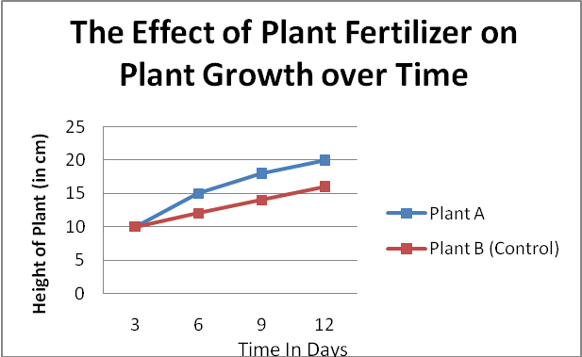

Graphs and charts should be neat – use a ruler. The informative title should include the IV and DV. Include all units.

5) Conclusion- The conclusion of a lab report is written in paragraph form.
In a conclusion you should….
- …restate the problem and hypothesis.
- …explain how the data obtained in the experiment supported or did not support your hypothesis – using specific examples If the data was inconclusive, explain why. (Do not try to make your data fit what you wished happened. Be honest and explain why it didn’t.)
* Do not use the word proved. It is bad form, and denotes absolutely no possibility of error.
* Explain at least three sources of actual or possible scientific error and how it could have made your data less accurate or different.

