**Name:______________________________________________Date:_________Per:________**

**10.2: Graph Quadratics in the Form *y* = *ax*² + *bx* + *c***

**Worksheet 1**

**Find the axis of symmetry and the vertex. Then graph the parabola by graphing points surrounding the vertex.**

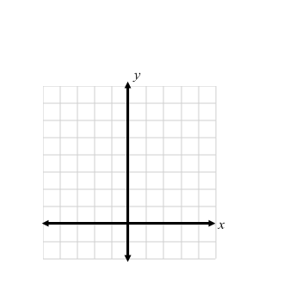

**1.** *y* = –4*x*² + 4*x* + 3 **2.** *y* = 7*x*² – 14*x* + 6

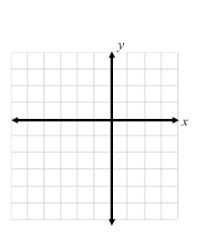

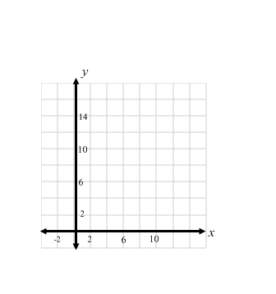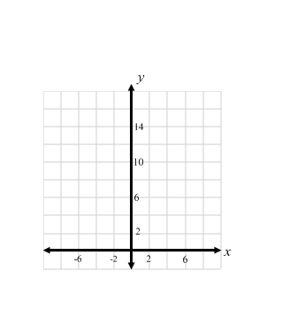**3.** *y* = 6*x*² – 12*x* + 13  **4. **

**5.  6.** *y* = –3*x*² + 18*x* – 4

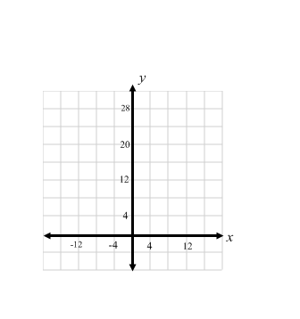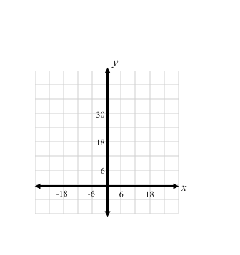

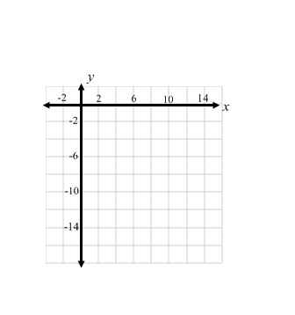**7.** *y* = *x*² + 2*x* + 5 **8.** *y* = *x*² – 8*x* + 1

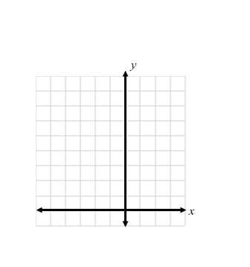

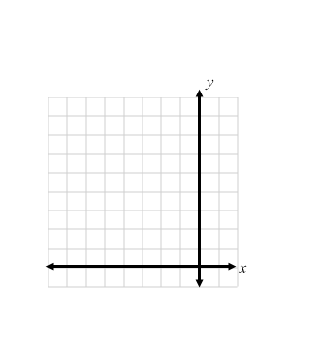**9.** *y* = –*x*² – 4*x* + 3 **10.** *y* = –2*x*² + 2*x* + 1

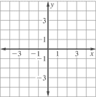

**11.** *y* = *x*² – 8*x*+ 5 **12. **

