**Name:_____________________________________Date:_____________Per:__________**

**10.2: Graph Quadratics in the Form *y* = *ax*² + *bx* + *c***

**Worksheet 2**

**Find the axis of symmetry and the vertex. Then graph the parabola by graphing points surrounding the vertex.**

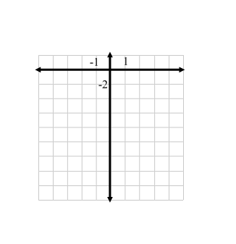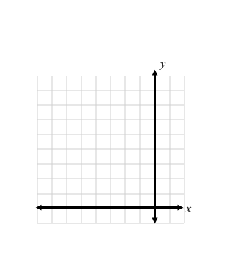

**1.** *y* = *x*² + 7*x* + 12 **2.** *y* = *x*² – *x* – 12

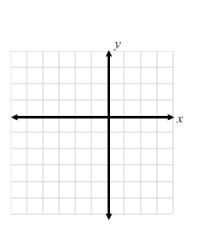

**3.** *y* = *x*² – 4*x* + 5 **4.** *y* = *x*² + 7*x* + 9

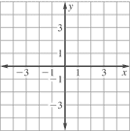

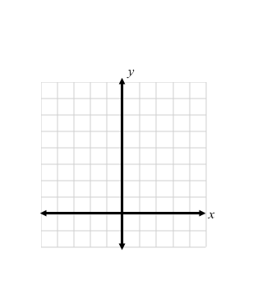**5.** *y* = *x*² – *x* – 4 **6.** *y* = *x*² – 4*x* + 6



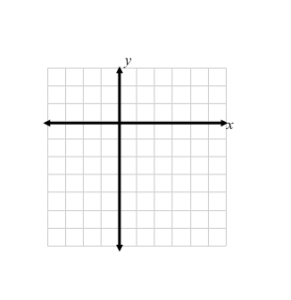

**7.** *y* = *x*² – 4*x* – 1 **8.** *y* = 4*x*² – 12*x* + 3

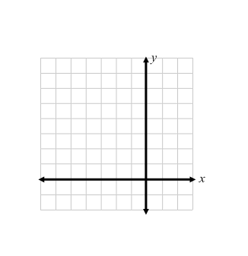

**9.** *y* = *x*² – 2*x* – 4 **10.** *y* = *x*² + 6*x* + 8

