**Name:**_____________________________________**Date:**____________**Period:**____________

**4.4 SLOPE**

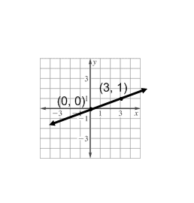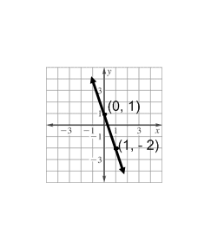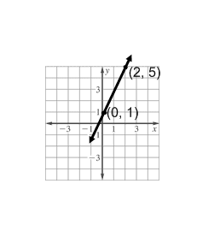**Worksheet 283**

**Find the slope of the line that passes through each pair of points.**

**1. 2. 3.**

**4.** (2, 5), (3, 6) **5.** (6, 1), (–6, 1) **6.** (4, 6), (4, 8)

**7.** (5, 2), (5, –2) **8.** (2, 5), (–3, –5) **9.** (9, 8), (7, –8)

**10.** (–5, –8), (–8, 1) **11.** (–3, 10), (3, 7) **12.** (17, 18), (18, 17)

**13.** (–6, –4), (4, 1) **14.** (10, 0), (–2, 4) **15.** (2, –1), (–8, –2)

**16.** (5, –9), (3, –2) **17.** (12, 6), (3, –5) **18.** (–4, 5), (–8, –5)

**Find the value of *r* so the line passes through each pair of points has the given slope.**

**20.** (*r*, 3), (5, 9), *m* = 2 **21.** (5, 9), (*r*, –3), *m* = –4

**22.** (*r*, 2), (6, 3), *m* = $\frac{1}{2}$**23.** (*r*, 4), (7, 1), *m* = $\frac{3}{4}$

**24.** (5, 3), (*r*, –5), *m* = 4 **25.** (7, *r*), (4, 6), *m* = 0

**Name:**_____________________________________**Date:**____________**Period:**____________

**SLOPE**

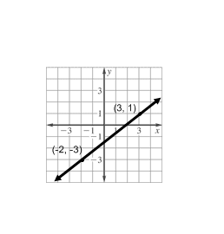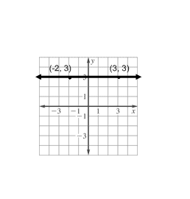**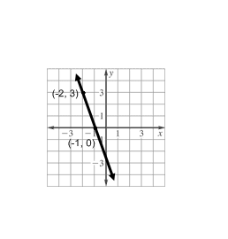Worksheet 284**

**Find the slope of the line that passes through each pair of points.**

**1. 2. 3.**

**4.** (6, 3), (7, –4)  **5.** (–9, –3), (–7, –5) **6.** (6, –2), (5, –4)

**7.** (7, –4), (4, 8) **8.** (–7, 8), (–7, 5) **9.** (5, 9), (3, 9)

**10.** (15, 2), (–6, 5) **11.** (3, 9), (–2, 8) **12.** (–2, –5), (7, 8)

**13.** (12, 10), (12, 5) **14.** (0.2, –0.9), (0.5, –0.9) **15. $\left(\frac{7}{3},\frac{4}{3}\right),\left(-\frac{1}{3},\frac{2}{3}\right)$**

**Find the value of *r* so the line that passes through each pair of points has the given slope.**

**16.** (–2, *r*), (6, 7), *m* = $\frac{1}{2}$**17.** (–4, 3), (*r*, 5), *m* = $\frac{1}{4}$**18.** (–3, –4), (–5, *r*), *m* = $-\frac{9}{2}$

**19.** (–5, *r*), (1, 3), *m* = $\frac{7}{6}$**20.** (1, 4), (*r*, 5), *m* undefined **21.** (–7, 2), (–8, *r*), *m* = –5

**22.** (*r*, 7), (11, 8), *m* = $-\frac{1}{5}$**23.** (*r*, 2), (5, *r*), *m* = 0

**24. ROOFING** The *pitch* of a roof is the number of feet the roof rises for each 12 feet horizontally. If a roof has a pitch of 8, what is its slope expressed as a positive number?

**25. SALES** A daily newspaper has 12,125 subscribers when it began publication. Five years later, it had

10,100 subscribers. What is the average yearly rate of change in the number of subscribers for the five-year period?