**Name:**__________________________________________**Date:**____________**Period:**_______

**WRITING EQUATIONS OF PARALLEL AND PERPENDICULAR LINES**

**Worksheet 311**

**Write the slope-intercept form for an equation of the line that passes through the given point and is parallel to the graph of each equation.**

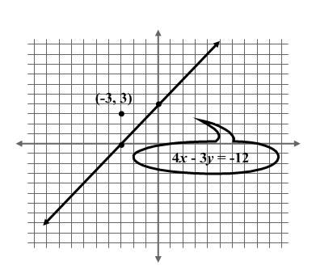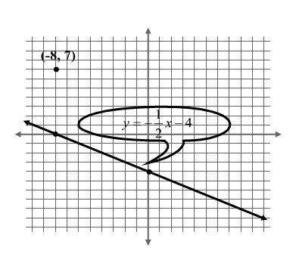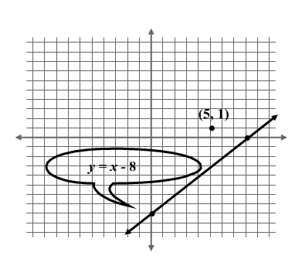

**1. 2. 3.**

**4.** (–2, 2)**,** *y* = 4*x* – 2 **5.** (6, 4), *y* = $\frac{1}{3}$*x* + 1 **6.** (4, –2), *y* = – 2*x* + 3

**7.** (–2, 4), *y* = – 3*x* + 10 **8.** (–1, 6), 3*x* + *y* = 12 **9.** (4, –6), *x* + 2*y* = 5

**10.**  Find an equation of the line that has a *y*-intercept of 2 that is parallel to the graph of the line 4*x* + 2*y* = 8

**11.**  Find an equation of the line that has a *y*-intercept of –1 that is parallel to the graph of the line *x* – 3*y* = 6

**12.** Find the equation of the line that has a y-intercept of –4 that is parallel to the graph of the line *y* = 6

**WRITING EQUATIONS OF PARALLEL AND PERPENDICULAR LINES**

**Worksheet 312**

**Write the slope-intercept form for an equation of the line that passes through the given point and is perpendicular to the graph of each equation.**

**1.** (4, 2), *y* = $\frac{1}{2}$*x* + 1 **2.** (2, –3), *y* = $-\frac{2}{3}$*x* + 4 **3.** (6, 4), *y* = 7*x* + 1

**4.** (–8, –7), *y* = –*x* – 8 **5.** (6, –2), *y* = –3*x* – 6 **6.** (–5, –1), *y* = $\frac{5}{2}$*x* – 3

**7.** (–9, 5), *y* = –3*x* – 1 **8.** (–1, 3), 2*x* + 4*y* = 12 **9.** (6, –6), 3*x* – *y* = 6

**10.** Find the equation of the line that has a *y*-intercept of –2 and is perpendicular to the graph of the

line *x* – 2*y* = 5.

**11.** Find the equation of the line that has a *y*-intercept of 5 and is perpendicular to the graph of the

line 4*x* + 3*y* = 8.