**Name:____________________________________________Date:___________Period:_____**

**Writing Equations of Parallel and Perpendicular Lines**

**Worksheet 313**

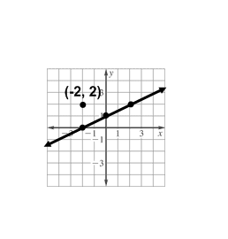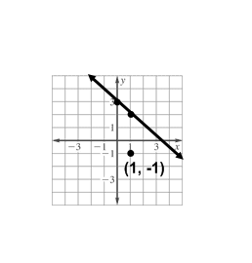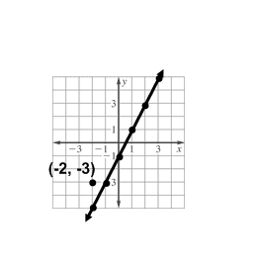

**Write the slope-intercept form of an equation of the line that passes through the given point and is parallel to the graph of each equation.**

**1. 2. 3.**

**4.** (3, 2), *y* = 3*x* +4 **5.** (–1, –2), *y* = –3*x* + 5 **6.** (–1, 1), *y* = *x* – 4

**7.** (1, –3), *y* = –4*x* – 1  **8.** (–4, 2), *y* = *x* + 3 **9.** (–4, 3), *y* = $\frac{1}{2}$*x* – 6

**10.** (4, 1), *y* = – $\frac{1}{4}$*x* + 7 **11.** (–5, –1), 2*y* = 2*x* – 4 **12.** (3, –1), 3*y* = *x* + 9

**Write the slope-intercept form of an equation of the line that passes through the given point and is perpendicular to the graph of each equation.**

**13.** (–3, –2), *y* = *x* + 2 **14.** (4, –1), *y* = 2*x* – 4 **15.** (–1, –6), *x* + 3*y* = 6

**16.** (–4, 5), *y* = –4*x* – 1 **17.** (–2, 3), *y* = $\frac{1}{4}$*x* – 4 **18.** (0, 0), *y* = $\frac{1}{2}$*x* – 1

**19.** (3, –3), *y* = $\frac{3}{4}$*x* + 5 **20.** (–5, 1), *y* = – $\frac{5}{3}$*x* – 7 **21.** (0, –2), *y* = –7*x* + 3

**22.** (2, 3), 2*x* + 10*y* = 3 **23.** (–2, 2), 6*x* + 3*y* = –9 **24.** (–4, –3), 8*x* – 2*y* = 16

**Name:____________________________________________Date:___________Period:_____**

**Worksheet 314**

**Write the given slope-intercept form of an equation of the line that passes through the given point and is parallel to the graph of each equation.**

**1.** (3, 2), *y* = *x* + 5 **2.** (–2, 5), *y* = –4*x* + 2 **3.** (4, –6), *y* = - $\frac{3}{4}$*x* + 1

**4.** (5, 4), *y* = $\frac{2}{5}$*x* – 2 **5.** (12, 3), *y* = $\frac{4}{3}$*x* + 5 **6.** (3, 1), 2*x* + *y* = 5

**7.** (–3, 4), 3*y* = 2*x* – 3 **8.** (–1, –2), 3*x* – *y* = 5 **9.** (–8, 2), 5*x* – 4*y* = 1

**10.** (–1, –4), 9*x* + 3*y* = 8 **11.** (–5, 6), 4*x* + 3*y* = 7 **12.** (3, 1), 2*x* + 5*y* = 7

**Write the slope-intercept form of an equation of the line that passes through the given point and is perpendicular to the graph of each equation.**

**13.** (–2, –2), *y* = $-\frac{1}{3}$*x* + 9 **14.** (–6, 5), *x* – *y* = 5 **15.** (–4, –3), 4*x* + *y* = 7

**16.** (0, 1), *x* + 5*y* = 15 **17.** (2, 4), *x* – 6*y* = 2 **18.** (–1, –7), 3*x* + 12*y* = 6

**19.** (–4, 1), 4*x* + 7*y* = 6 **20.** (10, 5), 5*x* + 4*y* = 8 **21.** (4, –5), 2*x* – 5*y* = –10

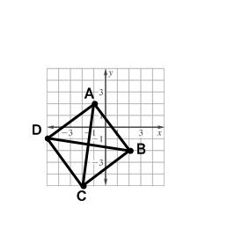

**22.** (1, 1), 3*x* + 2*y* = –7 **23.** (–6, –5), 4*x* + 3*y* = –6 **24.** (–3, 5), 5*x* – 6*y* = 9

**25.** **GEOMETRY** Quadrilateral *ABCD* has diagonals $\overline{AC}$ and $\overline{BD}$.

Determine whether $\overline{AC}$ is perpendicular to $\overline{BD}$. Explain.

**26. GEOMETRY** Triangle *ABC* has vertices A(0, 4), B(1, 2),

and C(4, 6). Determine whether triangle *ABC* has a right triangle. Explain.