**Name**:________________________________________**Date**:___________**Period**:__________

**Worksheet 299**

**Write an equation of the line that passes through each pair of points.**

**1.** (–1, 6), (7, –10) **2.** (0, 2), (1, 7) **3.**  (6, –25), (–1, 3)

**4.** (–2, –1), (2, 11) **5.** (10, –1), (4, 2) **6.** (–14, –2), (7, 7)

**7.** Write an equation of a line that passes through the *x*-intercept 4 and the *y*-intercept –2.

**8.** Write and equation of a line that passes through the *x*-intercept –3 and *y*-intercept 5.

**9.** Write an equation of a line that passes through (0, 16) and (–10, 0)

**Write an equation of the line that passes through each point with the given slope.**

**10.** (8, 2), *m* = – $\frac{3}{4}$**11.** (–1, –3), *m* = 5 **12.** (4, –5), *m* = – $\frac{1}{2}$

**13.** (–5, 4), *m* = 0 **14.** (2, 2), *m* = $\frac{1}{2}$**15.** (1, –4), *m* = –6

**16.** Write an equation of a line that passes through the *y*-intercept –3 with slope 2.

**17.** Write an equation of a line that passes through the *x*-intercept 4 with slope –3.

**18.** Write and equation of a line that passes through the point (0, 350) with slope of $\frac{1}{5}$.

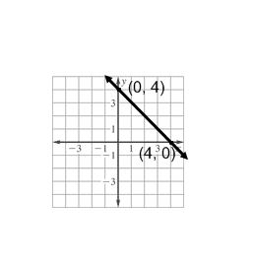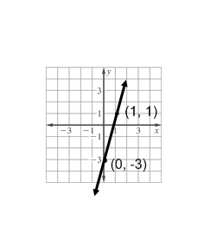**Write the equation of the line represented by the graph.**

**19. 20.**

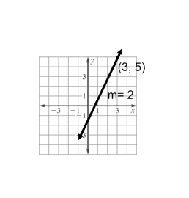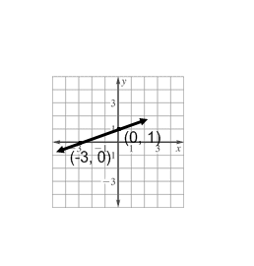

**21. 22.**

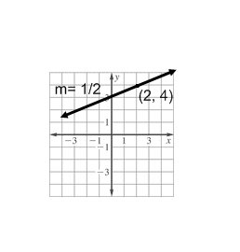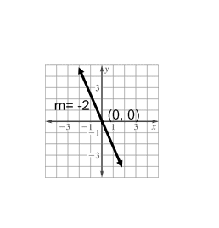

**23. 24.**

**25.** You are taking a Tae Kwon Do class that costs $15 a month. In addition, you need to purchase a uniform. You paid a total of $108 after 6 months. Find the cost of the uniform and then write an equation to represent the total cost you would pay after any number of months.