**Name:_____________________________________________Date:______________Per:_____**

**Worksheet 301**

**Write the equation of the line that passes through each point with the given slope.**

**1.** (1, 9), *m* = 4 **2.** (4, 2), *m* = –2 **3.** (2, –2), *m* = 3

**4.** (3, 0), *m* = 5 **5.** (–3, –2), *m* = 2 **6.** (–5, 4), *m* = –4

**Write the equation of the line that passes through each pair of points.**

**7.** (1, 3), (–3, –5) **8.**  (1, 4), (6, –1) **9.** (1, –1), (3, 5)

**10.** (–2, 4), (0, 6) **11.** (3, 3), (1, –3) **12.** (–1, 6), (3, –2)

**Write an equation of the line that has each pair of intercepts.**

**13.** *x*-intercept: –3, *y*-intercept: 6 **14.** *x*-intercept: 3, *y*-intercept: 3

**15.** *x*-intercept: 1, *y*-intercept: 2 **16.** *x*-intercept: 2, *y*-intercept: –4

**17.**  *x*-intercept: –4, *y*-intercept: –8 **18.**  *x*-intercept: –1, *y*-intercept: 4

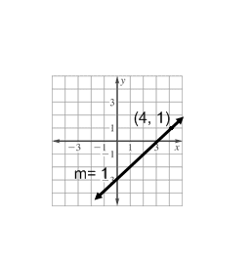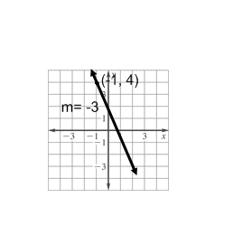**Write the equation of the line represented by the graph.**

**19. 20.**

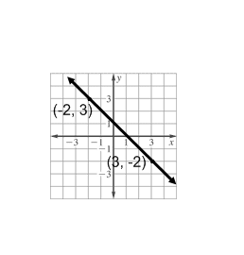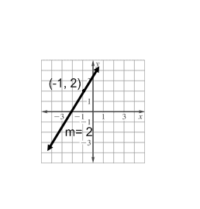

**21. 22.**

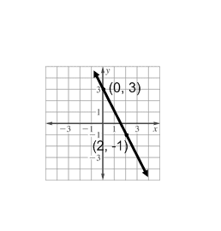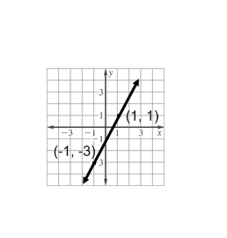

**23. 24.**