**Name:___________________________________________________Date:___________Per:_________**

**Write Equations in Slope-Intercept Form**

**Worksheet 302**

**Write the equation of the line that passes through each point with the given slope.**

**1.** (–5, 4), *m*= –3 **2.** (4, 3), *m*= $\frac{1}{2}$**3.** (1, –5), *m*= $-\frac{3}{2}$

**Write the equation of the line that passes through each pair of points.**

**4.** (0, –4), (5, –4) **5.** (–4, –4), (4, 0) **6.** (–2, –3), (4, 5)

**7.** (0, 1), (5, 3) **8.** (–3, 0), (1, –6) **9.**  (1, 0), (5, –1)

**Write an equation of the line that has each pair of intercepts.**

**10.** *x*-intercept: 2, *y*-intercept: –5 **11.**  *x*-intercept: 2, *y*-intercept: 10

**12.** *x*-intercept: –2, *y*-intercept: 1 **13.** *x*-intercept: –4, *y*-intercept: –3

**14. DANCE LESSONS** The cost for 7 dance lessons in $82. The cost for 11 lessons is $122. Write a linear equation to find the total cost *C* for *l* lessons. Then use the equation to find the cost of 4 lessons.

**15. WEATHER** It is 76ºF at the 6000-foot level of a mountain, and 49ºF at the 12,000-foot level of the mountain. Write a linear equation to find the temperature *T* at an elevation *e* on the mountain, where *e* is in the thousands of feet.

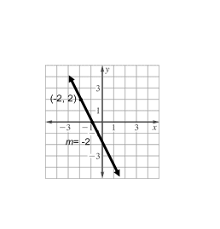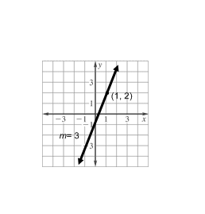**Write the equation of the line graphed.**

**16. 17.**

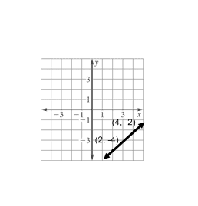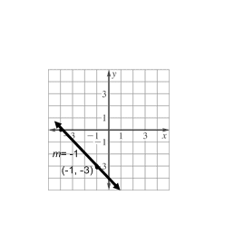

**18. 19.**

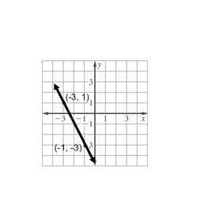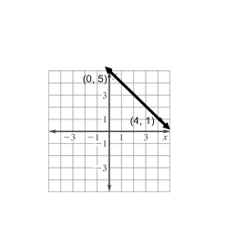

**20. 21.**