**Name**:_______________________________________**Date**:______________**Period**:_______

**Solve Multi-Step Inequalities - Worksheet 343**

**Solve each inequality. Then check your solution, and graph it on a number line.**

**1***. t* – 12 ≥ 16 **2.** *n* – 12 < 6 **3.**  6 ≤ *g* – 3

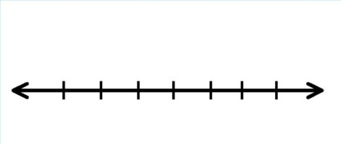

**4.** *n* – 8 < – 13 **5.** –12 > – 12 + *y* **6.**  –6 > *s* – 8



**Solve each inequality. Then check your solution.**

**7.** –3*x* ≤ 8 – 4*x* **8.**  0.6*n* ≥ 12 – 0.4*n* **9.** –8*k* – 12 < –9*k*

**10.** –*y* – 10 > 15 – 2*y* **11.** *z* – $\frac{1}{3}$ ≤ $\frac{4}{3}$**12.** –2*b* > –4 – 3*b*

**Define a variable, write an inequality, and solve each problem. The check your solution.**

**13.** A number decreased by 4 is less than 14.

**14.** The difference of two numbers is more than 12, and one of the numbers is 3.

**15.** Forty is no greater than the difference of a number and 2.

**Name:**_________________________________________**Date:**____________**Period:**_______**Solve Multi-Step Inequalities - Worksheet 344**

**Solve each inequality. Then check your solution, and graph it on the number line.**

**1.** *t* + 12 ≥ 8 **2.**  *n* + 12 > –12 **3.**  16 ≤ *h* + 9



**4.**  *y* + 4 > –2 **5.** 3*r* + 6 > 4*r* **6. $\frac{3}{2}$** *q* – 5 ≥ $\frac{1}{2}$*q*



**Solve each inequality. Then check your solution.**

**7.** 4*p* ≥ 3*p* + 0.7 **8.** *r* + $\frac{1}{4}$ > $\frac{3}{8}$**9.** 9*k* + 12 > 8*k*

**10.** –1.2 > 2.4 + *y*  **11.**  4*y* < 5*y* + 14 **12.**  3*n* + 17 < 4*n*

**Define a variable, write an inequality, and solve each problem. Then check your solution.**

**13.** The sum of a number and 8 is less than 12.

**14.** The sum of two numbers is at most 6, and one of the numbers is –2.

**15.** The sum of a number and 6 is greater than or equal to –4.