**Name:**________________________________________**Date:**_____________**Period:**_______

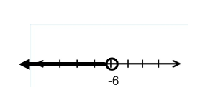**Solve Inequalities - Worksheet 345**

**Match each inequality with its corresponding graph.**

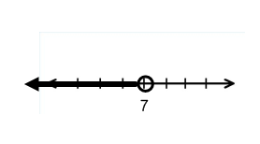

**1.** *x* + 11 > 16 **a)**

**2.** *x* – 6 < 1 **b)**

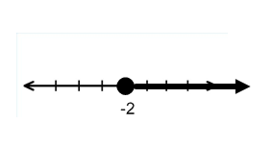

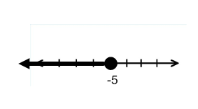

**3.** *x* + 2 $≤$–3 **c)**

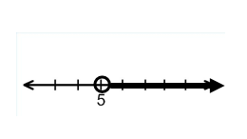

**4.** *x* + 3 ≥ 1 **d)**

**5.** *x* – 1 < –7 **e)**

**Solve each inequality. Then check your solution, and graph it on a number line.**

**6.** *d* – 5 ≤ 1 **7.**  *s* + 9 < 8  **8.** *a* – 7 > –13

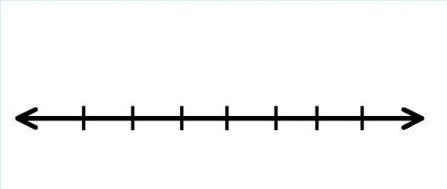

**9.** *w* – 1 < 4 **10.**  4 ≥ *k* + 3 **11.** –9 ≤ *b* – 4



**12.** –2 ≥ *x* + 4 **13.**  2*y* < *y* + 2



**Define a variable. Write an inequality, and solve each problem. Then check your solution.**

**14.** A number decreased by 10 is greater than –5.

**15.** A number increased by 1 is less than 9.

**16.** Seven more than a number is less than or equal to –18.

**17.** Twenty less than a number is at least 15.

**18.** A number plus 2 is at most 1.