**Name:**________________________________________**Date:**_____________**Period:**_______

**Solve Inequalities - Worksheet 346**

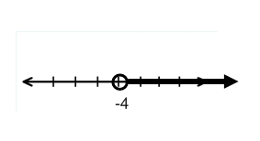**Match each inequality with its corresponding graph.**

**1.** –8 ≥ *x* – 15 **a)**

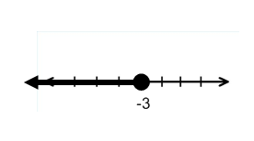

**2.** 4*x* + 3 < 5*x* **b)**

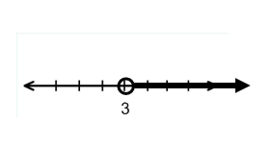

**3.** 8*x* > 7*x* – 4 **c)**

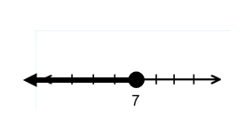

**4.** 12 + *x* ≤ 9 **d)**

**Solve each inequality. Then check your solution, and graph it on a number line.**

**5.** *r* – (– 5) > – 2 **6.** 3*x* + 8 ≥ 4*x* **7.** *n* – 2.5 ≥ –5

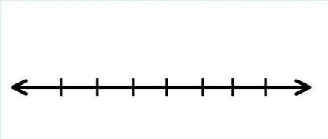

**8.**  1.5 < *y* + 1 **9.** *z* + 3 > $\frac{2}{3}$**10. $\frac{1}{2}$** ≤ *c* – $\frac{3}{4}$



**Define a variable, write an inequality, and solve each problem. Then check your solution.**

**11.** The sum of a number and 17 is no less than 26.

**12.** Twice a number minus 4 is less than three times the number.

**13.** Twelve is at most a number decreased by 7.

**14.** Eight plus four times a number is greater than five times the number.