**Name:**_________________________________________**Date:**____________**Period:**________

**Solve the following systems of equations by graphing.**

1. *x* – *y* = 6 **2.** 2*x* – 2*y* = –4 **3.** 2*x* – *y* = 1

2*x* + *y* = 0 *y* = 2 3*x* + *y* = –6

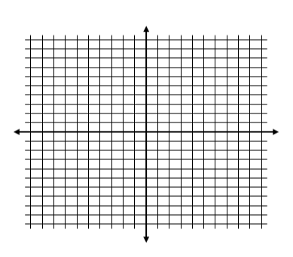

**4.** *x* + 2*y* = 4 **5.** 2*x* – *y* = 5 **6.** *x* = 3

2*x* *– y* = 8 *x* – *y* = 1 *y* = –2



**7.** *x* + *y* = 6 **8.** *x*– *y* = 4 **9.** 2*x* – *y* = 8

*x* – *y* = 0 *x* + *y* = 0 *x* + *y* = 1



**10.** *x* – *y* = 3 **11.** 5*x* + 2*y* = 10 **12.** *x* + *y* = –8

2*x* + *y* = 3 5*x* – 2*y* = 10 3*x* + *y* = –6

