**Name:__________________________________________Date:__________Period:________**

**Graphing Systems of Equations**

**Worksheet 404**

**Solve each system of equations by graphing. Be sure to state the solution.**

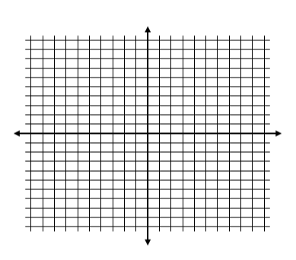**1.** *y* = –2 **2.** *x* = 2 **3.** *y* = $\frac{1}{2}$*x*

3*x* – *y* = –1 2*x* + *y* = 1 *x* + *y* = 3

**4.** 2*x* + *y* = 6 **5.** *x* + *y* = 3 **6.** *x* – *y* = –4

2*x* – *y* = –2 *x* – *y* = 5 3*x* – *y* = –10

**7.** *x* – *y* = –2 **8.** 4*x* – 2*y* = 8 **9.** *x* = 5

*x* + 2*y* = 10 *y* = 3 *y* = –1

**10.** 3*x* – 4*y* = 12 **11.** *x* = 4 **12.** *y* = 2*x* + 3

5*x* + 4*y* = –12 3*x* – 2*y* = 4 *y* = *x* + 6

**13.** 3*x* + 2*y* = 6 **14.** *x* – 2*y* = 1 **15.** *x* = 1

 *y* = *x* + 3 *x* + *y* = 1 *y* = –1

******16.** 2*y* = *x* + 3 **17.** *x* – *y* = 1 **18.** *x* + *y* = 5

 2*x* + *y* = –1 *x* + 2*y* = –2 *x* – *y* = 2

**19.** *y* = –*x* + 3 **20.** *x* + *y* = 3 **21.** *x* + *y* = 3

 *y* = –*x* – 2 2*x* + 2*y* = 6 *x* – 2*y* = 0