**Name:__________________________________________Date:____________Period:______**

**Graphing Systems of Inequalities**

**Worksheet 429**

**Solve each system of inequalities by graphing.**

**1.** *x* > –1 **2.** *y* > 2 **3.** *y* > *x* + 3

*y* ≤ –3 *x* < –2 *y* ≤ –1

**4.** *x* < 2 **5.** *x* + *y* ≤ –1 **6.** *y* – *x* > 4

 *y* – *x* ≤ 2 *x* + *y* ≥ 3 *x* + *y* > 2

**7.** *y* > *x* + 1 **8.** *y* ≥ –*x* + 2  **9.** *y* < 2*x* + 4

*y* ≥ –*x* + 1 *y* < 2*x* – 2 *y* ≥ *x* + 1

**Write a system of inequalities for each graph.**

**10. 11. 12.**

**Solve each system of inequalities by graphing.**



**13.** *y* > *x* – 2 **14.** *y* ≥ *x* + 2 **15.**  *x* + *y* ≥ 1

*y* ≤ *x* *y* > 2*x* + 3 *x* + 2*y* > 1



**16.**  *y* < 2*x* – 1 **17.**  *y* > *x* – 4 **18.**  2*x* – *y* ≥ 2

*y* > 2 – *x*  2*x* + *y* ≤ 2 *x* – 2*y* ≥ 2

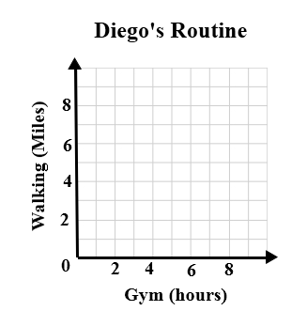**19. FITNESS** Diego started an exercise program in which each week he works out at a gym between 4.5 and 6 hours and walks between 9 and 12 miles. Write and graph a system of inequalities showing the number of hours he works out at the gym and number of miles he walks per week.

**20.** List 3 possible combinations of working out and

walking that meets Diego’s goal.