**Name:_____________________________________________Date:_________Per:________**

**Polynomials – Worksheet 475**

**State whether each expression is a polynomial. If yes, identify it as a *monomial*, *binomial,* *trinomial* or *polynomial*.**

**1. $5mn+n^{2}$**  **2. $4by+2b-by$**  **3.**  –32

**4. $\frac{3x}{7}$**  **5. $5x^{2}-3x^{-4}$**  **6. $2c^{2}+8c+9-3$**

**Find the degree of each polynomial.**

**7.** 12 **8. $3r^{4}$**  **9. $b+6$**

**10. $4a^{3}-2a$**  **11. $5abc-2b^{2}+1$**  **12. $8x^{5}y^{4}-2x^{8}$**

**Arrange the terms of each polynomial so that the powers of *x* are in descending order.**

**13. $3x+1+2x^{2}$**  **14. $3a^{2}x^{4}+14a^{2}-10x^{3}+ax^{2}$**  **15. $9x^{2}+2+x^{3}+x$**

**16. $-3+3x^{3}-x^{2}+4x$**  **17. $7r^{5}x+21r^{4}-r^{2}x^{2}-15x^{3}$**  **18. $5x-6+3x^{2}$**

**19. $x^{2}+3x^{3}+27-x$**  **20. $x-3x^{2}+4+5x^{3}$**  **21. $25-x^{3}+x$**

**22. $x^{2}+64-x+7x^{3}$**  **23. $2cx+32-c^{3}x^{2}+6x^{3}$**

**24. $13-x^{3}y^{3}+x^{2}y^{2}+x$**

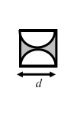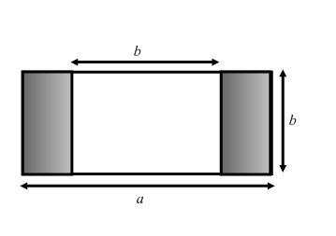

**Write a polynomial to represent the area of each shaded region.**

**25. 26.**