**Name:________________________________________Date:___________Per:__________**

**Polynomials – Worksheet 476**

**State whether each expression is a polynomial. If yes, identify it as a *monomial*, *binomial,* *trinomial* or *polynomial*.**

**1. $7a^{2}b+3b^{2}-a^{2}b$**  **2. $\frac{1}{5}y^{3}+y^{2}-9$**  **3. $6g^{2}h^{3}k$**

**Find the degree of each polynomial.**

**4. $x+3x^{4}-21x^{2}+x^{3}$**  **5. $3g^{2}h^{3}+g^{3}h$**  **6. $-2x^{2}y+3xy^{3}+x^{2}$**

**7. $5n^{3}m-2m^{3}+n^{2}m^{4}+n^{2}$**  **8. $a^{3}b^{2}c+2a^{5}c+b^{3}c^{2}$**  **9. $10s^{2}t^{2}+4st^{2}-5s^{3}t^{2}$**

**Arrange the terms of each polynomial so that the powers of *x* are in descending order.**

**10. $8x^{2}-15+5x^{5}$**  **11. $10bx-7b^{2}+x^{4}+4b^{2}x^{3}$**  **12. $-3x^{3}y+8y^{2}+xy^{4}$**

**13. $7ax-12+3ax^{3}+a^{2}x^{2}$**  **14. $13x^{2}-5+6x^{3}+2$**  **15. $4x+2x^{5}-6x^{3}+2$**

**16. $g^{2}x-3gx^{3}+7g^{3}+4x^{2}$**  **17. $-11x^{2}y^{3}+6y-2xy+2x^{4}$**

**18. $7a^{2}x^{2}+17-a^{3}x^{3}+2ax$**  **19. $12rx^{3}+9r^{6}+r^{2}x+8x^{6}$**

**20.** Write a polynomial to represent the value of *t* ten-dollar bills, *f* fifty-dollar bills, and *h* one-hundred-dollar bills.

**21.** The height above the ground of a ball thrown upward with a velocity of 96 feet per second from a height of 6 feet is: 6 + 96*t* – 16*t*² feet, where *t* is time in seconds. According to this model, how high is the ball after 7 seconds?

**Write a polynomial to represent the area of each shaded region.**

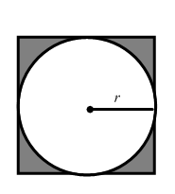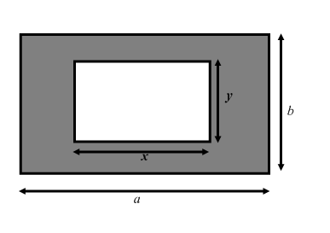

**23. 24.**