**Name: ___________________________________ Date: ______________ Period: ________**

**Multiplying Polynomials**

**Worksheet 493**

**Find each product.**

**1.** (*m* + 4)(*m* + 1) **2.** (*x* + 2)(*x* + 2) **3.** (*b* + 3)(*b* + 4)

**4.** (*t* + 4)(*t* – 3) **5.** (*r* + 1)(*r* – 2) **6.** (*z* – 5)(*z* + 1)

**7.** (3*c* + 1)(*c* – 2) **8.** (2*x* – 6)(*x* + 3) **9.** (*d* – 1)(5*d* – 4)

**10.** (2*l* + 5)(*l* – 4) **11.** (3*n* – 7)(*n* + 3) **12.** (*q* + 5)(5*q* – 1)

**13.** (3*b* + 3)(3*b* – 2) **14.** (2*m* + 2)(3*m* – 3) **15.** (4*c* + 1)(2*c* + 1)

**16.** (5*a* – 2)(2*a* – 3) **17.** (4*h* – 2)(4*h* – 1) **18.** (*x* – *y*)(2*x* – *y*)

**19.** (*e* + 4)( $e^{2}$ + 3*e* – 6) **20.** (*t* + 1)( $t^{2}$ + 2*t* + 4) **21.** (*k* + 4)( $k^{2}$ + 3*k* – 6)

**22.** (*m* + 3)( $m^{2}$ + 3*m* + 5)

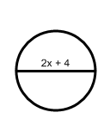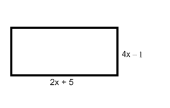**GEOMETRY Write an expression to represent the area of each figure.**

**23.** **24.**