**10.1: Graph *y* = *ax*² + *c***

**Goals:** *Graph quadratic functions by making a table

*Identify the vertex of a parabola

*Identify whether a quadratic function will have minimum or maximum point without graphing

*Identify characteristics of a parabola based on a quadratic equation

**\*RECALL (from Ch. 9)* quadratic function:** *y* = *ax*² + *bx* + *c*

**parabola:** U-shaped graph obtained by graphing a quadratic equation

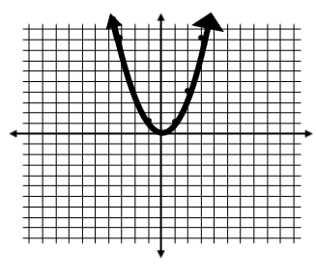

**Ex:** Graph *y* = *x*² by making a table:

|  |  |  |  |  |  |  |  |
| --- | --- | --- | --- | --- | --- | --- | --- |
| ***x*** | –3 | –2 | –1 | 0 | 1 | 2 | 3 |
| ***y*** | 9 | 4 | 1 | 0 | 1 | 4 | 9 |

*y* = *x*² is called the “Parent quadratic function”

you compare all other quadratic functions to it.

**vertex:** The highest (maximum) or lowest (minimum) point on a parabola

**axis of symmetry:** The **LINE** that passes through the vertex and divides the parabola into two symmetrical parts

**\*OBSERVATIONS\***

1. **Graph the following quadratic functions. Graph the odds by making a table and graph the evens by using a graphing calculator and copying it onto the graph provided.**
2. **For each parabola identify the vertex and axis of symmetry.**
3. **Compare each parabola to *y* = *x*² and begin to come up with some observations about characteristics of parabolas as they compare to their quadratic equations. (Ex: Direction it is facing/opening, narrowness/wideness, vertex)**

**1.  2. **

|  |  |  |  |  |  |  |  |
| --- | --- | --- | --- | --- | --- | --- | --- |
| ***x*** | –3 | –2 | –1 | 0 | 1 | 2 | 3 |
| ***y*** | 18 | 8 | 2 | 0 | 2 | 8 | 18 |

**Vertex: __(0, 0)_________ Vertex: __(0, 0)______**

**Axis of Symmetry: ____*x* = 0_________ Axis of Symmetry: ___ *x* = 0_____**

**3.  4. **

|  |  |  |  |  |  |  |  |
| --- | --- | --- | --- | --- | --- | --- | --- |
| ***x*** | –3 | –2 | –1 | 0 | 1 | 2 | 3 |
| ***y*** | –18 | –8 | –2 | 0 | –2 | –8 | –18 |

**Vertex: ___(0, 0)________ Vertex: ______(0, 0)______**

**Axis of Symmetry: ___*x* = 0_________ Axis of Symmetry: _*x* = 0______**

**5.  6. **

|  |  |  |  |  |  |  |  |
| --- | --- | --- | --- | --- | --- | --- | --- |
| ***x*** | –6 | –4 | –2 | 0 | 2 | 4 | 6 |
| ***y*** | 18 | 8 | 2 | 0 | 2 | 8 | 18 |

**Vertex: ___(0, 0)________ Vertex: ______(0, 0)______**

**Axis of Symmetry: ___*x* = 0_________ Axis of Symmetry: _*x* = 0______**

**7.  8. **

|  |  |  |  |  |  |  |  |
| --- | --- | --- | --- | --- | --- | --- | --- |
| ***x*** | –3 | –2 | –1 | 0 | 1 | 2 | 3 |
| ***y*** | 45 | 20 | 5 | 0 | 5 | 20 | 45 |

**Vertex: ___(0, 0)________ Vertex: ______(0, 0)______**

**Axis of Symmetry: ___*x* = 0_________ Axis of Symmetry: _*x* = 0______**

**9.  10. **

|  |  |  |  |  |  |  |  |
| --- | --- | --- | --- | --- | --- | --- | --- |
| ***x*** | –3 | –2 | –1 | 0 | 1 | 2 | 3 |
| ***y*** | 14 | 9 | 6 | 5 | 6 | 9 | 14 |

**Vertex: ___(0, 5)________ Vertex: __(0, –1)__________**

**Axis of Symmetry: ____*x* = 0_________ Axis of Symmetry: ____*x* = 0_____**

**11.  12. **

|  |  |  |  |  |  |  |  |
| --- | --- | --- | --- | --- | --- | --- | --- |
| ***x*** | –3 | –2 | –1 | 0 | 1 | 2 | 3 |
| ***y*** | 13 | 8 | 5 | 4 | 5 | 8 | 13 |

**Vertex: __(0, 4)_________ Vertex: __(0, –2)__________**

**Axis of Symmetry: ___*x* = 0__________ Axis of Symmetry: _____*x* = 0____**

**Now use your observations to sketch the graphs of the following quadratic functions:**

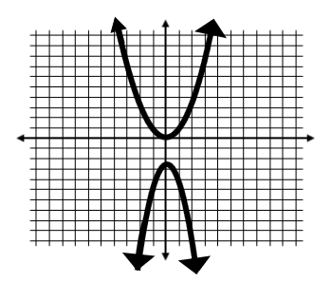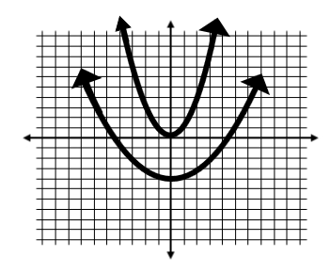**1.  2. **

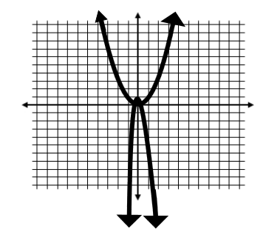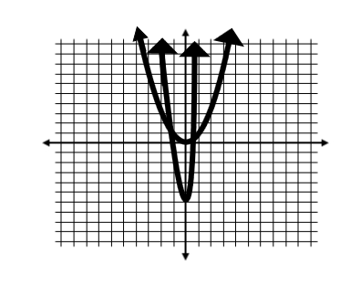**3.  4. **

**\*\*THOUGHTS TO CONSIDER\*\***

* **What makes a parabola narrower? If $\left|a\right|$ > 1, then the parabola will be narrower**
* **What makes a parabola wider? If $\left|a\right|$ < 1, then the parabola will be wider**
* **What makes a parabola open facing upward (U- shaped)? If *a* > 0, the parabola opens upward**
* **What makes a parabola open facing downward (∩ -shaped)? If *a*< 0, the parabola opens downward**
* **What shifts a parabola up on the *y*-axis? If *c* is being added (positive), then the parabola shifts up**
* **What shifts a parabola down on the *y*-axis? If *c* is being subtracted (negative) then the parabola shifts down**