**10.2: Graph *y* = *ax*² + *bx* + *c***

**Goals:** *Find axis of symmetry

*Find the vertex

*Graph a quadratic function by finding the axis of symmetry and vertex

**Properties of Graphs of Quadratic Functions**:

· If *a* > 0 then the parabola will be narrower than *y* = *x*²

*a* < 0 then the parabola will be wider than *y* = *x*²

· If  > 1 then the parabola will open upward

 < 1 then the parabola will open downward

· To find the axis of symmetry use: $x=-\frac{b}{2a}$

· The vertex always occurs: on the axis of symmetry

· so to find the vertex: plug in the *x*-value found by finding the axis of symmetry to find the *y*-value

· *y*-intercept: still the place where the parabola crosses the *y*-axis, still happens when *x* = 0

**For each quadratic function, find the axis of symmetry and the vertex. State whether the vertex is a minimum or maximum point.**

**Ex:** *y* = *x*² – 2*x* – 3 **Ex:** *y* = 3*x*² + 12*x* – 1

$x=\frac{2}{2}=1$ $x=\frac{12}{6}=2$

Vertex: (1, –4) Vertex: (2, 35)

Minimum Minimum

**For each quadratic function find the maximum or minimum value. State which it is.**

**Ex:** *y* = –3*x*² – 12*x* + 10 **Ex:** *f*(*x*) = 2*x*² – 16*x +* 4

Maximum: 22 Minimum: –28

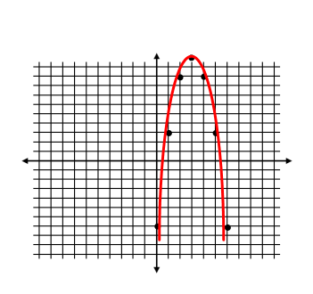**Graph. First find the vertex then choose 2 – 3 point around the vertex to complete the graph. Use your knowledge of characteristics of parabolas to ensure your final graph makes sense.**

**Ex:** *y* = –2*x*² + 12*x* – 7

*x* = 3 (3, 11)

|  |  |  |  |  |  |  |  |
| --- | --- | --- | --- | --- | --- | --- | --- |
| ***x*** | 0 | 1 | 2 | 3 | 4 | 5 | 6 |
| ***y*** | –7 | 3 | 9 | 11 | 9 | 3 | –7 |

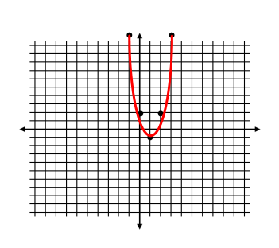

**Ex:** *y* = 3*x*² – 6*x* + 2

*x* = 1, (1, –1)

|  |  |  |  |  |  |  |  |
| --- | --- | --- | --- | --- | --- | --- | --- |
| ***x*** | –2 | –1 | 0 | 1 | 2 | 3 | 4 |
| ***y*** | 26 | 11 | 2 | –1 | 2 | 11 | 26 |

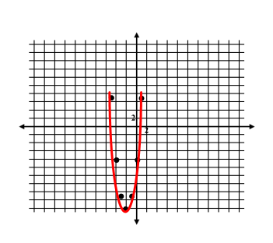

**Ex:** *y* = 3*x*² + 12*x* – 8

*x* = –2 , (–2, –20)

|  |  |  |  |  |  |  |  |
| --- | --- | --- | --- | --- | --- | --- | --- |
| ***x*** | –5 | –4 | –3 | –2 | –1 | 0 | 1 |
| ***y*** | 7 | –8 | –17 | –20 | –17 | –8 | 7 |

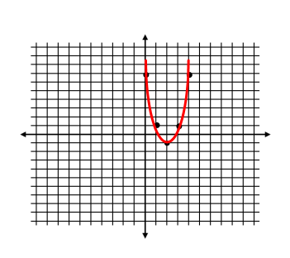**Ex:** *y* = 2*x*² – 8*x* + 7

*x* = 2 (2, –1)

|  |  |  |  |  |  |  |  |
| --- | --- | --- | --- | --- | --- | --- | --- |
| ***x*** | –1 | 0 | 1 | 2 | 3 | 4 | 5 |
| ***y*** | 17 | 7 | 1 | –1 | 1 | 7 | 17 |

**Ex:** The suspension cables between two towers of the Mackinac Bridge in Michigan form a parabola that can be modeled by the graph of *y* = 0.000097*x*² – 0.37*x* + 549 where *x* and *y* are measured in feet. What is the height of the cable at the lowest point?

The height is 196 feet above water. First find the axis of symmetry and then find the vertex, since that is where the minimum point will occur.

**Ex:** The cables between two telephone poles can be modeled by the equation *y* = 0.0024*x*² – 0.1*x* + 24, where *x* and *y* are measured in feet. To the nearest foot, what is the height of the cable above the ground at its lowest point?

Minimum Cable Height: 23 feet

**Ex:** The cables between the two towers of the Tacoma Narrows bridge form a parabola that can be modeled by the equation *y* = 0.00014*x*² – 0.4*x* + 507 where *x* and *y* are measured in feet. What is the height of the cable above the water at its lowest point? Round your answer to the nearest foot.

Minimum Cable Height: 221 feet