**10.3: Solve Quadratic Equations by Graphing**

**Goals:** *Identify solutions to a quadratic equation by graphing

*Approximate solutions of a quadratic equation to the nearest tenth

**RECALL**

A **quadratic equation** is: *y* = *ax*² + *bx* + *c*

A **solution** to a quadratic equation can also be called a: “Root”

**Solutions** or ___ROOTS____________ are the values of *x* so the quadratic equation is equal to: zero

**We already know how to solve a quadratic equation by: Factoring

Since we know that solutions occur when *y* = 0, how can you identify solutions on a graph then?

Look for the values of *x* when *y* = 0. *Y* = 0 on the *x*-axis. So we are looking for the points where the parabola crosses the *x*-axis

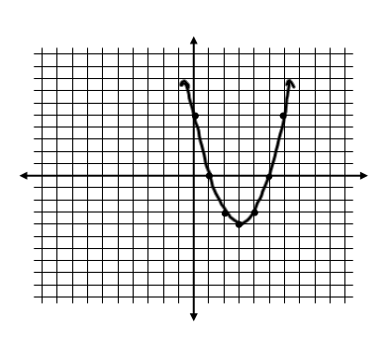**Ex:** The graph below models the parabola formed by the quadratic equation *y* = *x*² – 6*x* + 5. What do you think the solutions are? Why?

Solutions: *x* = 1 and *x* = 5

**Solve the following quadratic equations by graphing:**

**Ex:** *x*² – 2*x* = 3 **Ex:** –*x*² + 2*x* = 1

*x* = –1 and *x* = 3 *x* = 1

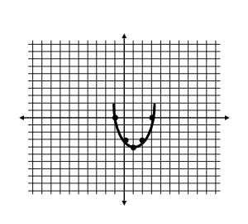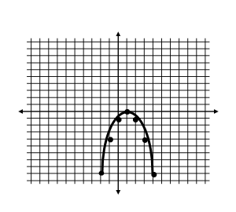

**Ex:** *x*² + 7 = 4*x* **Ex:** *x*² – 6*x* + 8 = 0

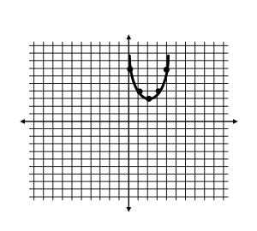No Solution *x* = 2 and *x* = 4

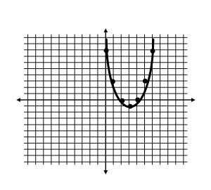

**Graph the following quadratic equations on a graphing calculator and identify the solutions.**

**Ex:** *x*² + 4*x* = 5 **Ex:** –*x*² – 6*x* = 9 **Ex:** *x*² + 4*x* = –6

*x* = –5 and *x* = 1 *x =* –3No solution

**Ex:** *x*² + *x* = –1 **Ex:** –*x*² + 6*x* = 9

No Solution *x* = 3

**Find the zeros of the function.**

**Ex:** *f*(*x*) = *x*² + 6*x* – 7 **Ex:** *f*(*x*) = *x*² + 7*x* + 6

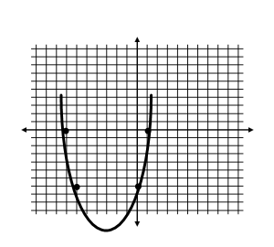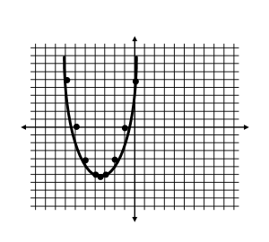*x* = 1, *x* = –7 *x* = –1 and *x* = –6

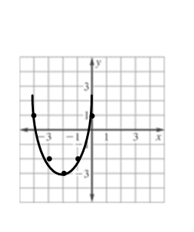

**Approximate zeros to the nearest tenth: Ex:** *f*(*x*) = *x*² + 4*x* + 1

**1. Graph**

**2. Find the two integers the root falls between**

**3. Make a table with increments of 0.1 for *x* values. Look for**

**a change in signs since 0 falls between positive and negative numbers.**

|  |  |  |  |  |  |  |  |  |  |
| --- | --- | --- | --- | --- | --- | --- | --- | --- | --- |
| ***x*** | –0.9 | –0.8 | –0.7 | –0.6 | –0.5 | –0.4 | –0.3 | –0.2 | –0.1 |
| ***y*** | –1.79 | –1.56 | –1.31 | –1.04 | –0.75 | –0.44 | –0.11 | 0.24 | 0.61 |

|  |  |  |  |  |  |  |  |  |  |
| --- | --- | --- | --- | --- | --- | --- | --- | --- | --- |
| ***x*** | –3.9 | –3.8 | –3.7 | –3.6 | –3.5 | –3.4 | –3.3 | –3.2 | –3.1 |
| ***y*** | 0.61 | 0.24 | –0.11 | –0.44 | –0.75 | –1.04 | –1.31 | –1.56 | –1.79 |

***x* is approx..** –0.3 and –3.7

**Use a graphing calculator to solve.**

**Ex:** *f*(*x*) = *x*² + *x* – 6 **Ex:** *f*(*x*) = –*x*² + 2*x* + 2

*x* = –3 and *x* = 2 *x* = –0.7 and *x* = 2.7

**Ex:** An athlete throws a shot put with an initial vertical velocity of 40 ft/s.

a) Write an equation that models the height of the shot put as a function of the time it is in the air.

***h* = –16*t*² + 40*t***

b) Use the equation to find the time the shot put is in the air.

About 2.5 seconds

**Ex:** A baseball player throws a ball into the air with an initial vertical velocity of 32 ft/s and is released at a height of 5 feet.

a) Write an equation that models the height of the ball based on time in the air.

*h* = –16*t*² + 32*t* + 5

b) Find out how long the ball is in the air.

About 2.1 seconds