Name:____________________________________________________

Final Exam
Chapters 3 – 4 Review
Proportions, Percents, and Slope

Solve each proportion or percent problem. Show all work. Circle your answer.

1. $\frac{x−8}{−2}=\frac{\text{11}−4x}{\text{11}}$ 2. $\frac{5m}{6}=\frac{\text{10}}{\text{12}}$ 3. $\frac{\text{18}}{d+\text{13}}=\frac{6}{d−\text{13}}$

4. A recipe that yields 12 buttermilk biscuits calls for 2 cups of flour. How much flour is needed to make 30 biscuits?

5. What percent of 75 is 27? 6. What number is 35% of 80?

7. 81 is 54% of what number?

8. In a school transportation survey of 225 students, 18 of the students surveyed said that they walk to school. What percent of students walk to school?

Find the slope of the line that passes through each pair of points.

9. (2, –1) (4, 5) 10. (–3, –2) (–3, 6)

11. (1, 3) (3, –2) 12. (–9, 1) (1, 1)

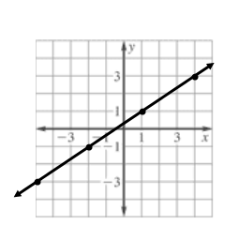
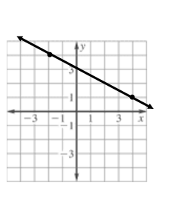
Find the slope of each graphed line.

13. 14.

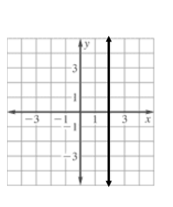
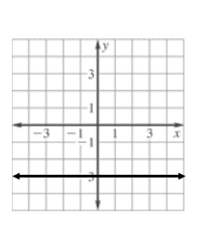

15. 16.

