Name:_________________________________________Date:_____________Per:__________

Writing Equations of Lines In Slope-Intercept Form
Review

Slope – intercept form:

- When a line is written in slope – intercept form, what two characteristics of a line can you identify?

- To write the equation of a line in slope – intercept form you must know what two things for your final answer?

- If you are given two points, which formula would you use to find the slope?

- If you are given a graphed line, which formula, different than the one above, can you use to find the slope?

- If you are given a graphed line how can you visually identify the y – intercept?

- Other than never intersecting, what do you know about parallel lines?

- Other than intersecting at right angles, what do you know about perpendicular lines
Use the given information to write the equation of each line in slope-intercept form. Assume the line passes through any points given.

8. Slope: 8, y-intercept: –7 9. (4, 17) and (0, 5)

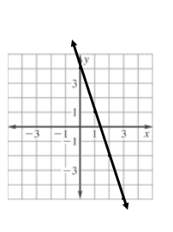
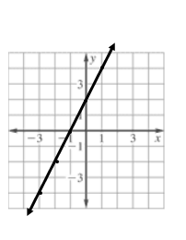

10. 11.

12. Slope: 2, (6, 3) 13. Slope: –4, (–1, 3)

14. (1, –2), (–5, 4) 15. f(–2) = 10, f(4) = –2

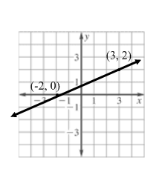
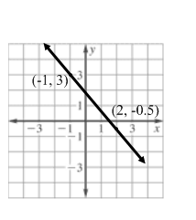
16. 17.

PARALLEL AND PERPENDICULAR LINES
Write the equation of the line using the given information. The line passes through any point given.

18. (–1, 3) to y = 2x + 2 19. (5, –1) to 5y + 3x = 10

20. (5, 1) to y = 5x – 2 21. (8, –1) to 4y + 2x = 12

