**Name:________________________________________________Date:_________Per:_____**

**Similar Figures – Worksheet 181**

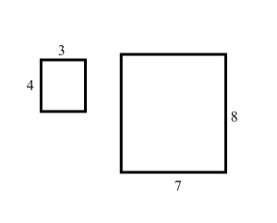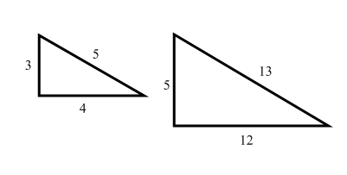**Determine whether each pair of figures is similar. Show or explain your work.**

**1. 2.**

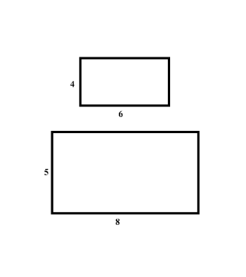

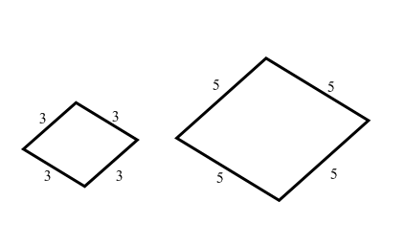

**3. 4.**

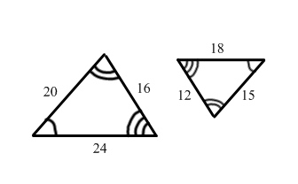

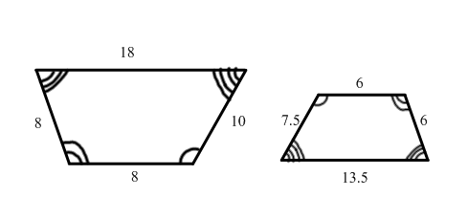

**5. 6.**

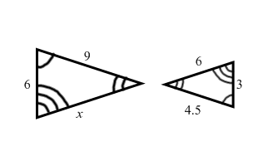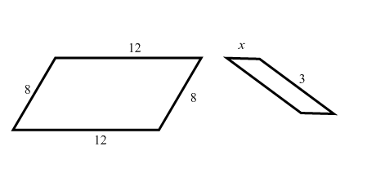**Each pair of polygons is similar. Write a proportion to find each missing measure. Then solve.**

**7. 8.**

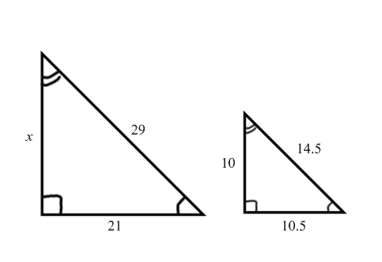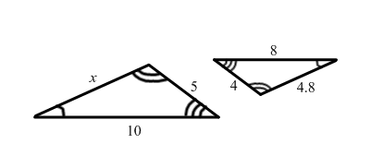

**9. 10.**

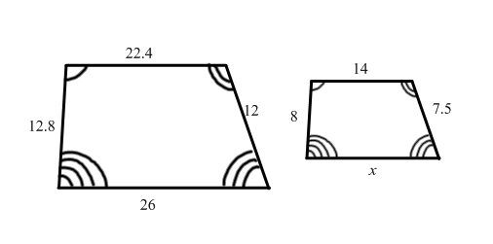

**11.**