**Midterm Review Questions (Set 1)**

**1.** Is the following a function? Why or why not?

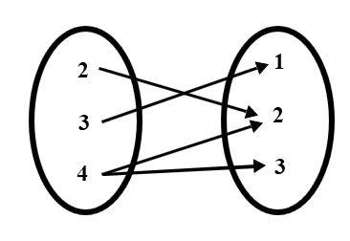

**2.** Translate the following verbal phrase:

“4 less than twice the sum of a number and 3”

**3.** Is 2 a solution? Show or explain.

4*x* – 1 > 7

**4.** Write a rule for the function.

|  |  |  |  |  |  |
| --- | --- | --- | --- | --- | --- |
| ***x*** | 0 | 2 | 4 | 6 | 8 |
| ***y*** | –3 | –2 | –1 | 0 | 1 |

**5.** Solve for *l*:

$S=πr^{2}+πrl$

**6.** Simplify:

$\frac{20x-10}{-5}$

**7.** Rewrite in function form:

3*x* – 2*y* = –6

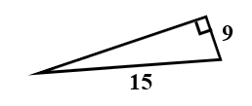

**8.** Find the missing side:

**9.** Add:

$-6\frac{3}{4}+1\frac{2}{5}$

**10.** Simplify: **11. $\sqrt{2}(\sqrt{6}+4\sqrt{10})$**

4(*x* – 3) – 2(*x* – 9) (Acc. Only)

**Answers:**

**1.** No, 4 has more than one output.

**2.** 2(*x* + 3) – 4

**3.** No, 7 is not greater than 7

**4.** *y* = ½*x* – 3

**5. $l=\frac{S-πr^{2}}{πr}$**  or $l=\frac{S}{πr}-r$

**6.** –4*x* + 2

**7. $y=3+\frac{3}{2}x$**

**8.** *x* = 12

**9. $-5\frac{7}{20}$**

**10.** 2*x* + 6

**11. $2\sqrt{3}+8\sqrt{5}$**