1.7: Represent Functions as Graphs
Goals: *Graph ordered pairs (x, y)
*Graph functions so you can visualize trends
*Decide if a graph represents a function based on the “vertical line test”

**RECALL**
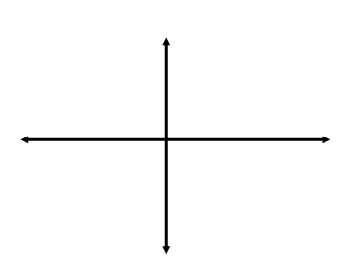
Coordinate Plane

Ex: Graph the function y = ½ x with a domain of 0, 2, 4, 6, 8

Ex: Graph the function y = 2x – 3 with a domain of 2, 3, 4, 5

Ex: Graph the function y = 2x – 1 with a domain of 1, 2, 3, 4, 5

Ex: The table shows the average score, s, on the mathematics section of the SAT in the United States from 1997 to 2003 as a function of time, t, since 1997. In the table, 0 corresponds to the year 1997, 1 to 1998 and so on. Graph the function. What trend, if any, do you notice?

Years since 1997, t | 0 | 1 | 2 | 3 | 4 | 5 | 6
Average score, s | 511 | 512 | 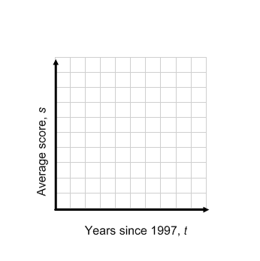  511 | 514 | 514 | 516 | 519

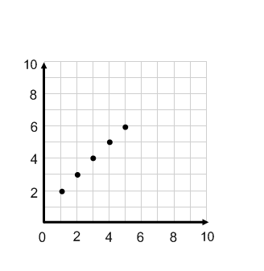
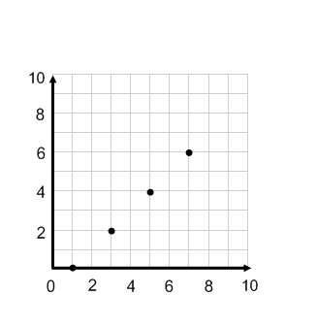
For each graph given, write a rule for the function, then identify the domain and range.

Ex: Ex:

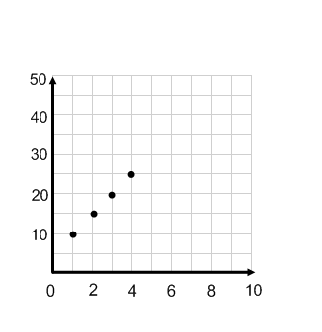

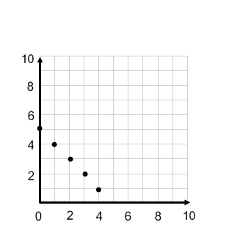
Ex: Ex:

