10.3: Solve Quadratic Equations by Graphing
Goals: *Identify solutions to a quadratic equation by graphing
*Approximate solutions of a quadratic equation to the nearest tenth

**RECALL**

A quadratic equation is:

A solution to a quadratic equation can also be called a:

Solutions or _______________ are the values of x so the quadratic equation is equal to:

**We already know how to solve a quadratic equation by:

Since we know that solutions occur when y = 0, how can you identify solutions on a graph then?

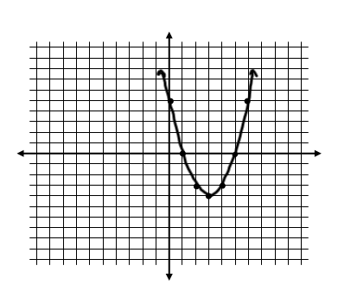
Ex: The graph below models the parabola formed by the quadratic equation y = x² – 6x + 5. What do you think the solutions are? Why?

Solve the following quadratic equations by graphing:

Ex: x² – 2x = 3 Ex: –x² + 2x = 1

Ex: x² + 7 = 4x Ex: x² – 6x + 8 = 0

Graph the following quadratic equations on a graphing calculator and identify the solutions.

Ex: x² + 4x = 5 Ex: –x² – 6x = 9 Ex: x² + 4x = –6

Ex: x² + x = –1 Ex: –x² + 6x = 9

Find the zeros of the function.

Ex: f(x) = x² + 6x – 7 Ex: f(x) = x² + 7x + 6

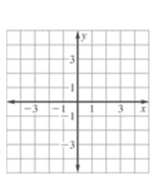
Approximate zeros to the nearest tenth: Ex: f(x) = x² + 4x + 1

1.

2.

3.

x | –0.9 | –0.8 | –0.7 | –0.6 | –0.5 | –0.4 | –0.3 | –0.2 | –0.1
y

x | –3.9 | –3.8 | –3.7 | –3.6 | –3.5 | –3.4 | –3.3 | –3.2 | –3.1
y

Use a graphing calculator to solve.

Ex: f(x) = x² + x – 6 Ex: f(x) = –x² + 2x + 2

Ex: An athlete throws a shot put with an initial vertical velocity of 40 ft/s.

a) Write an equation that models the height of the shot put as a function of the time it is in the air.

b) Use the equation to find the time the shot put is in the air.

Ex: A baseball player throws a ball into the air with an initial vertical velocity of 32 ft/s and is released at a height of 5 feet.

a) Write an equation that models the height of the ball based on time in the air.

b) Find out how long the ball is in the air.

